**PARTICLES AND WAVES**

**Exercises**

**Section 34.2 Blackbody Radiation**

**15. Interpret** This is a problem about blackbody radiation. We want to explore the connection between temperature and the radiated power.

**Develop** From the Stefan-Boltzmann law (Equation 34.1), 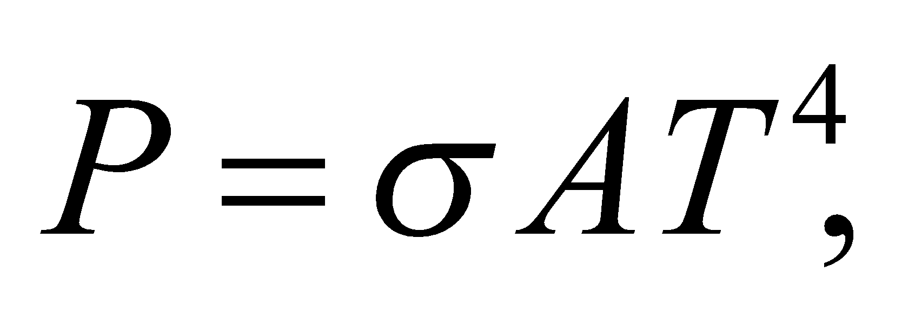 we see that the total radiated power, or luminosity, of a blackbody is proportional to *T*4.

**Evaluate** Doubling the absolute temperature increases the luminosity by a factor of 24 = 16.

**Assess** A blackbody is a perfect absorber of electromagnetic radiation. As the temperature of the blackbody increases, its radiated power also goes up.

**16.** **Interpret** This problem explores black-body characteristics of a star. We are to find the power radiated, the peak emission wavelength, and the median emission wavelength of the star Rigel.

**Develop** To a good approximation, the surface of Rigel radiates like a blackbody, so the power radiated per unit area may be found from the Stefan-Boltzmann law (Equation 34.1), dividing both sides by the area *A*:

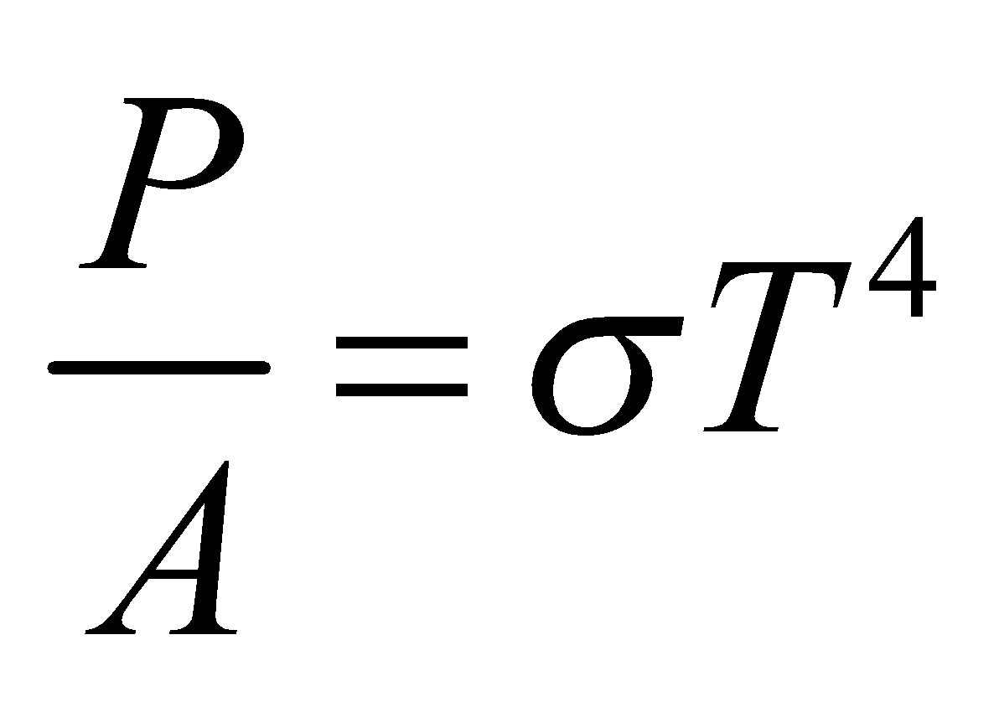

The peak and median wavelengths may be found from Equations 34.2a and 34.2b.

**Evaluate (a)** The power radiated per unit area is



**(b)** From Equation 34.2a, the peak wavelength is

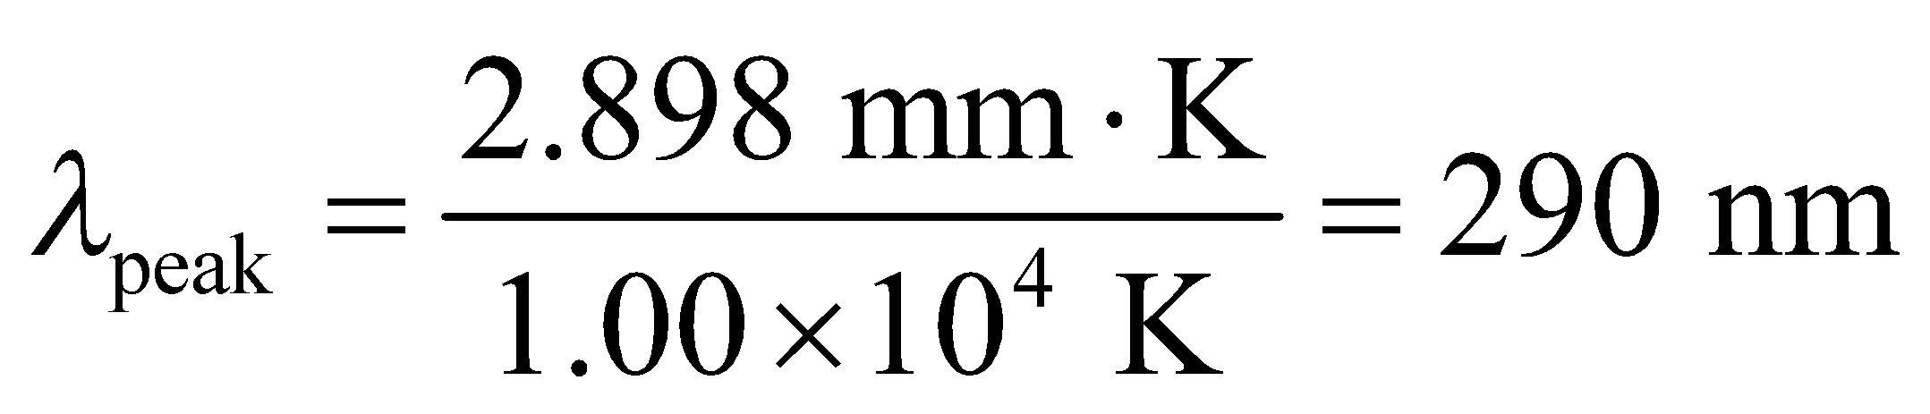

**(c)** From Equation 34.2b, the median wavelength is

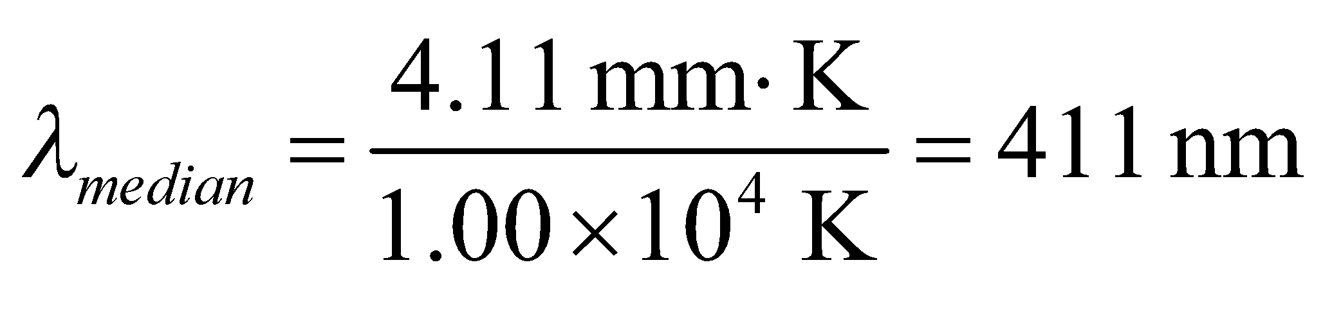

**Assess** The median wavelength is longer than the peak wavelength because of the long-wavelength tail of the temperature distribution (see Figure 34.2).

**17. Interpret** We are given the temperature of a blackbody (i.e., the Earth) and asked to find the wavelengths that correspond to peak radiance and median radiance.

**Develop** The wavelength at which a blackbody at a given temperature radiates the maximum power is given by Wien’s displacement law (Equation 34.2a):

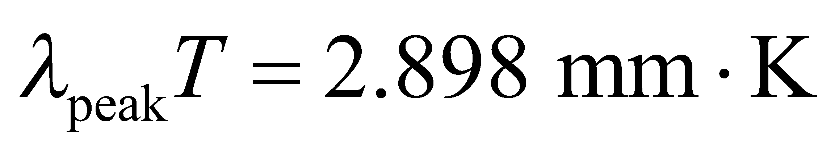

Similarly, the median wavelength, below and above which half the power is radiated, is given by Equation 34.2b:

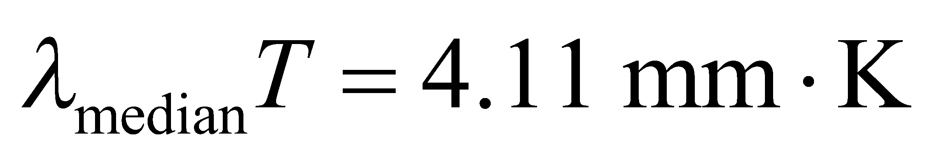

**Evaluate** Using the above formulas, we obtain

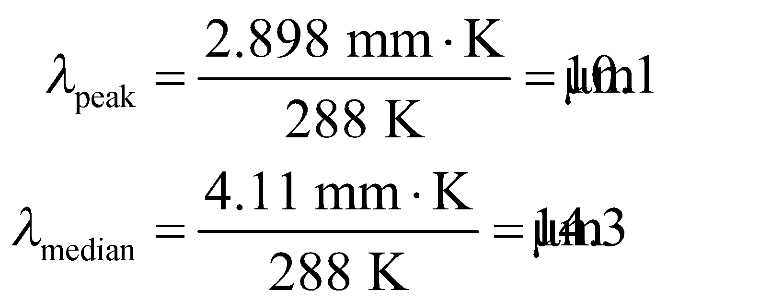

**Assess** The wavelengths are in the infrared. Note that 

**18.** **Interpret** This problem involves blackbody radiation. We are given the wavelength at which the peak power is emitted, and are asked to find the temperature.

**Develop** Apply Equation 34.2a



with *λ*peak = 40 μm.

**Evaluate** The asteroid’s temperature is

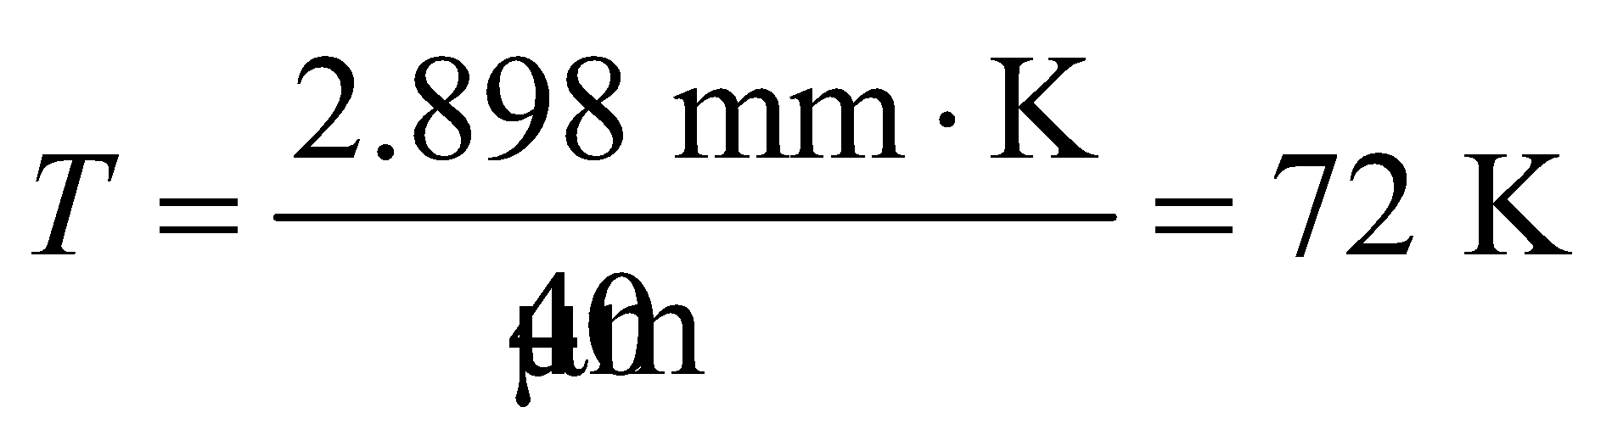

**Assess** This is a cold asteroid. According to NASA, the temperature of a typical asteroid in the asteroid belt is around 200 K.

**19. Interpret** We are to find the wavelength for the peak radiance of solar blackbody radiation, and the median wavelength. In both cases, we’ll use the per-unit-wavelength basis; Equations 34.2a and 34.2b.

**Develop** Wien’s law (Equation 34.2a) gives us the peak wavelength: 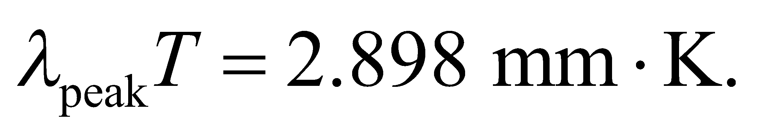 The median wavelength is given by Equation 34.2b:  The temperature of the Sun is *T* = 5800 K, so we can use these equations to solve for the respective wavelengths.

**Evaluate** Inserting the temperature gives

**(a)** 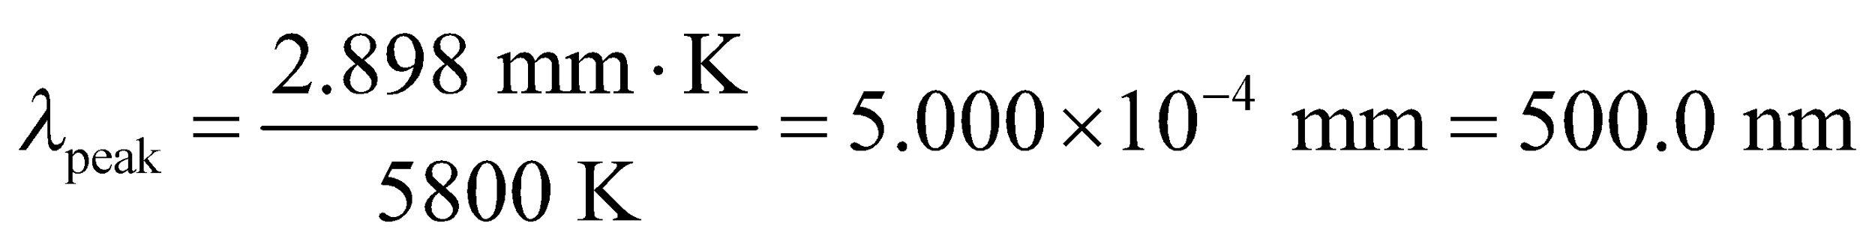

**(b)** 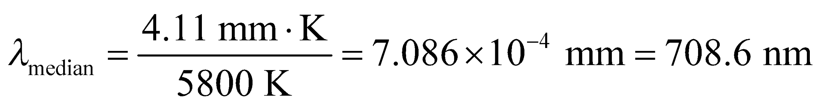

**Assess** The peak wavelength is near the center of the visible spectrum (green) and the median wavelength is just beyond the visible in the near-infrared region.

**Section 34.3 Photons**

**20. Interpret** This problem explores the connection between frequency and energy. We are given the frequency of photons and are asked to find the energy in electron volts (eV).

**Develop** Apply Equation 34.6, *E* = *hf*.

**Evaluate** (a) For *f* = 1.0 MHz, 

(b) For *f* = 5.0 × 1014 Hz, 

(c) For *f* = 3.0 × 1018 Hz, 

**Assess** The energy for the photon of part (a) corresponds roughly to radio frequencies, that for part (b) is visible light, and that for part (c) is X-ray radiation.

**21. Interpret** We're asked to express the range of human eye sensitivity in terms of photon energies.

**Develop** The photon energy is given by Equation 34.6: 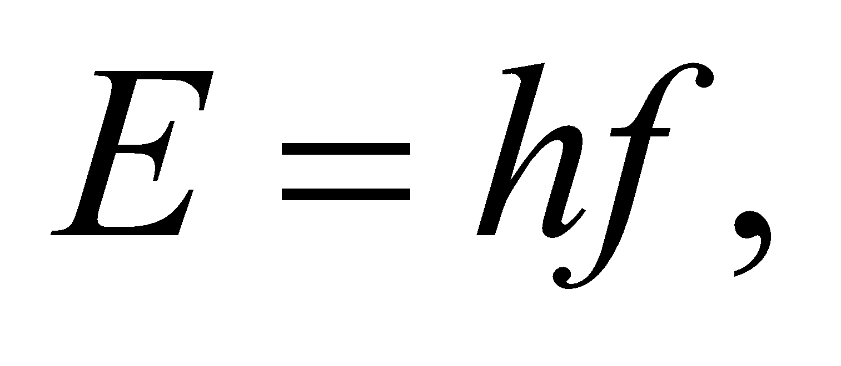 or in terms of wavelength: 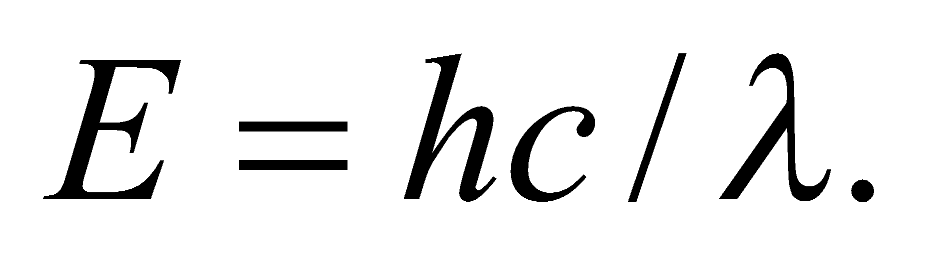

**Evaluate** The limits of human eye sensitivity are

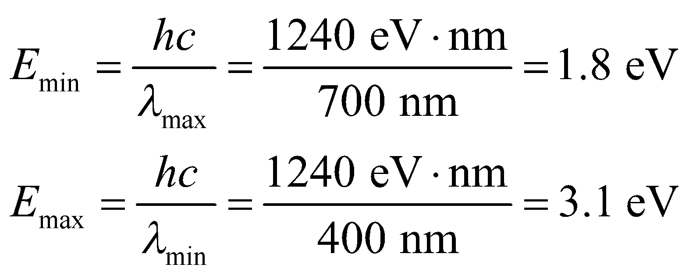

**Assess** We've used the common shorthand of 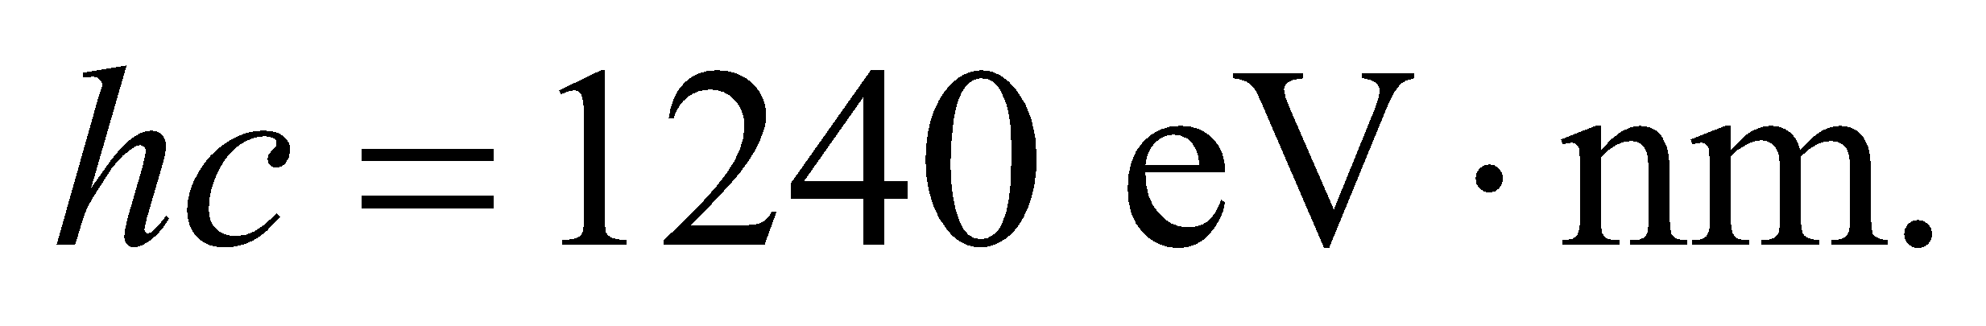

**22.** **Interpret** We are to find the energy of the photons produced by a microwave oven and the rate at which they are produced for a 900-W oven.

**Develop** Apply Equation 34.6, *E* = *hf* to find the photon energy E. To find the photon production rate, divide the oven power by the photon energy (in joules).

**Evaluate (a)** For *f* = 2.4 GHz, .

**(b)** The photon production rate is

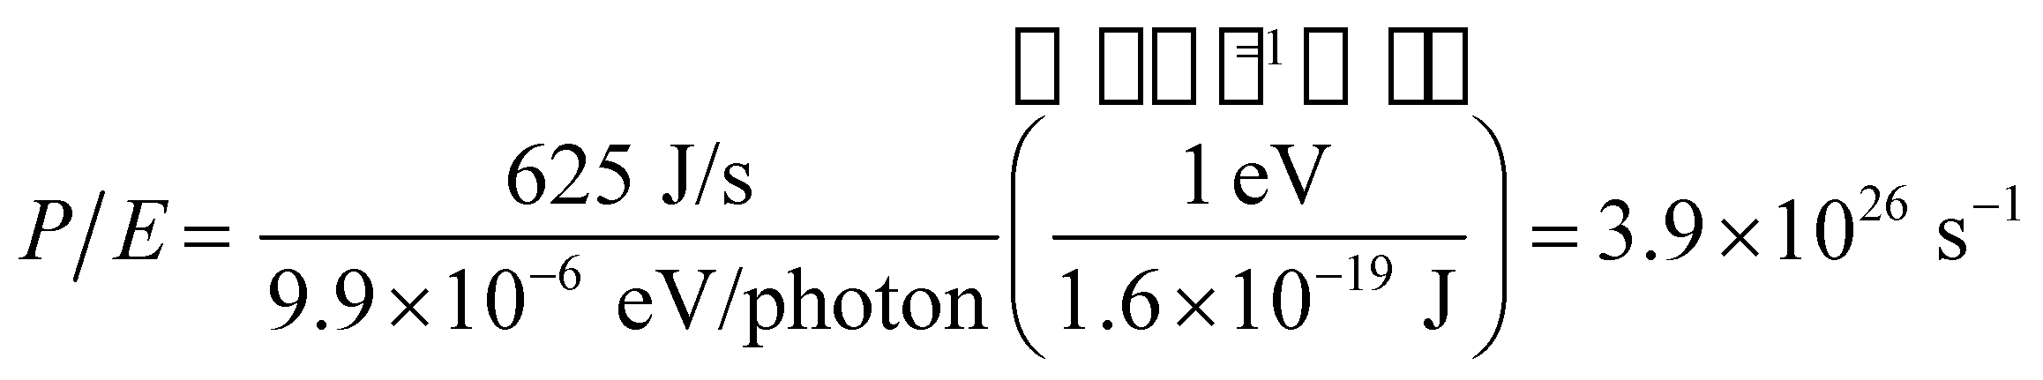

**Assess** The production rate is quite large because the photon energy is quite small.

**23. Interpret** The problem asks for a comparison of the power output by a red laser and a blue laser. The lasers emit photons at the same rate, but the photon energy of each laser is different.

**Develop** Using *λ* = *c*/*f* and Equation 34.6, *E* = *hf*, the ratio of the photon energies is

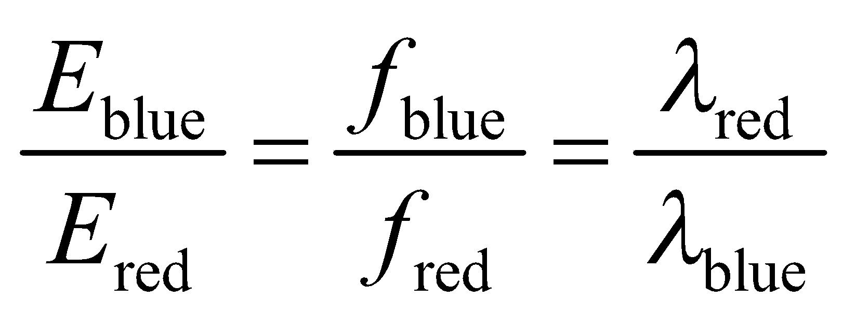

**Evaluate** Using the above equation, the ratio of the energies is

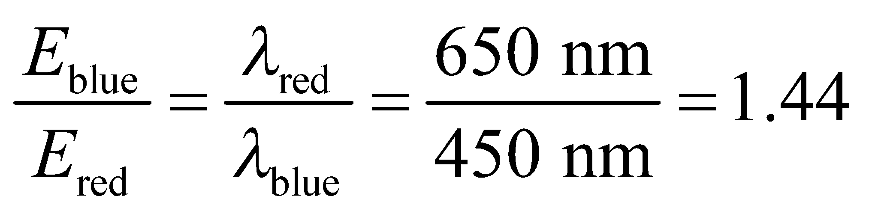

Since the lasers emit photons at the same rate, this is also the ratio of their power outputs. Thus the power of the blue laser is 1.44 times that of the red laser.

**Assess** Blue lasers, with shorter wavelength (higher frequency), are more energetic than red lasers.

**24. Interpret** We are to find the minimum work function that would allow photons to be ejected by 900-nm light.

**Develop** Equation 34.7 *K*max = *hf* − *φ* gives the maximum kinetic energy for electrons ejected by light at a frequency *f* from a material with a work function *φ*. Use *c* = *λf* to convert this to a function of wavelength. The result is

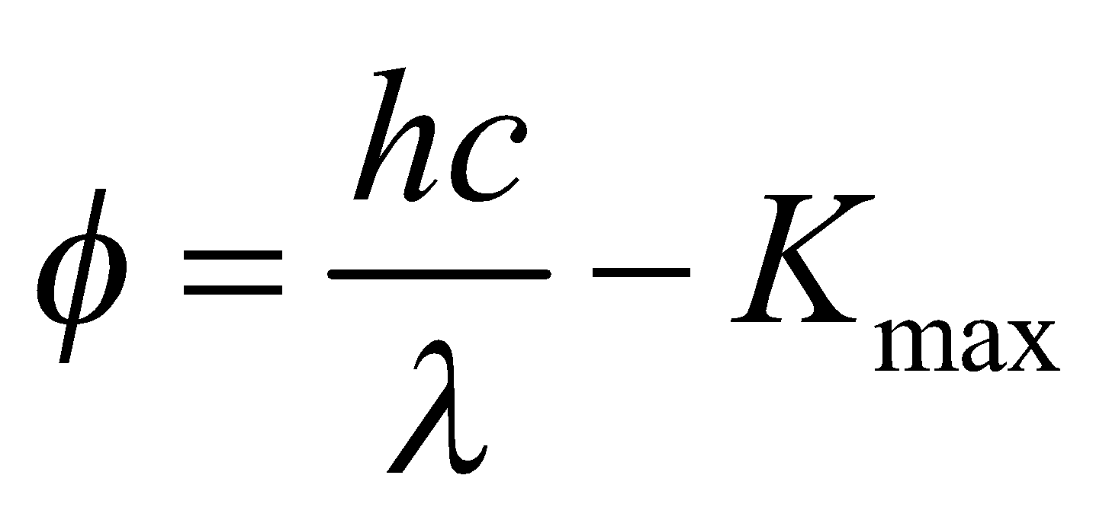

The minimum work function occurs for *K*max = 0.

**Evaluate** For *K*max = 0, the work function is .

**Assess** The work function for many materials is greater than this, so 900-nm light would not be able to eject electrons from these materials.

**Section 34.4 Atomic Spectra and the Bohr Atom**

**25. Interpret** This problem is about the energy levels of a hydrogen atom using the Bohr model. We are interested in the wavelengths of the first three lines in the Lyman series.

**Develop** The wavelength can be calculated using Equation 34.9:

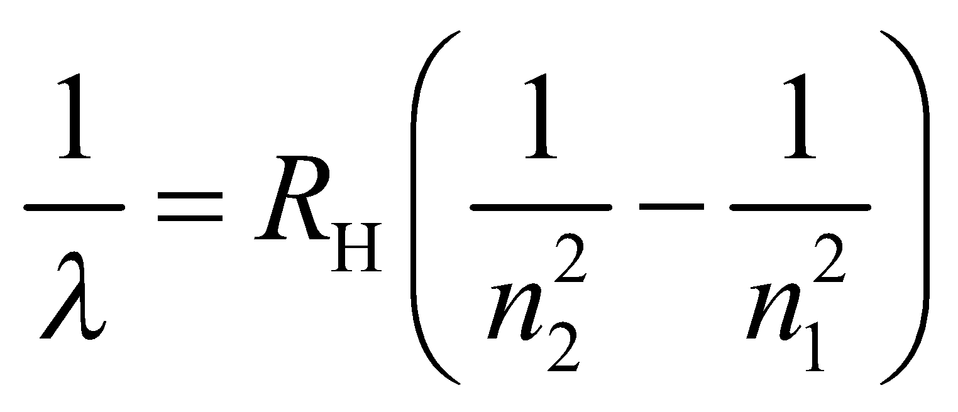

where 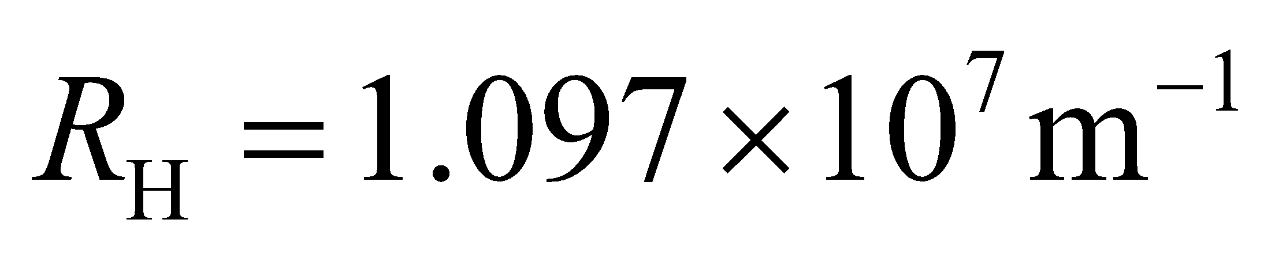 is the Rydberg constant and 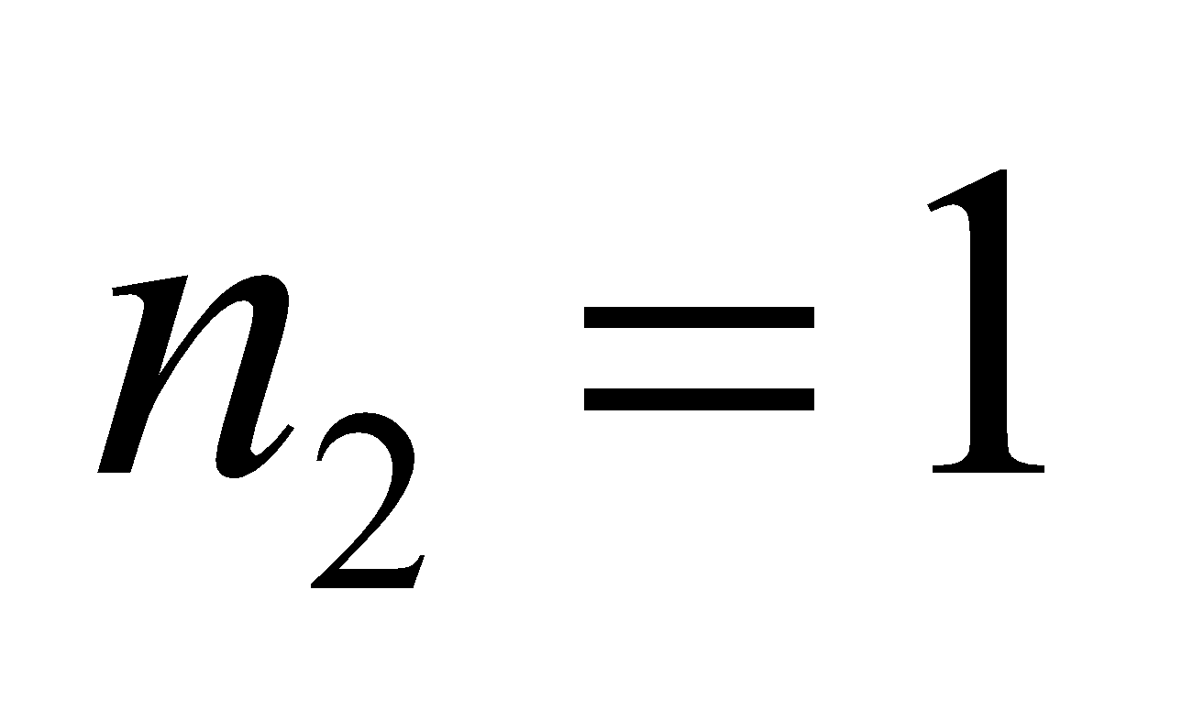 for the Lyman series.

**Evaluate** The first three lines correspond to 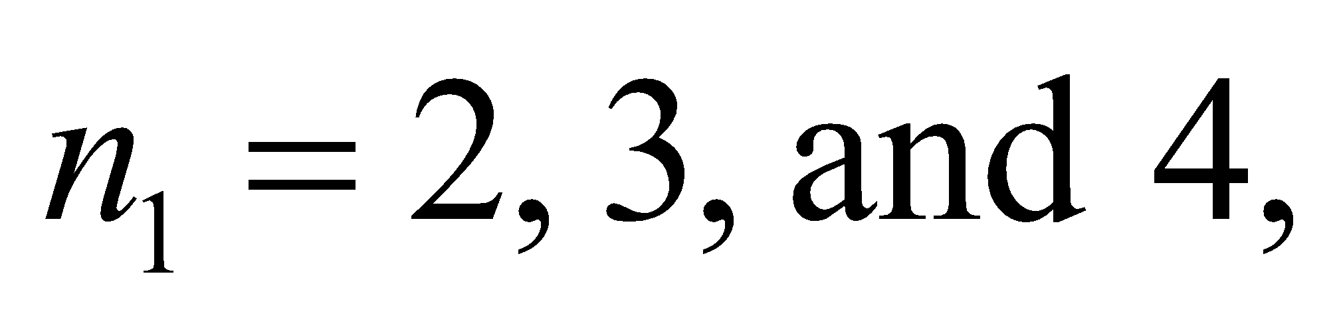 and the wavelengths are, respectively,

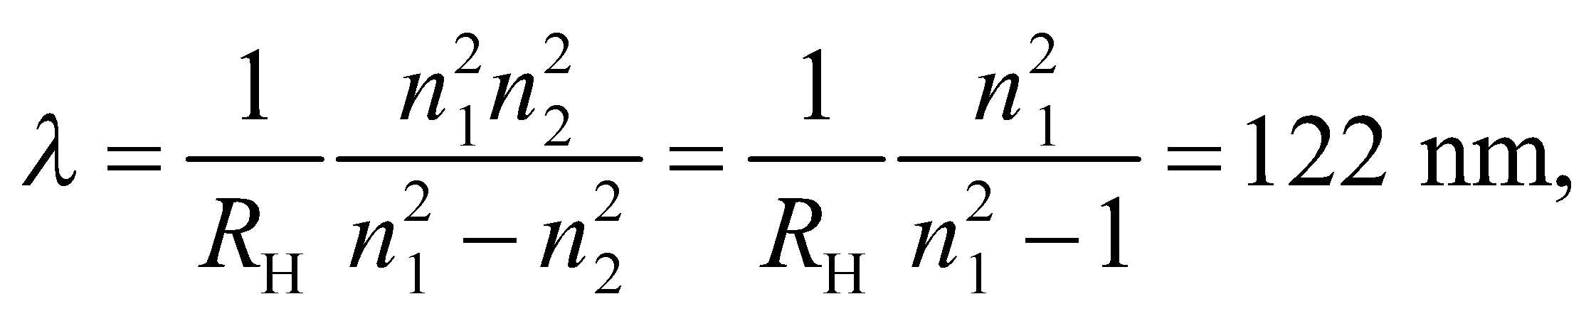103 nm, and 97.2 nm

Note that 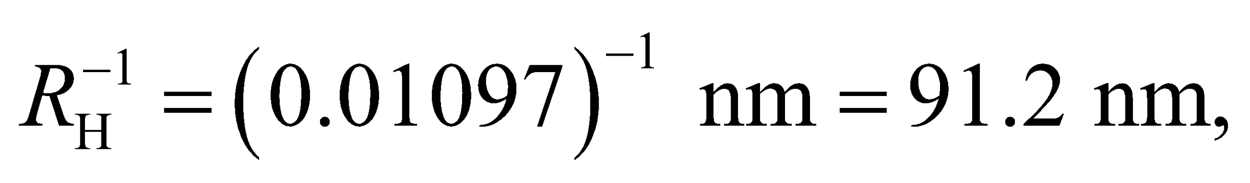 which is the Lyman series limit.

**Assess** The wavelengths are less than 400 nm. Therefore, the Lyman spectral lines are in the ultraviolet regime.

**26. Interpret** This problem involves finding the spectral line in the Paschen series that corresponds to the wavelength 1282 nm.

**Develop** The wavelengths in the Paschen series for hydrogen are given by Equation 34.9, with 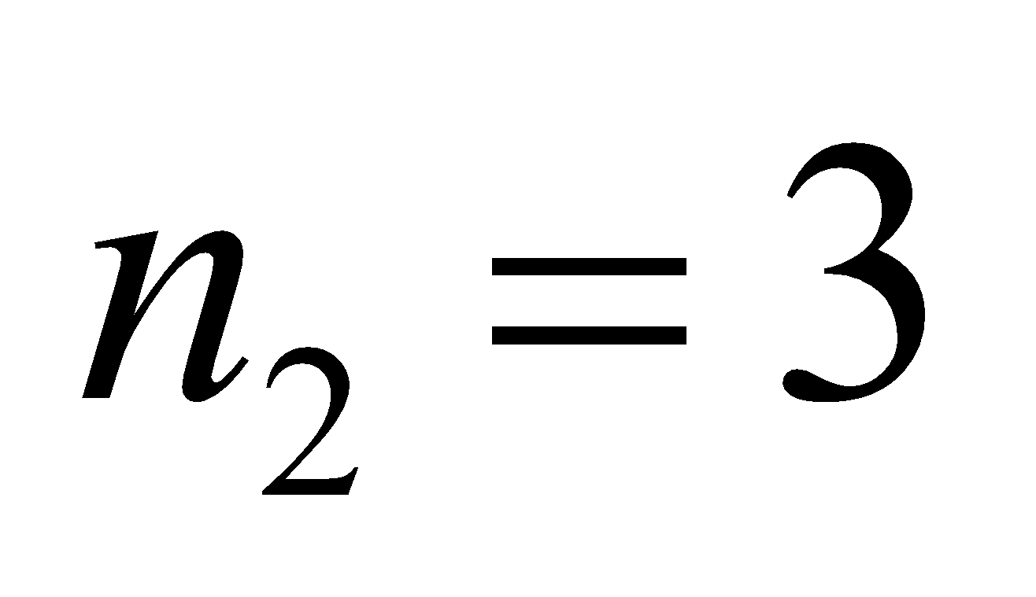 and

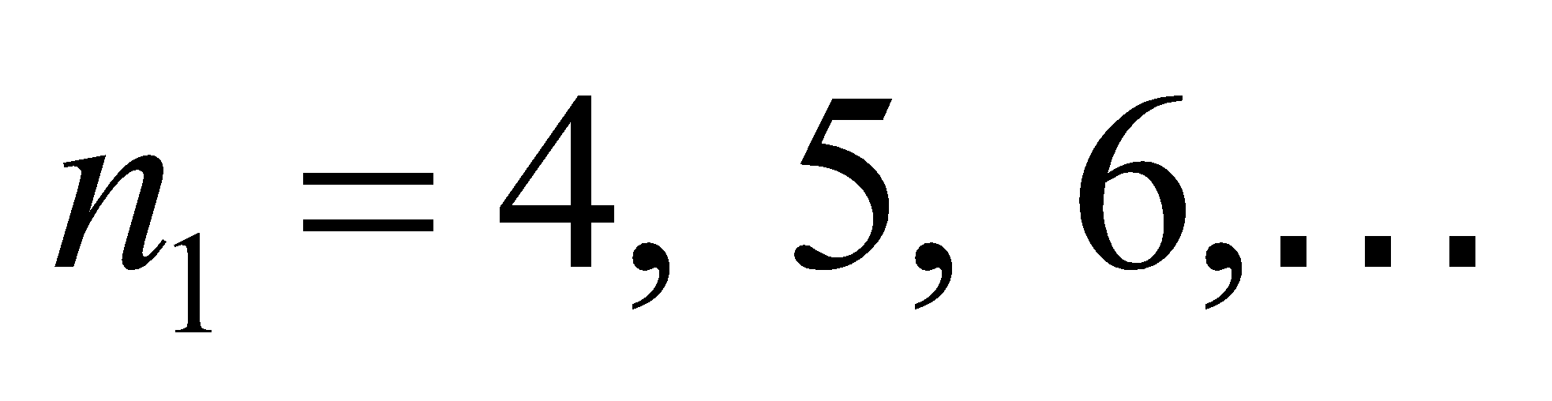, which gives

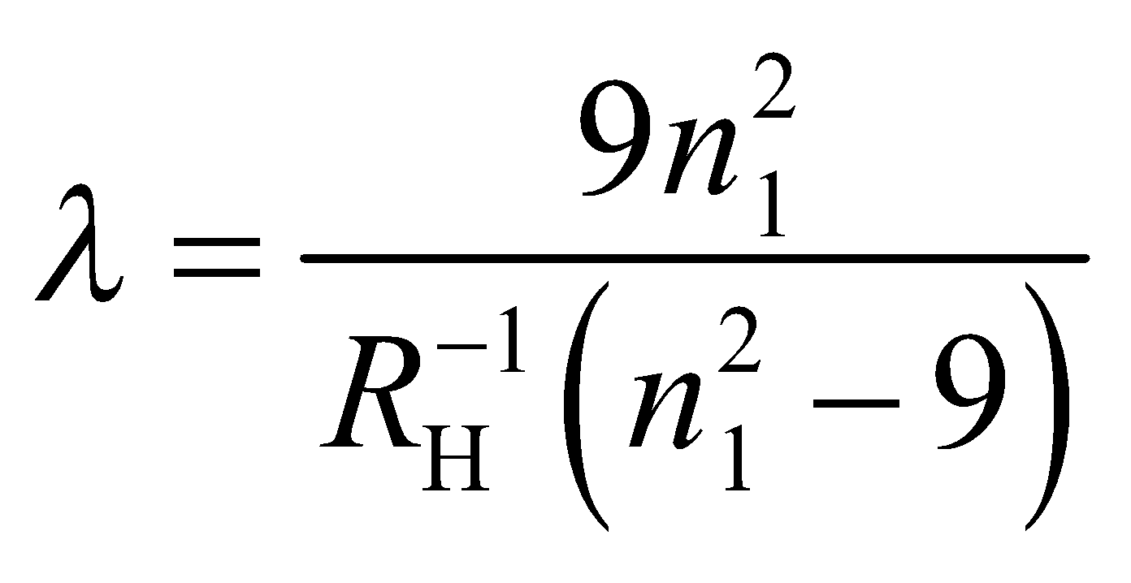

**Evaluate** With 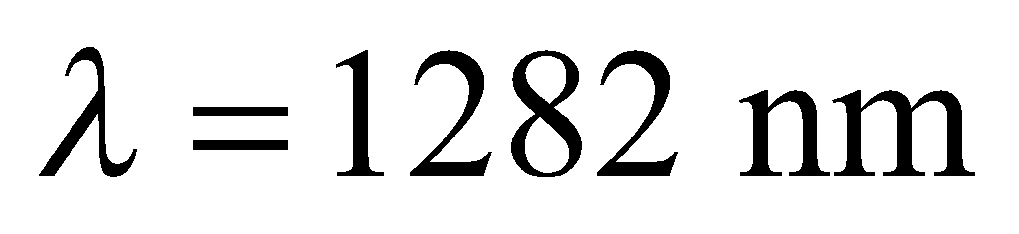 and 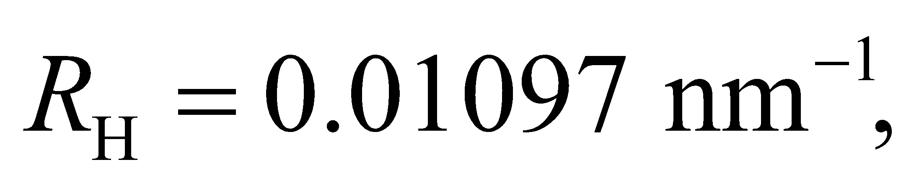 one finds

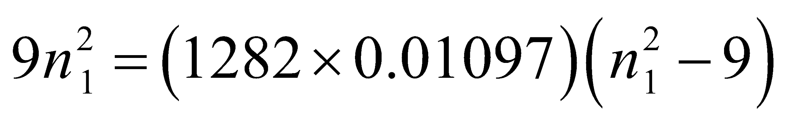

or

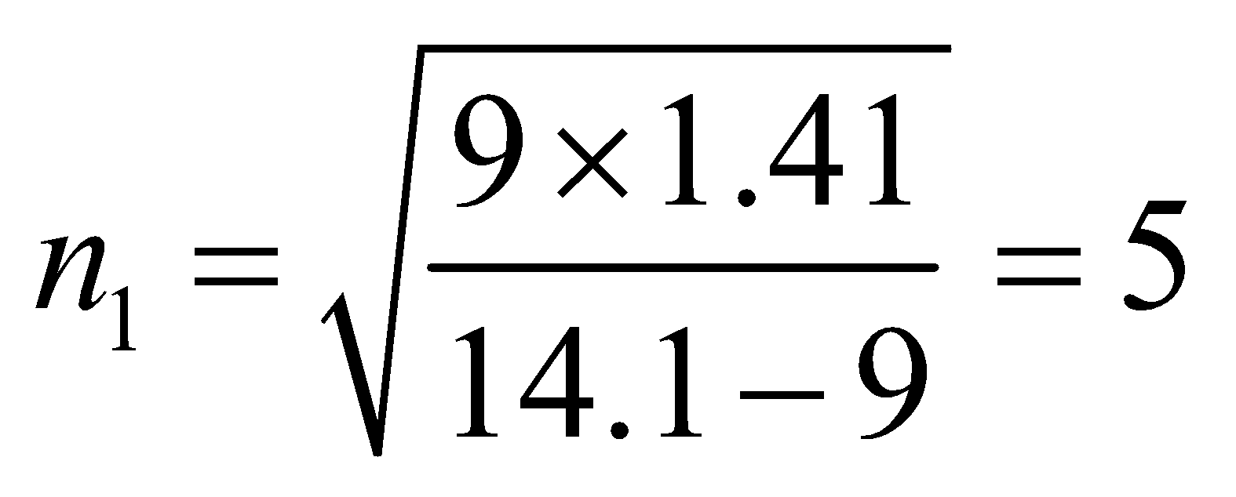

which corresponds to the second line in this series.

**Assess** The wavelength 1282 nm is in the infrared portion of the spectrum.

**27. Interpret** This problem is about the ionization energy of a hydrogen atom in its ground state. We want to find the wavelength that corresponds to a photon carrying this much energy.

**Develop** The energy of the ground state of hydrogen is given by Equation 34.12b (with *n* = 1): 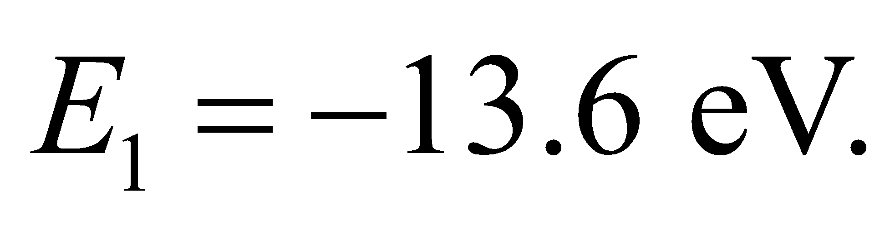 Therefore, the ionization energy is 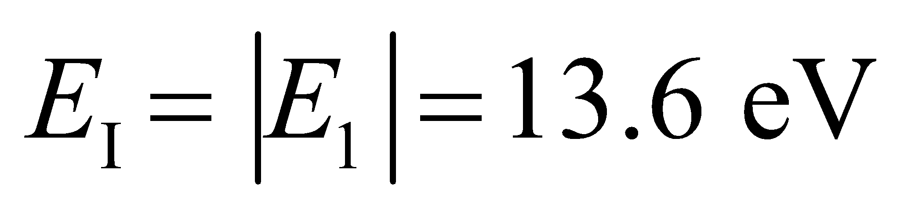 (the subscript “I” is for ionization). For a photon whose wavelength is *λ*, the energy it carries is (Equation 34.6) 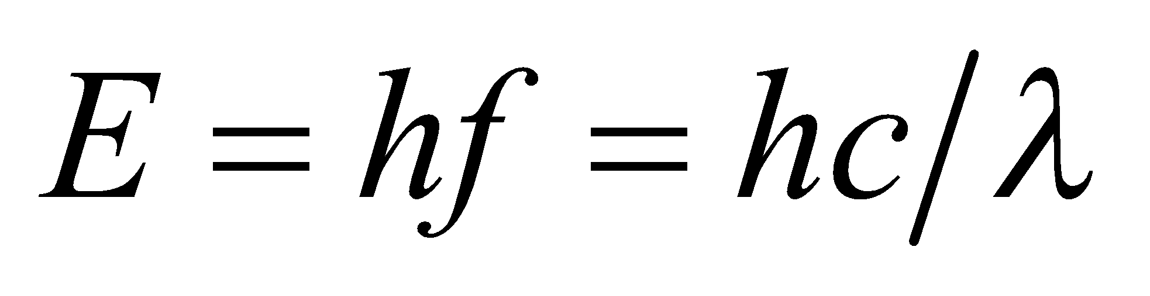.

**Evaluate** A photon with energy 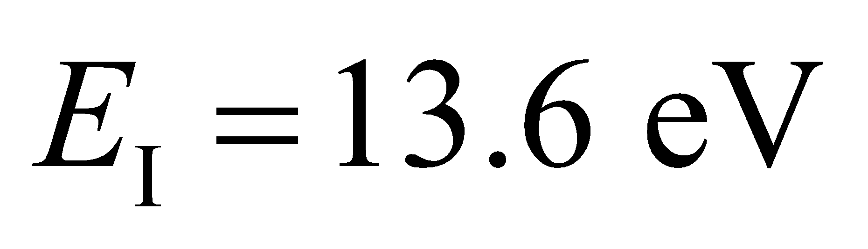 has wavelength

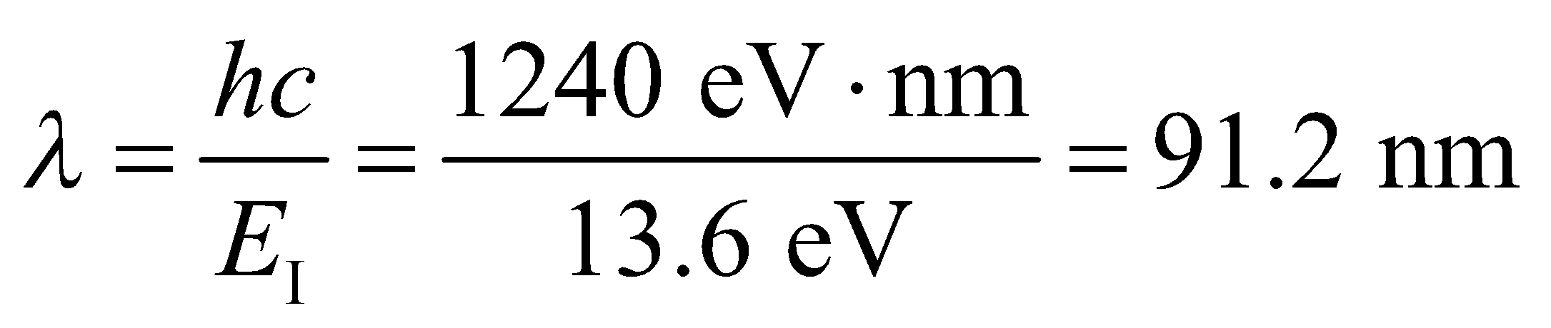

**Assess** This is the same as the Lyman series limit (Equation 34.9 with  and 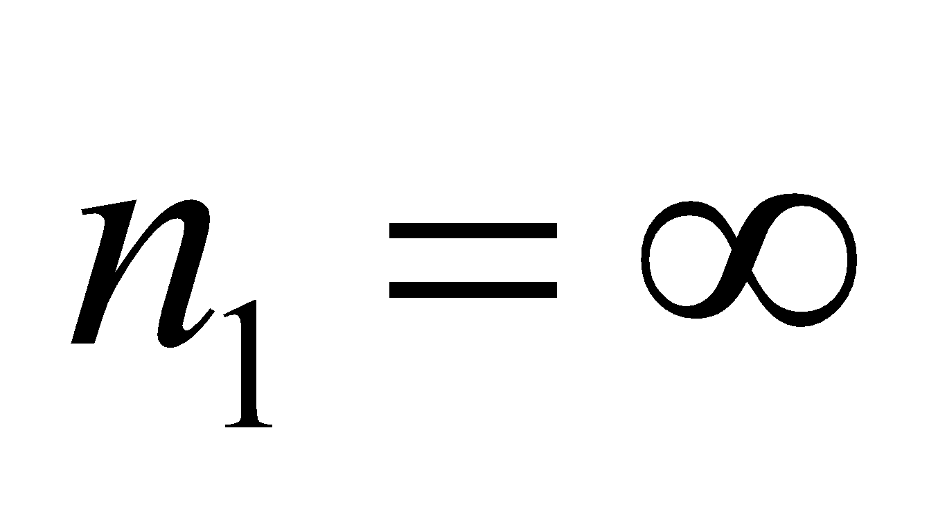) 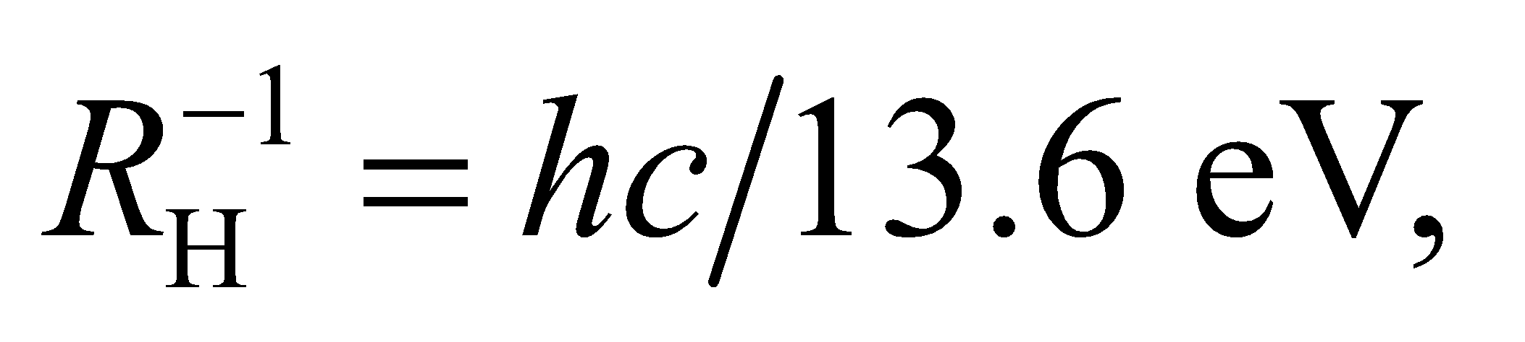 and lies in the ultraviolet.

**28. Interpret** We are to find the energy level of a Bohr hydrogen atom that has a diameter of 5.18 nm.

**Develop** The diameter of a hydrogen atom in the Bohr model is (Equation 34.13)

so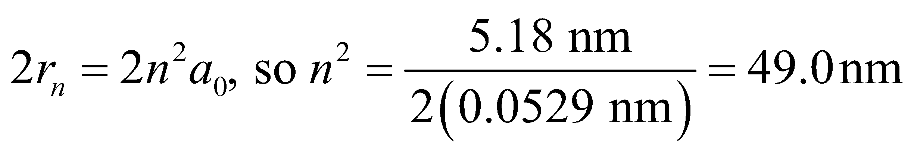

or *n* = 7.

**Evaluate** This is the sixth excited state.

**Assess** The radius of this state is two orders of magnitude larger than that of the ground state.

**Section 34.5 Matter Waves**

**29. Interpret** In this problem, we are asked to find the de Broglie wavelength of the Earth orbiting the Sun and an electron moving at the given speed.

**Develop** For nonrelativistic momentum, Equation 34.14 becomes

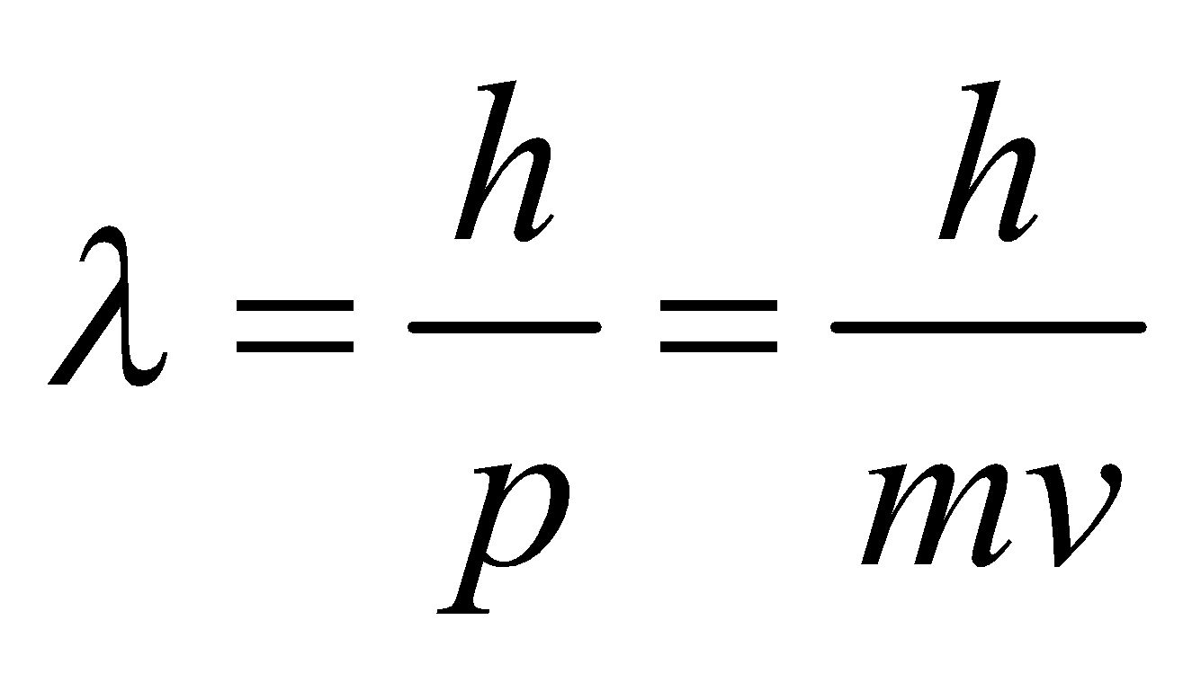

**Evaluate** **(a)** Using the orbital speed given and the Earth’s mass from Appendix E gives

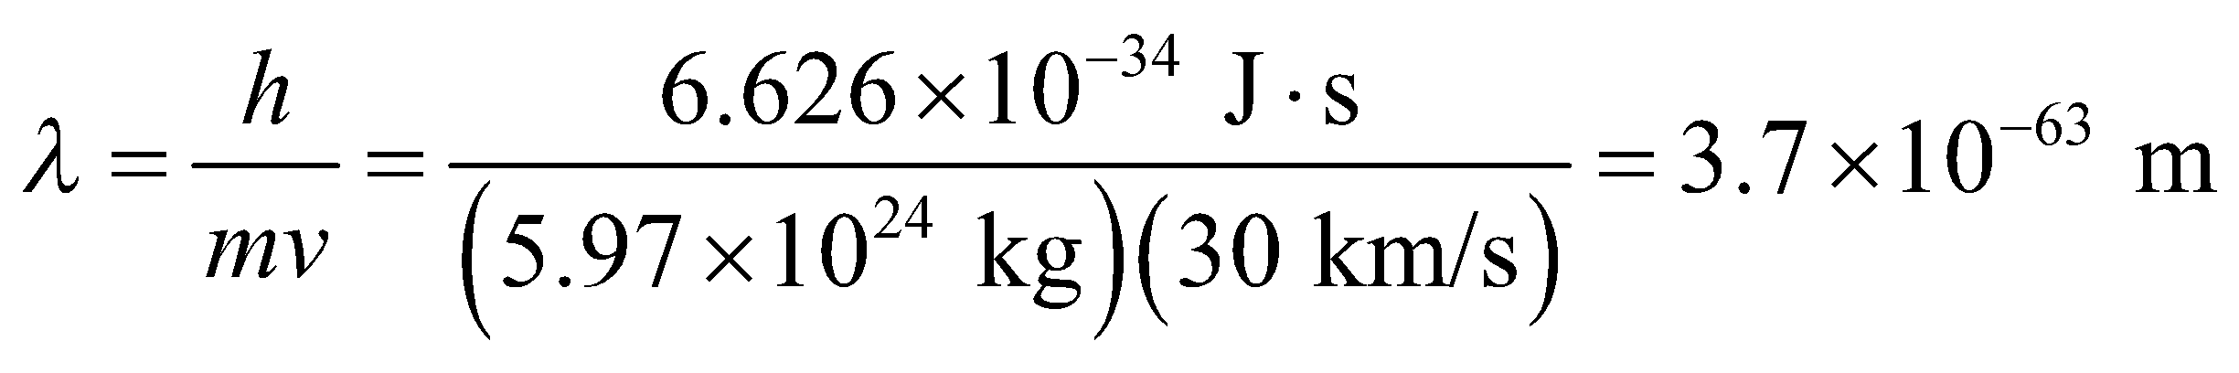

**(b)** For the given electron,

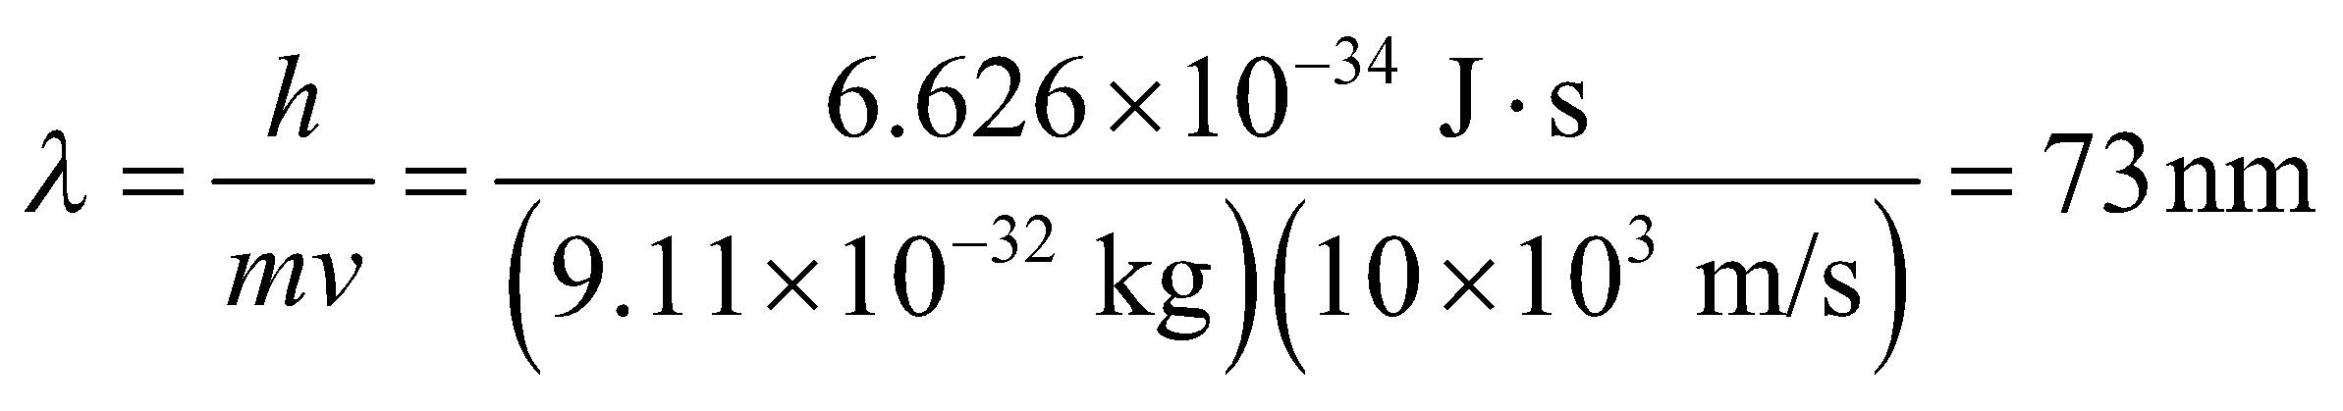

**Assess** The Earth’s de Broglie wavelength is much smaller than the smallest physically meaningful distance.

**30. Interpret** This problem involves finding the momentum of an electron with the given de Broglie wavelength.

**Develop** For a nonrelativistic electron 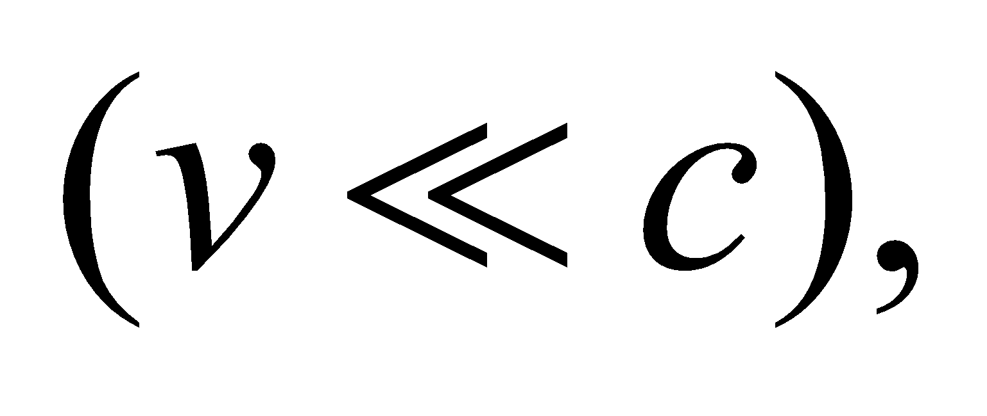 we can use the classical expression *p* = *mv* for momentum. The de Broglie wavelength is then *λ* = *h*/(*mv*).

**Evaluate** Solving for velocity gives

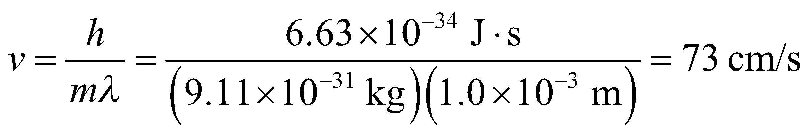

**Assess** This velocity is far less than the speed of light, so we were justified in using the classical expression for momentum.

**31. Interpret** The problem asks what relative speed must an electron have in order to have the same de Broglie wavelength as a proton.

**Develop** Since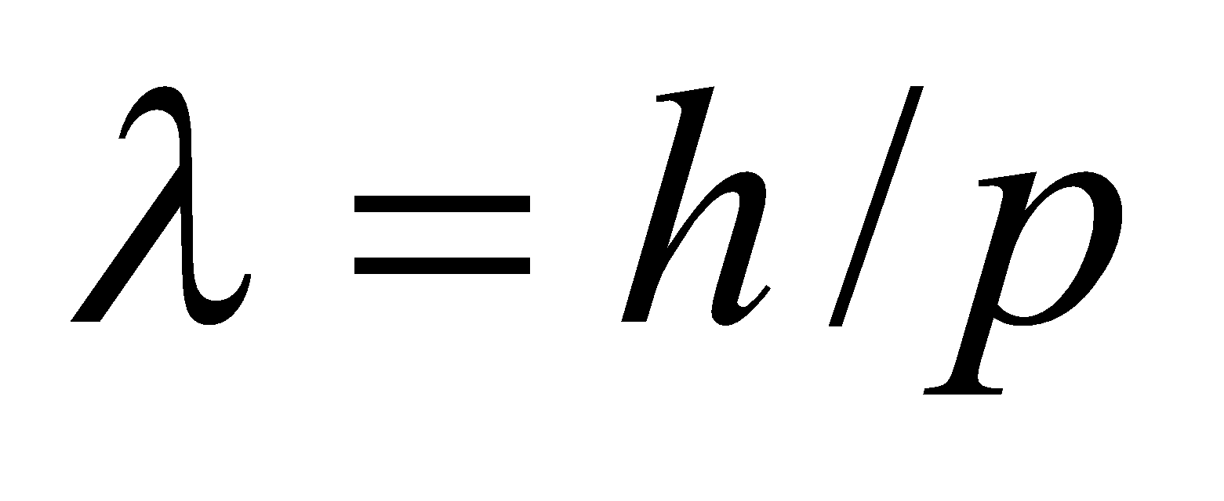 (Equation 34.14), the same de Broglie wavelength means the same momentum.

**Evaluate** At non-relativistic speeds, the equal momenta implies 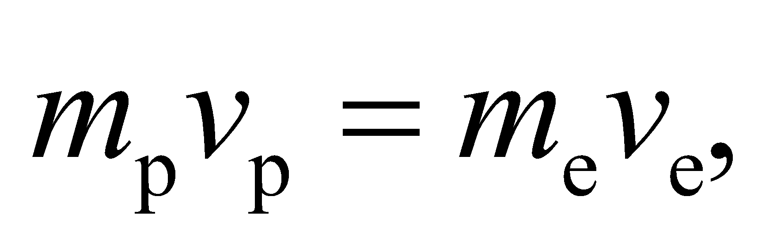or

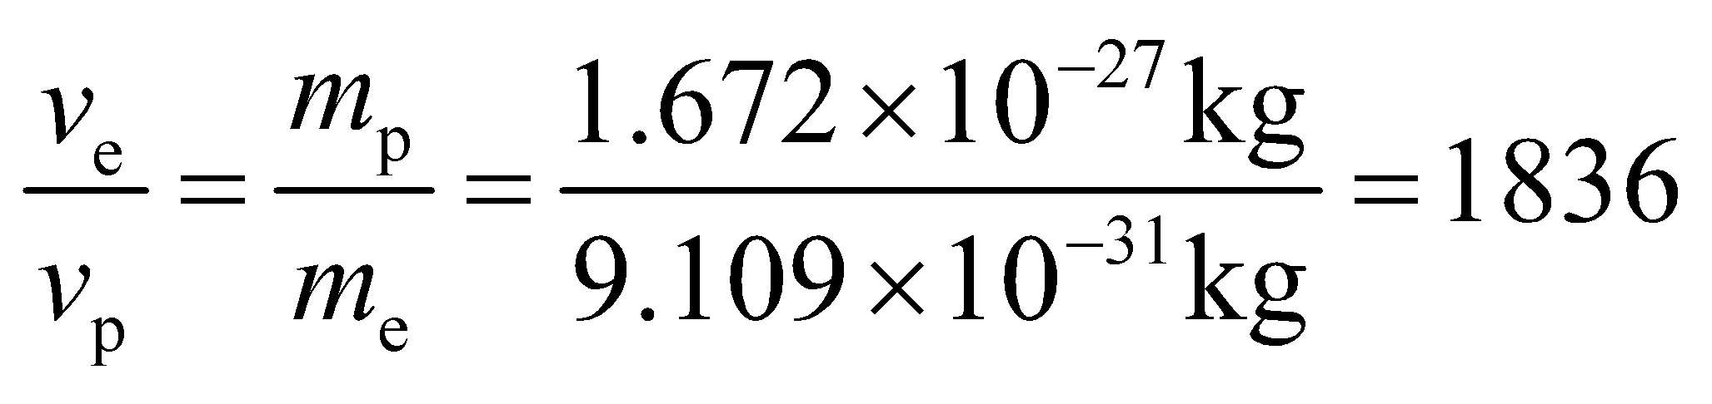

This says that the electron will need to be moving 1836 times faster than the proton.

**Assess** The problem would be more complicated if the momenta were relativistic: 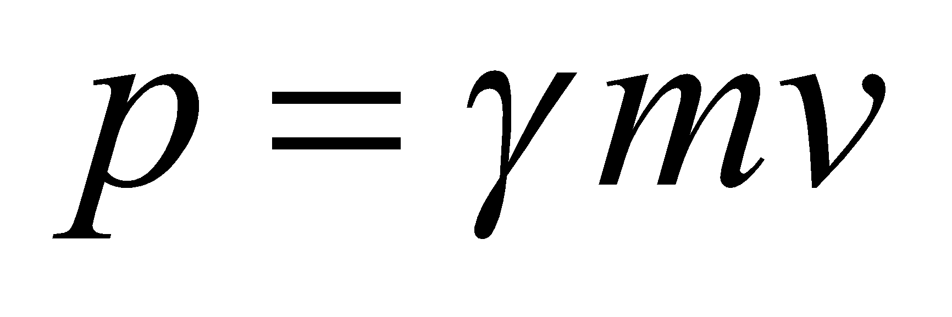 (Equation 33.7).

**32. Interpret** We are to find the de Broglie wavelength of electrons with various kinetic energies.

**Develop** We shall use Equation 34.14 *λ* = *h*/*p* for the de Broglie wavelength. Because the largest kinetic energy, 10 keV, is small compared to the electron’s rest energy *mc*2 = 511 keV, we can use the nonrelativistic expressions *K* = *p*2/(2*m*), so the expression for the de Broglie wavelength becomes

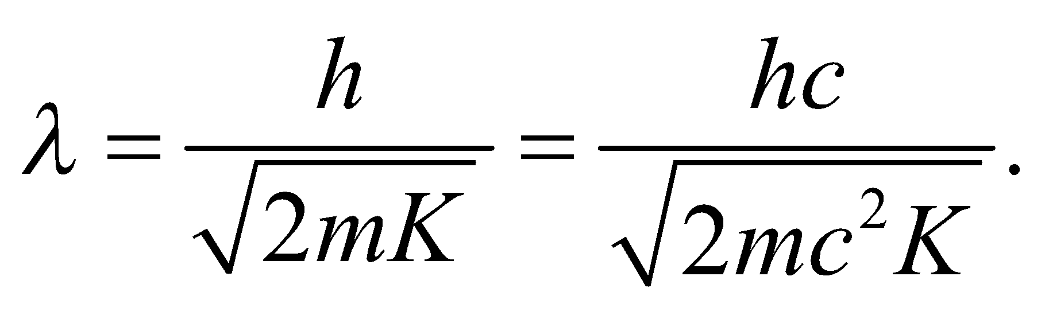

**Evaluate**  **(a)** For *K* = 10 eV,

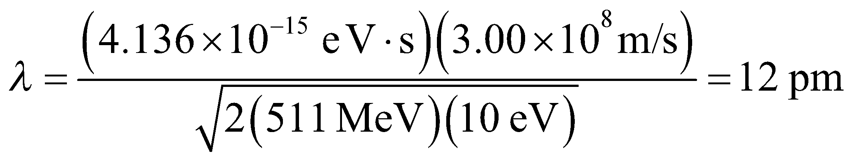

**(b)** For *K* = 1.0 eV,

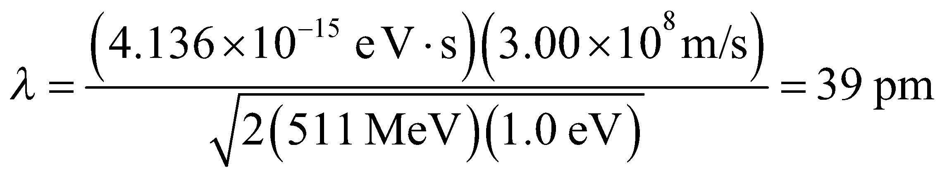

**(c)** For *K* = 10 keV,

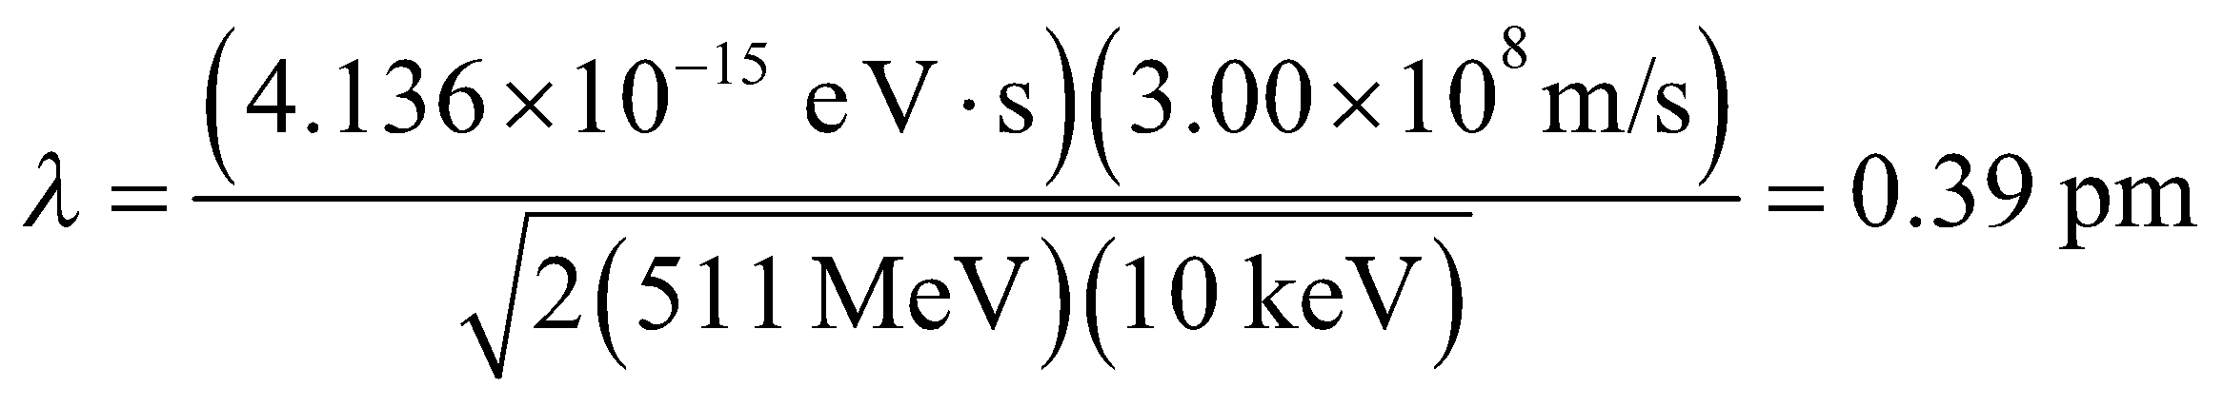

**Assess** For part (c), the relativistic relation 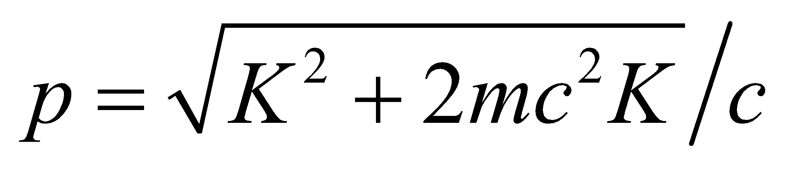 leads to a result that differs by about 0.0005%.

**Section 34.6 The Uncertainty Principle**

**33. Interpret** We want to find the minimum uncertainty in the velocity of a proton, given the uncertainty in its position.

**Develop** To find *Δv*, use the uncertainty principle, 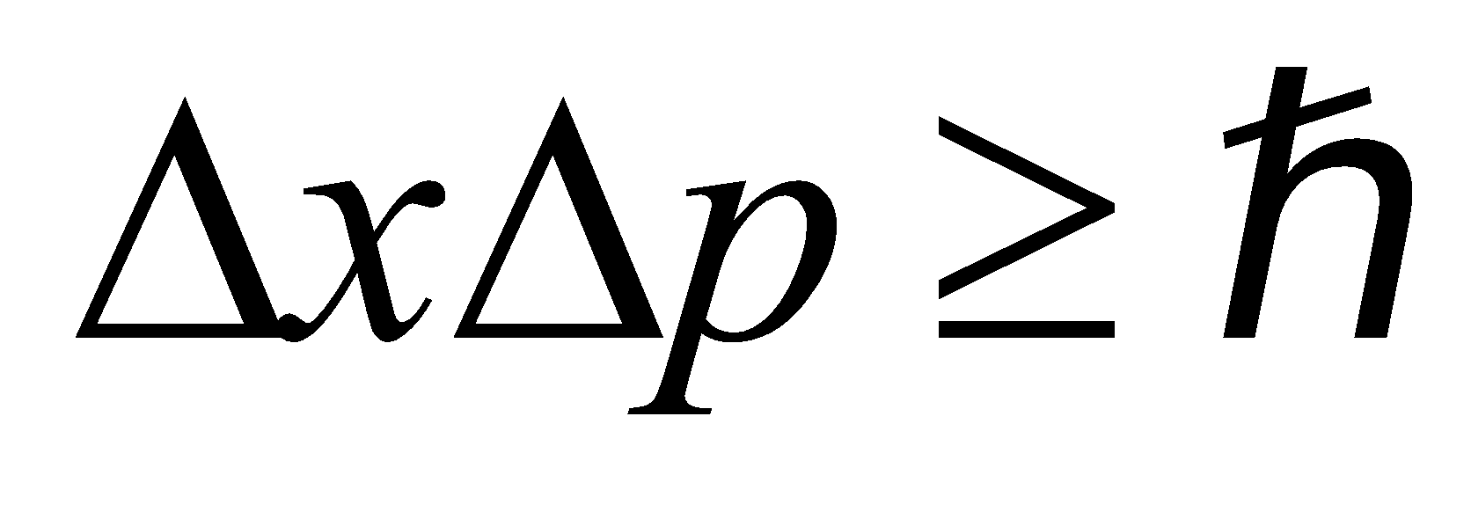 (Equation 34.15) with 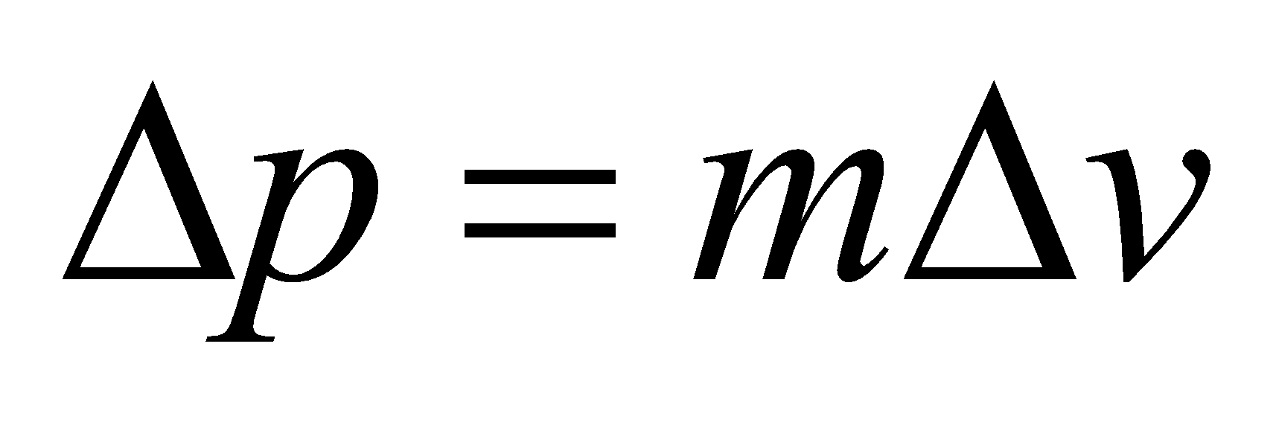 and

*Δx* = 1 fm.

**Evaluate** The above equation gives

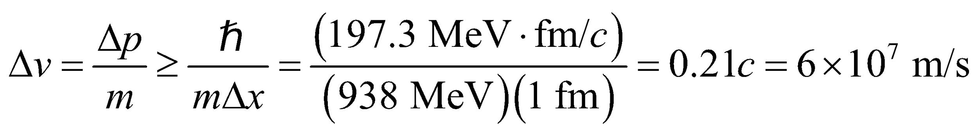

**Assess** The quantity 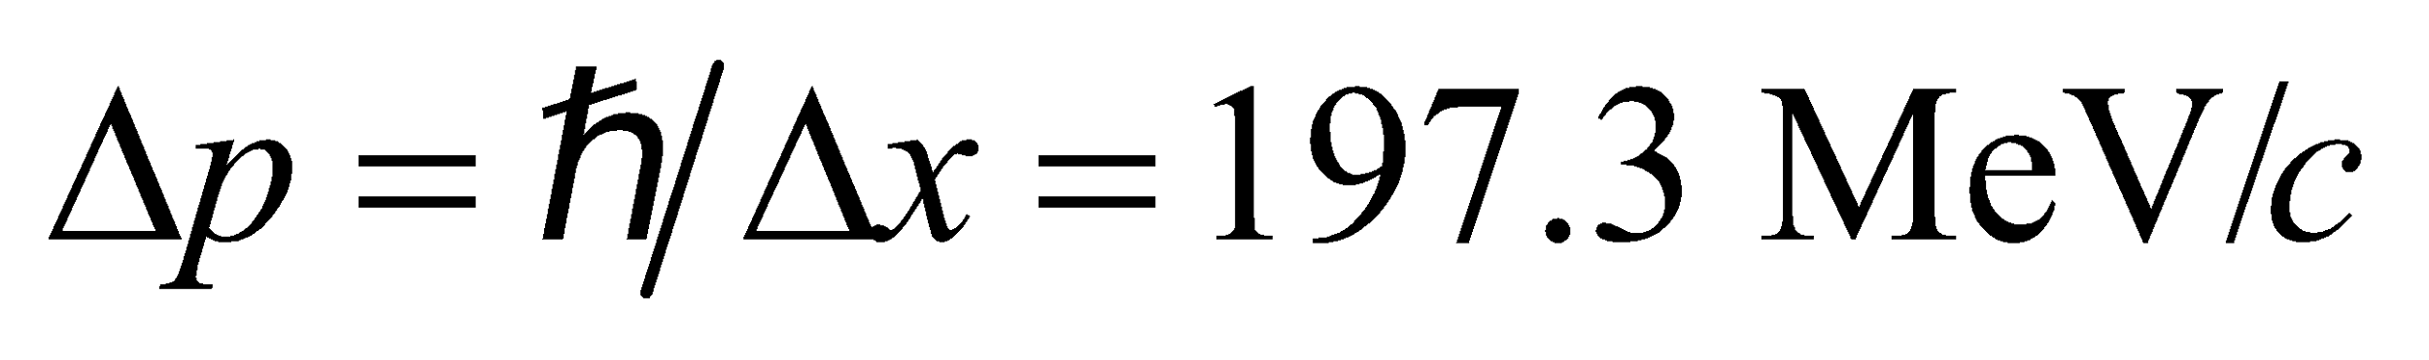 is barely small enough compared to *mc* = 938 MeV/*c* to justify using the nonrelativistic relation *p* = *mv*, but this is good enough for the purpose of approximation.

**34. Interpret** This problem involves the uncertainty principle, which we shall use to determine the precision with which we can measure an electrons velocity and position.

**Develop** The uncertainty principle (Equation 34.15) is . For the speeds considered in this problem, we can use the nonrelativistic expression *p* = *mv* for momentum, which leads to

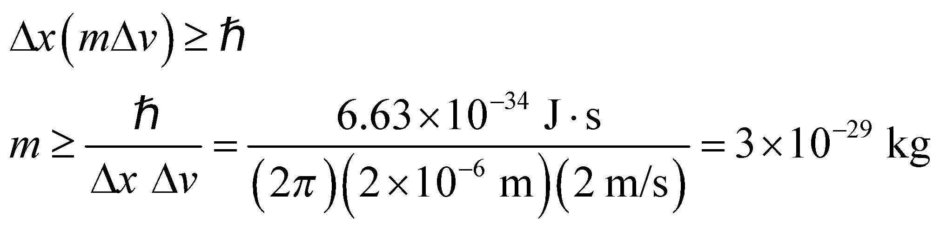

where we have used *Δx* = 2 μm and *Δv* = 2 m/s. Insert the mass of the electron and proton to see if the inequality is satisfied.

**Evaluate** For an electron, *m* = 9.11 × 10−31 kg, so the inequality is not satisfied. The mass of a proton is *m* = 1.67 × 10−27 kg, so the inequality is satisfied.

**Assess** Thus, we cannot determine both the velocity and position to the desired precision for an electron, but we can do so for a proton.

**35. Interpret** In this problem, we want to find the uncertainty in the position of a proton given the uncertainty in its velocity.

**Develop** To find *Δx*, we use the uncertainty principle,  (Equation 34.15), where 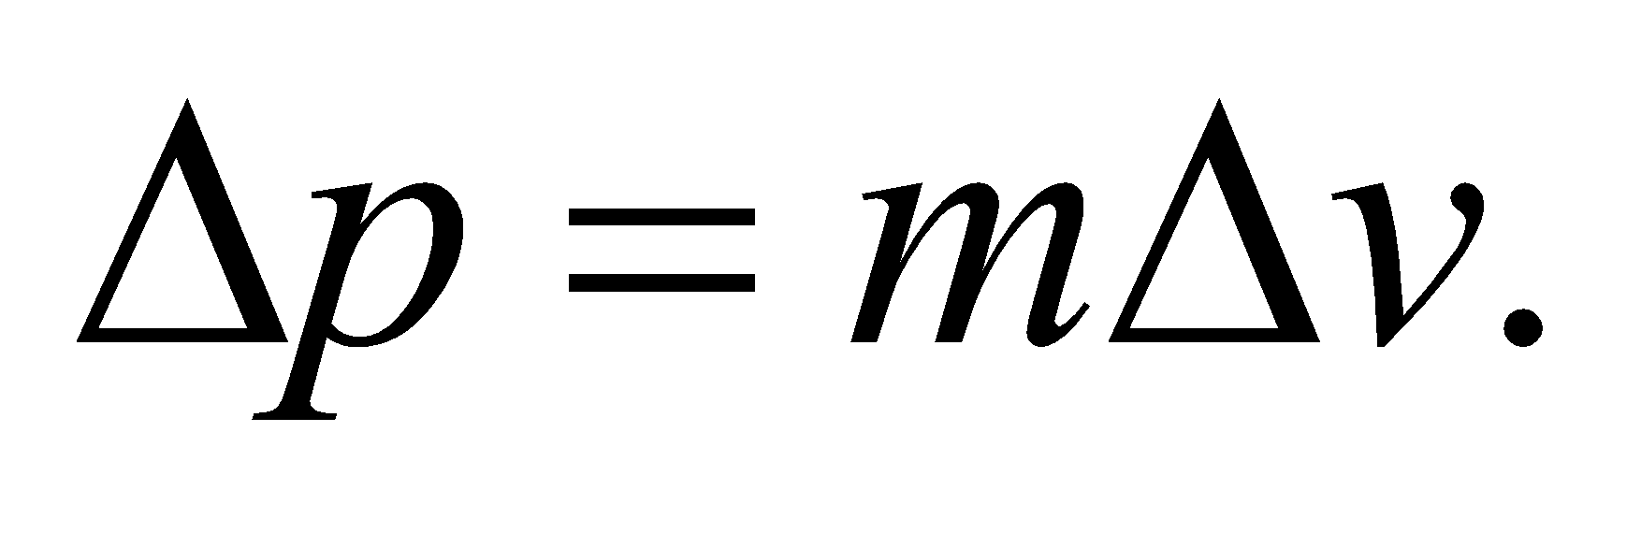 We take the uncertainty in velocity to be the full range of variation given; that is, 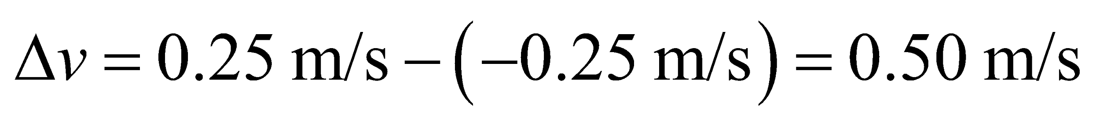.

**Evaluate** The position uncertainty of the proton is

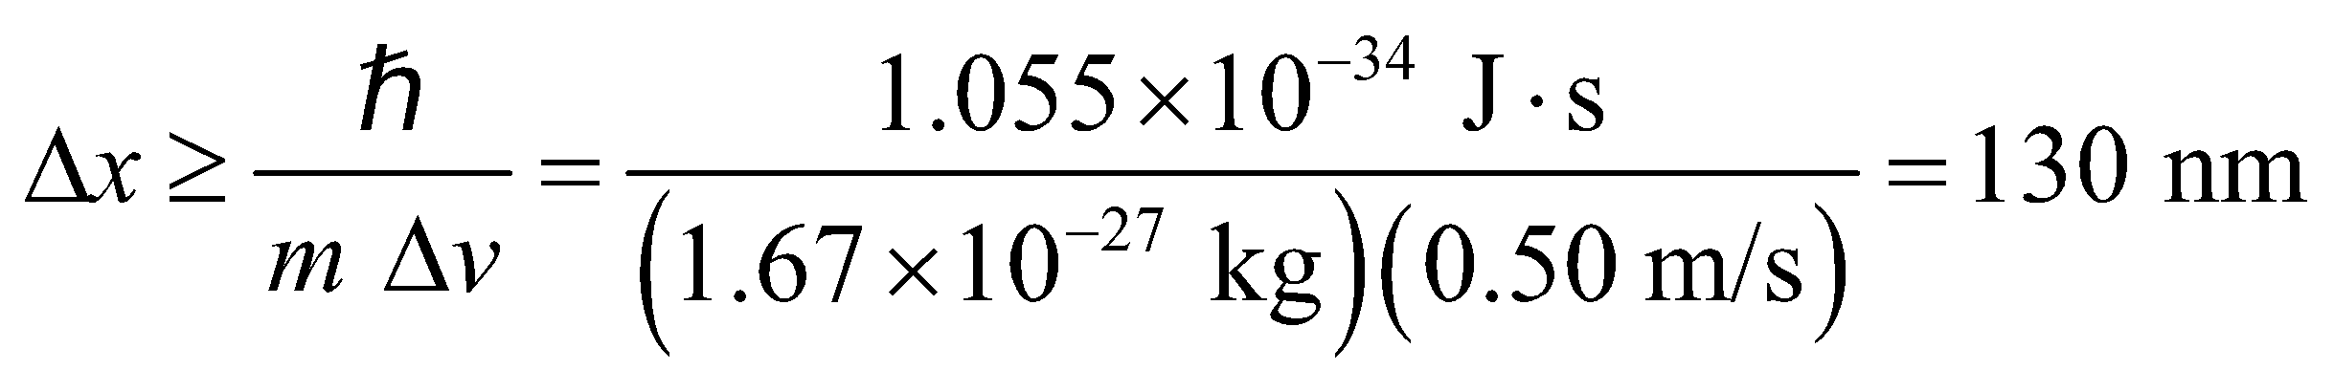

**Assess** The smaller the uncertainty *Δv* in velocity, the greater the uncertainty *Δx* in position.

**36. Interpret** We are given the uncertainty in the speed of an electron and are asked to find the uncertainty in its position.

**Develop** The electron is moving at

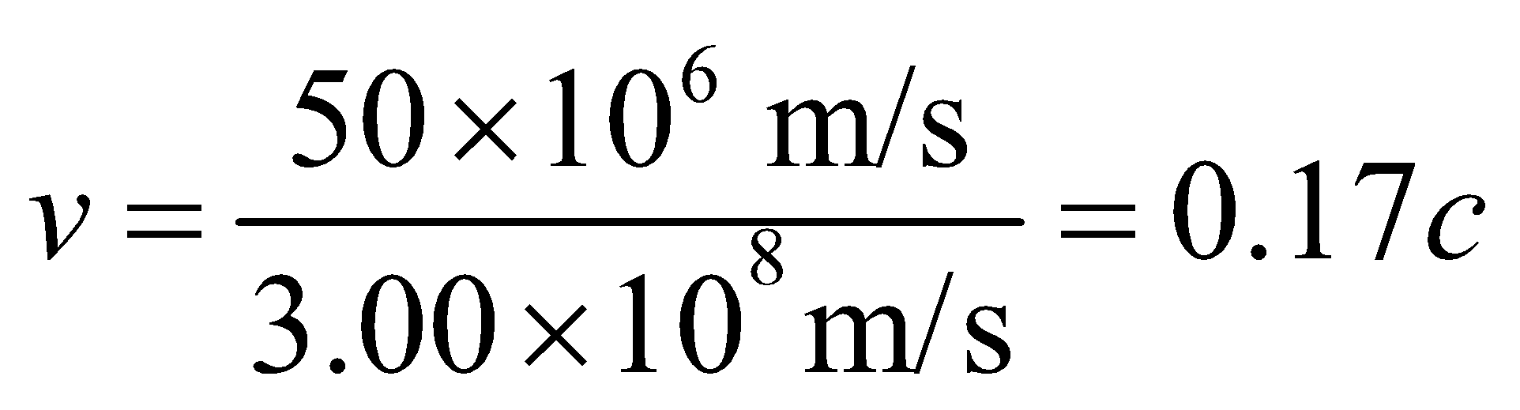

so we can use the classical approximation for the momentum, *p* = *mv*. Thus, the uncertainty in momentum is



where *Δv* = (0.20)(50 × 106 m/s). Insert this into the expression for the uncertainty principle (Equation 34.15) to find the minimum uncertainty in position.

**Evaluate** This minimum uncertainty in position *Δx* is

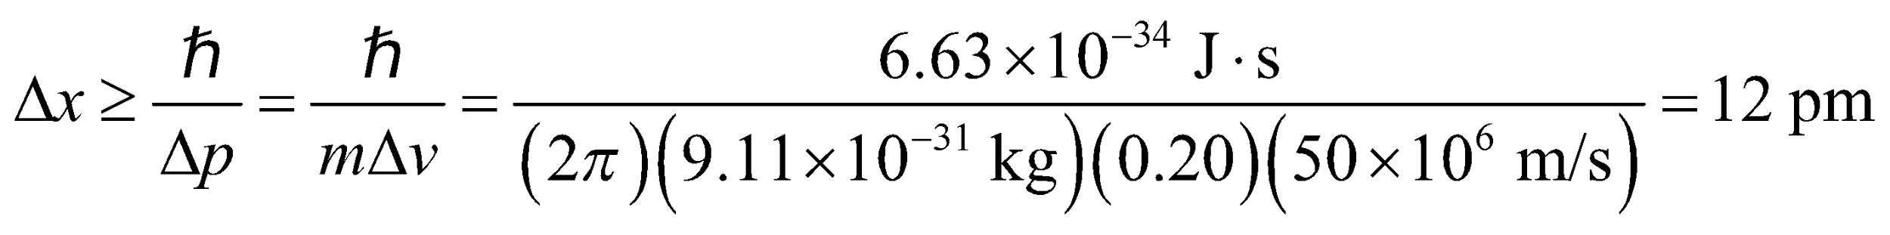

**Assess** As a rule of thumb, relativistic formulas should be used for 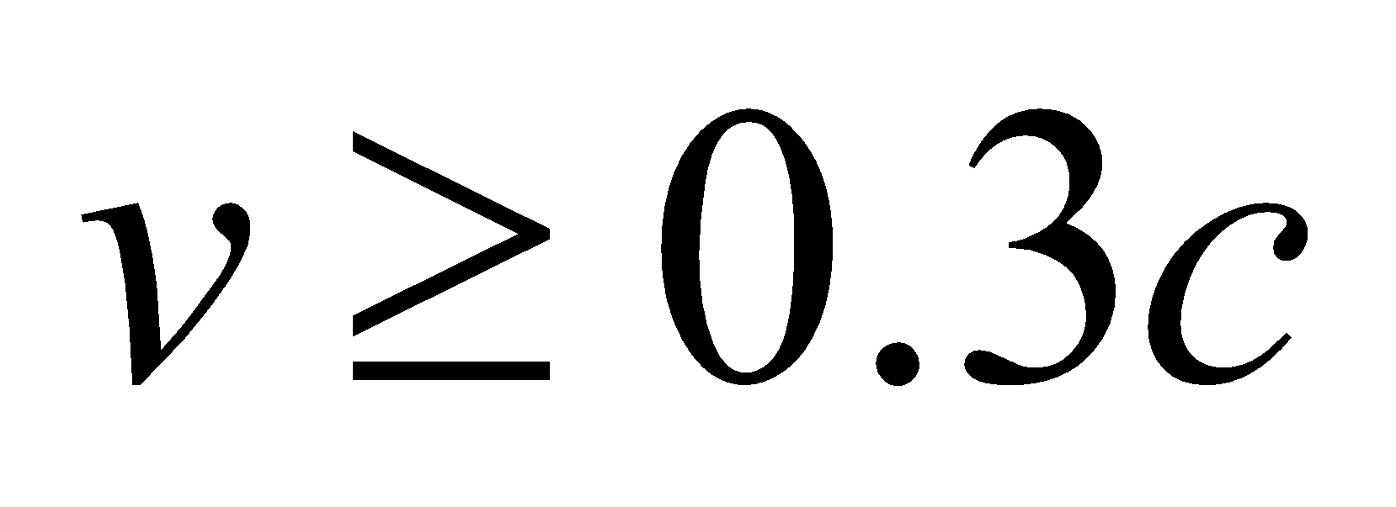.

**37. Interpret** The neutron is confined in the uranium nucleus with *Δx* equal to the diameter of the nucleus. We are to find the minimum energy of the neutron using the uncertainty principle.

**Develop** Using the same reasoning as given in Example 34.6, for a neutron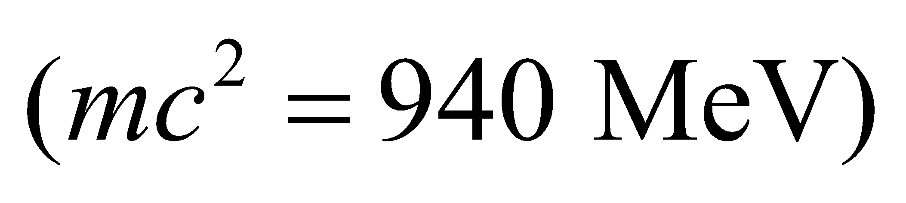confined to a uranium nucleus 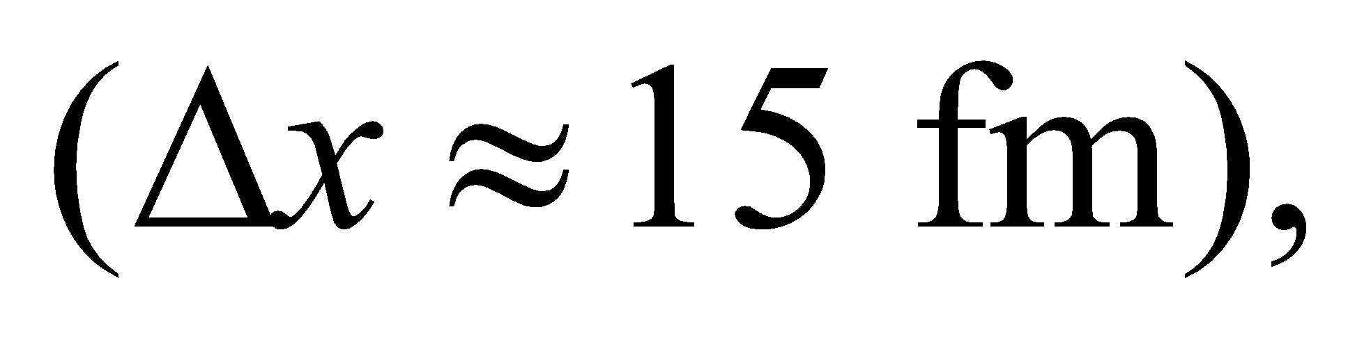 the uncertainty principle requires that

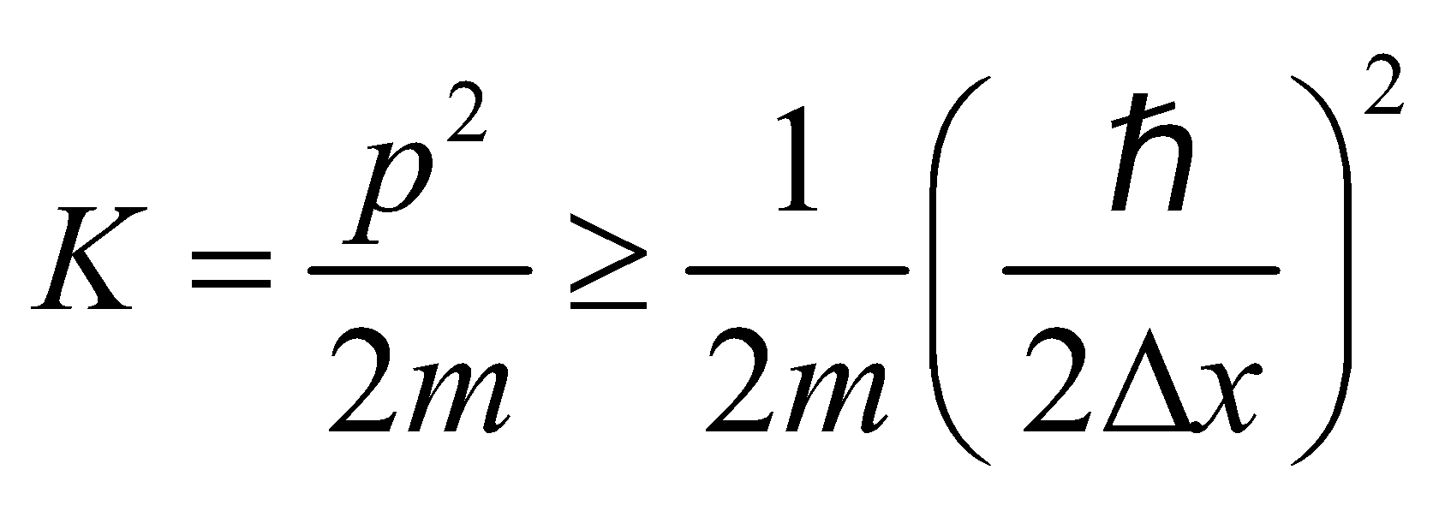

**Evaluate** From the above equation, we find the minimum kinetic energy to be

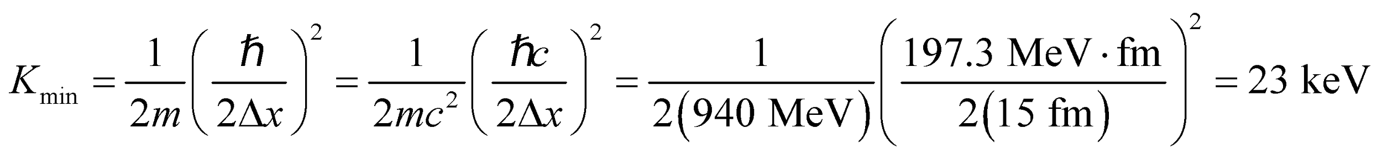

**Assess** This is smaller than the 5 MeV estimated for the nucleon in Example 34.6 by a factor of 152 = 225 because *Δx* is 15 times larger. Most estimates of nuclear energies for single-particle states, based on the uncertainty principle, give values of the order of 1 MeV, consistent with experimental measurements.

**Problems**

**38. Interpret** This problem involves blackbody radiation, which we can use to find the power emitted per unit area by the lamp within the given wavelength range.

**Develop** The power emitted is 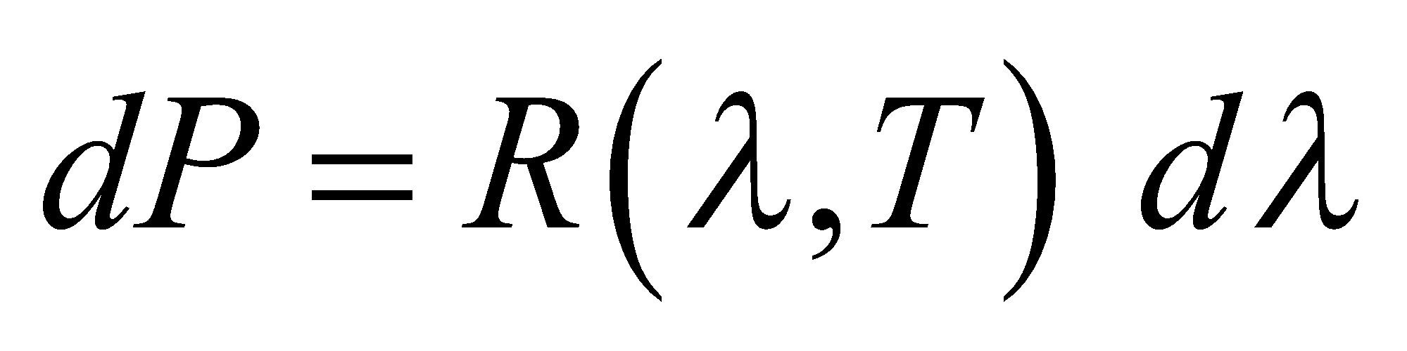 (Equation 34.3) where

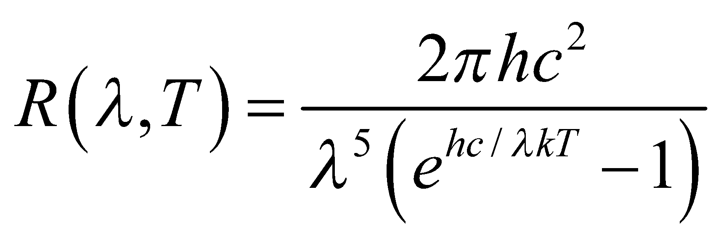

Since *dλ* = 2 nm is such a small interval around 500 nm, integration is not necessary.

**Evaluate** With 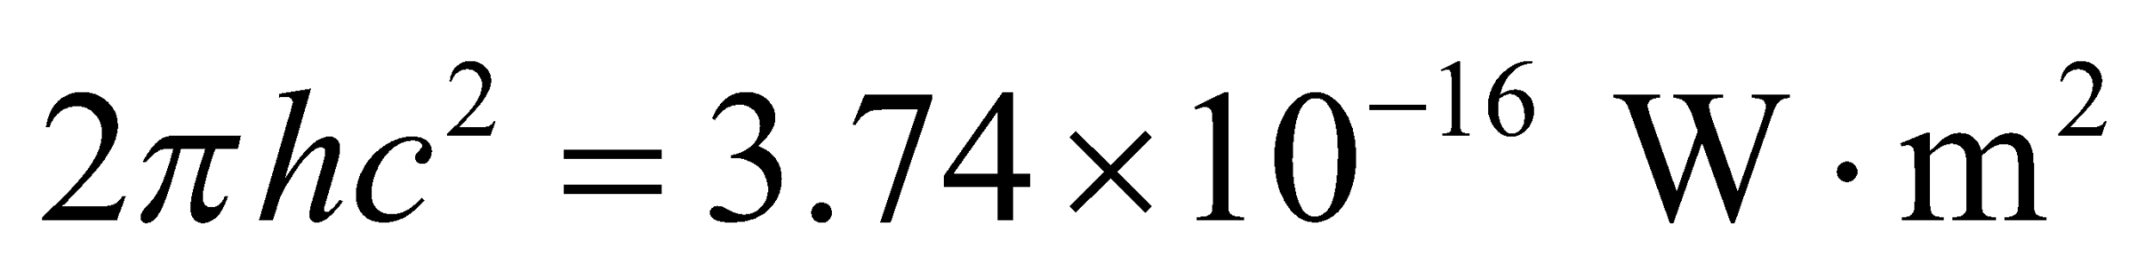 and 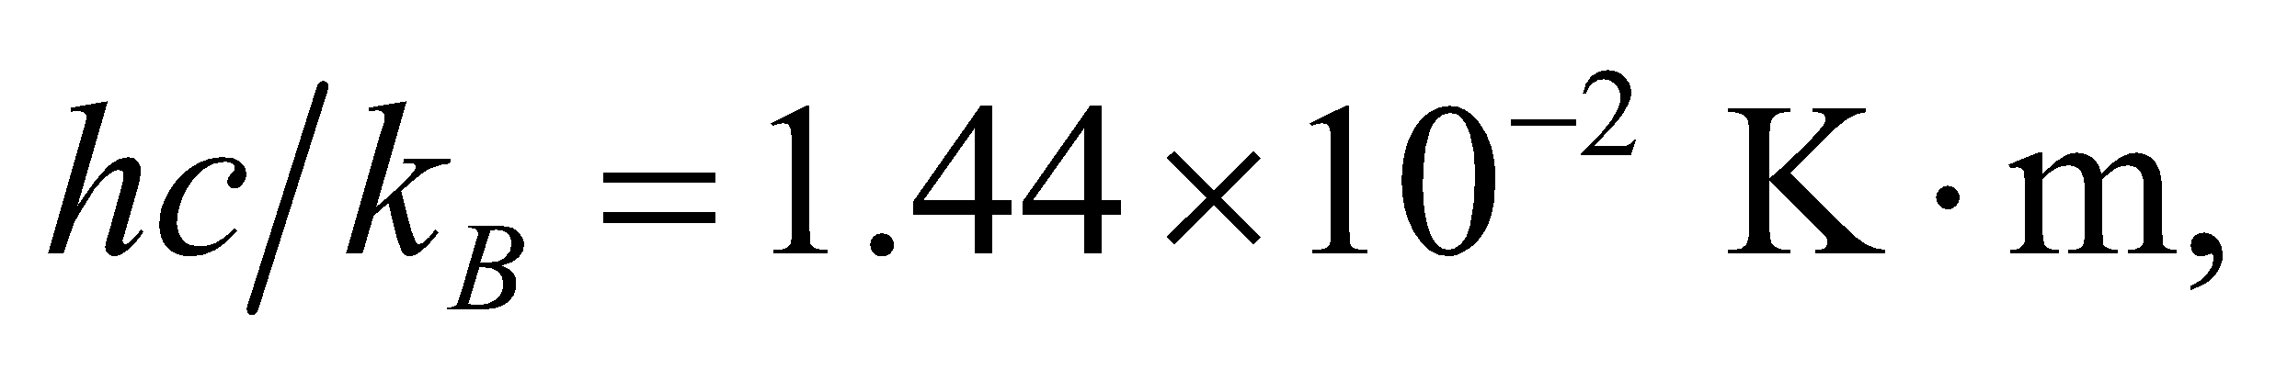 and with *λ* = 500 nm and *T* = 3000 K, we find



to a single significant figure.

**Assess** If we assume an average of half this value is emitted over the entire visible spectrum, then the surface area of a 60-W incandescent light bulb should be approximately

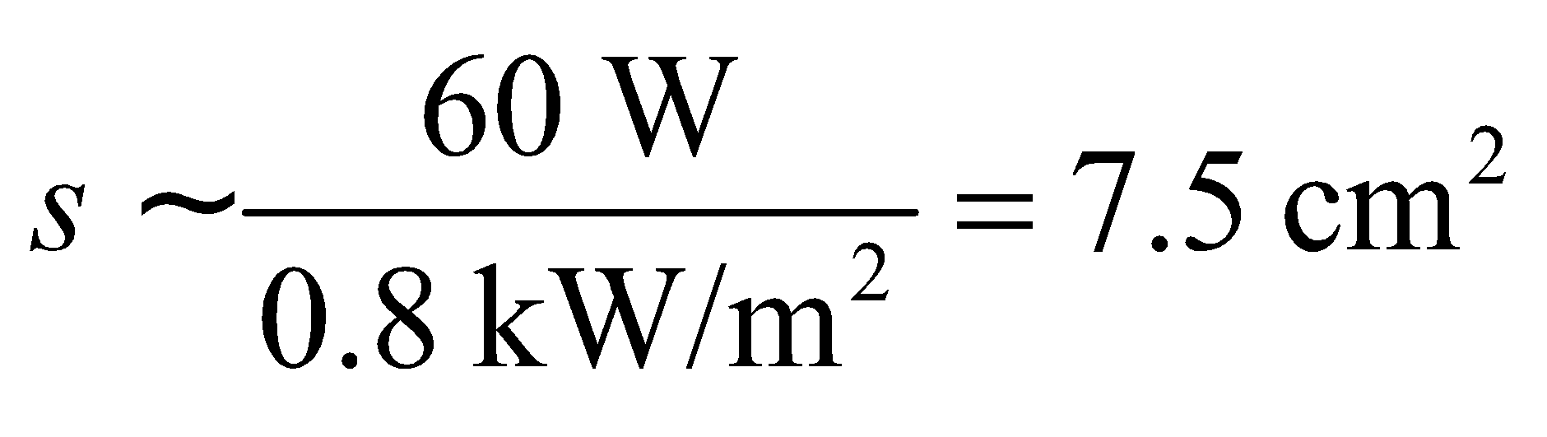

which seems like a reasonable order-of-magnitude estimate.

**39. Interpret** We are given the temperature of the Sun, which we shall treat as a blackbody, and asked to compare its radiance at two different wavelengths.

**Develop** The radiance of a blackbody is given by Equation 34.4:



This equation allows us to compare the radiance at two different wavelengths.

**Evaluate** From the above equation (also see Example 34.1), the ratio of the blackbody radiances for the two given wavelengths is

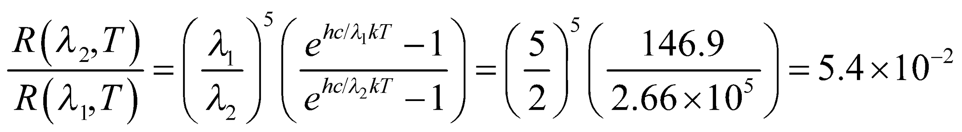

where 

**Assess** The characteristic radiance as a function of wavelength is shown in Figure 34.2. For a given wavelength, the radiance increases with temperature.

**40. Interpret** We are to compare the Rayleigh-Jeans law to the Planck formula for blackbody radiation at the three wavelengths given.

**Develop** The ratio of the radiances for the Rayleigh-Jeans and Planck laws is

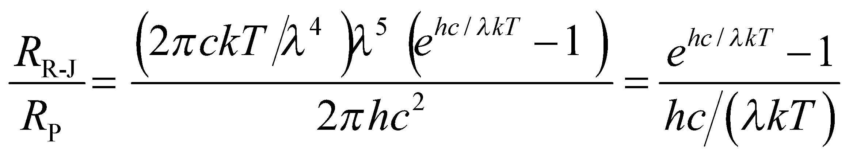

Accurate values of 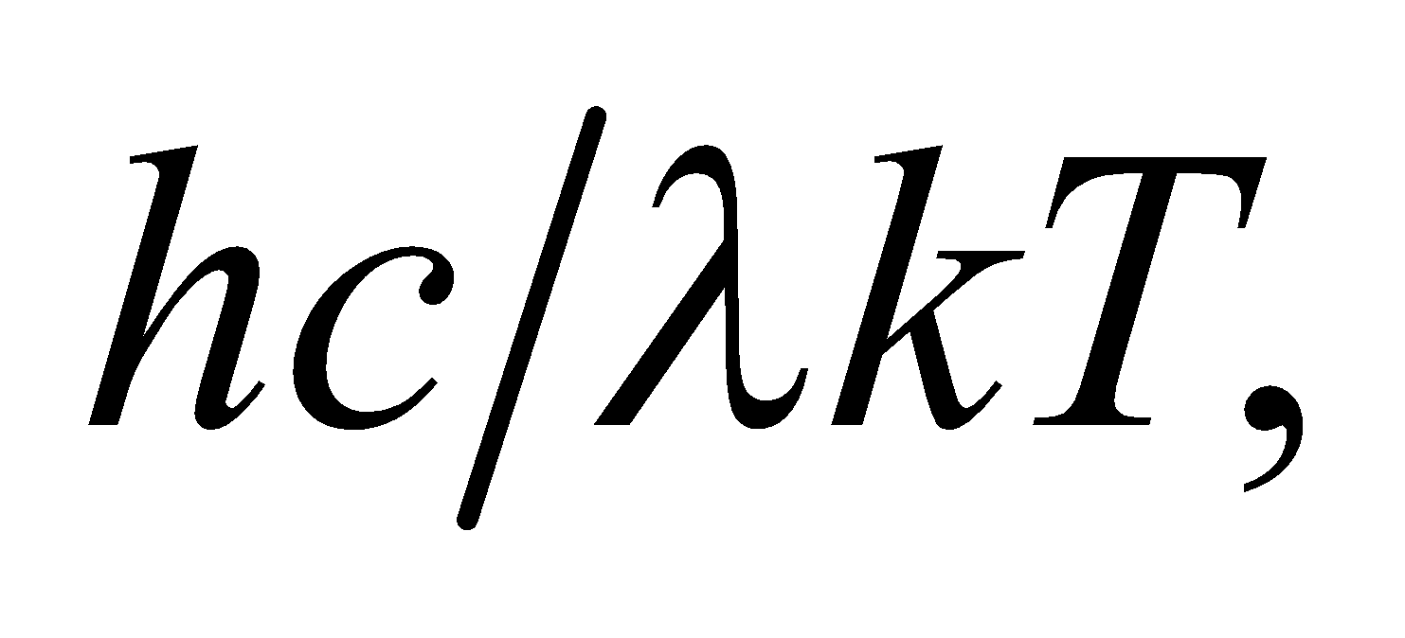 for  are 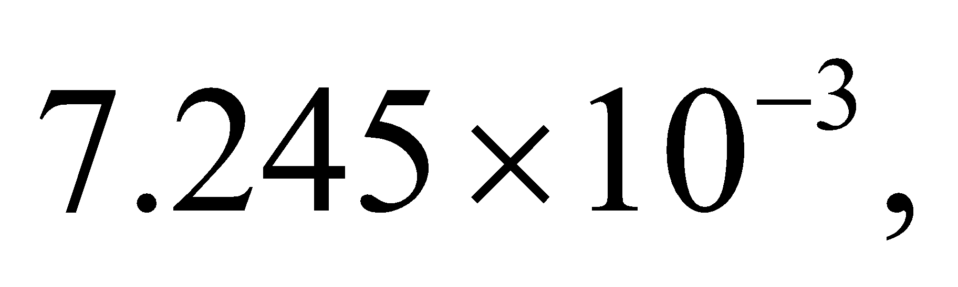 0.7245, and 7.245, respectively.

**Evaluate** The percent difference is

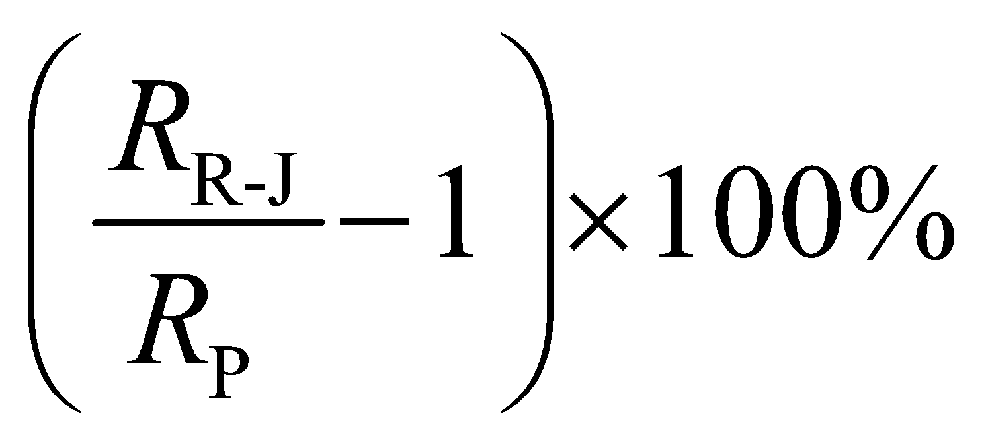

which equals **(a)** 0.36%, **(b)** 47%, and **(c)** (1.9 × 104)% for the three given wavelengths.

**Assess** The error becomes increasingly large as the wavelengths approach the visible part of the spectrum.

**41. Interpret** This problem is about blackbody radiation. We are given the wavelengths that correspond to peak radiance and asked to find the temperature of the blackbody. We also want to compare the radiance at two different wavelengths.

**Develop** The wavelength at which a blackbody at a given temperature radiates the maximum power is given by Wien’s displacement law (Equation 34.2a):  For part **(b)**, to compare the radiance at two different wavelengths, we use Equation 34.4:

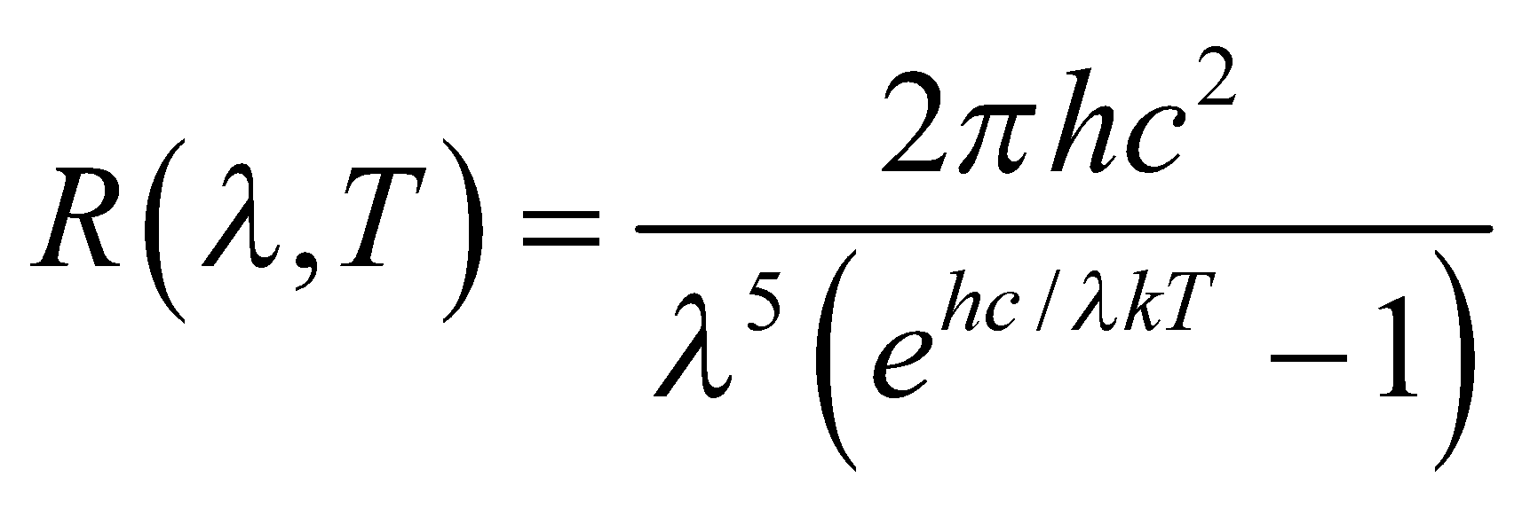

**Evaluate** **(a)** Equation 34.2a gives

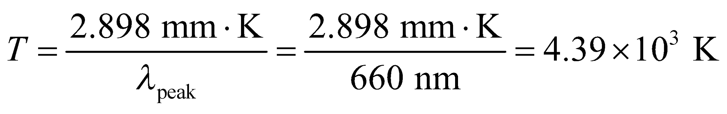

**(b)** With 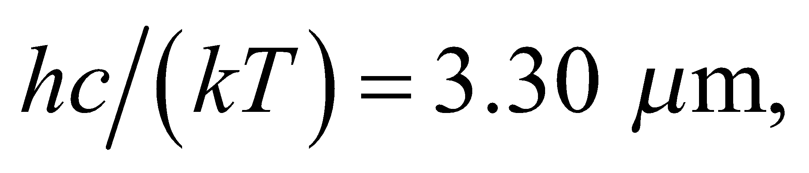 the ratio of the radiances is

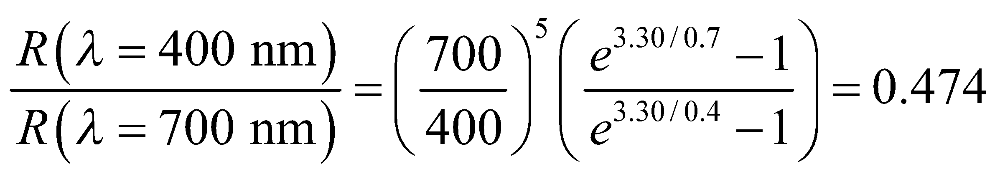

**Assess** The wavelengths considered are in the visible spectrum. Note that the characteristic radiance as a function of wavelength is shown in Figure 34.2. For a given wavelength, the radiance increases with temperature.

**42. Interpret** This problem examines the Compton wavelength of a proton and the energy of a gamma ray with an equivalent wavelength.

**Develop** The constant in Equation 34.8 gives the Compton wavelength 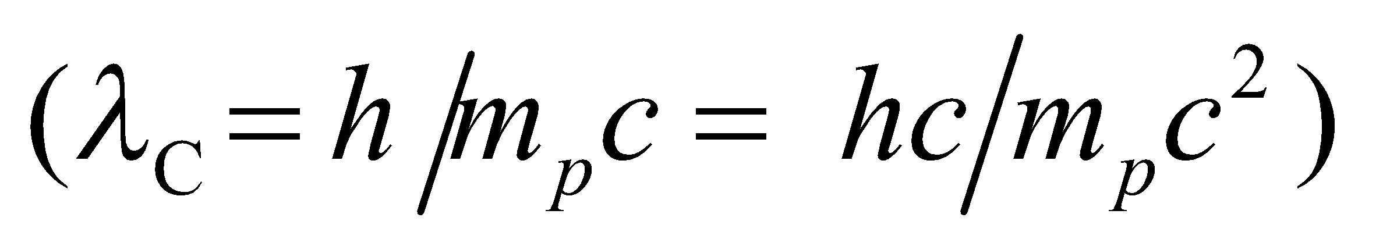 to find the Compton wavelength. Use Equation 34.6, 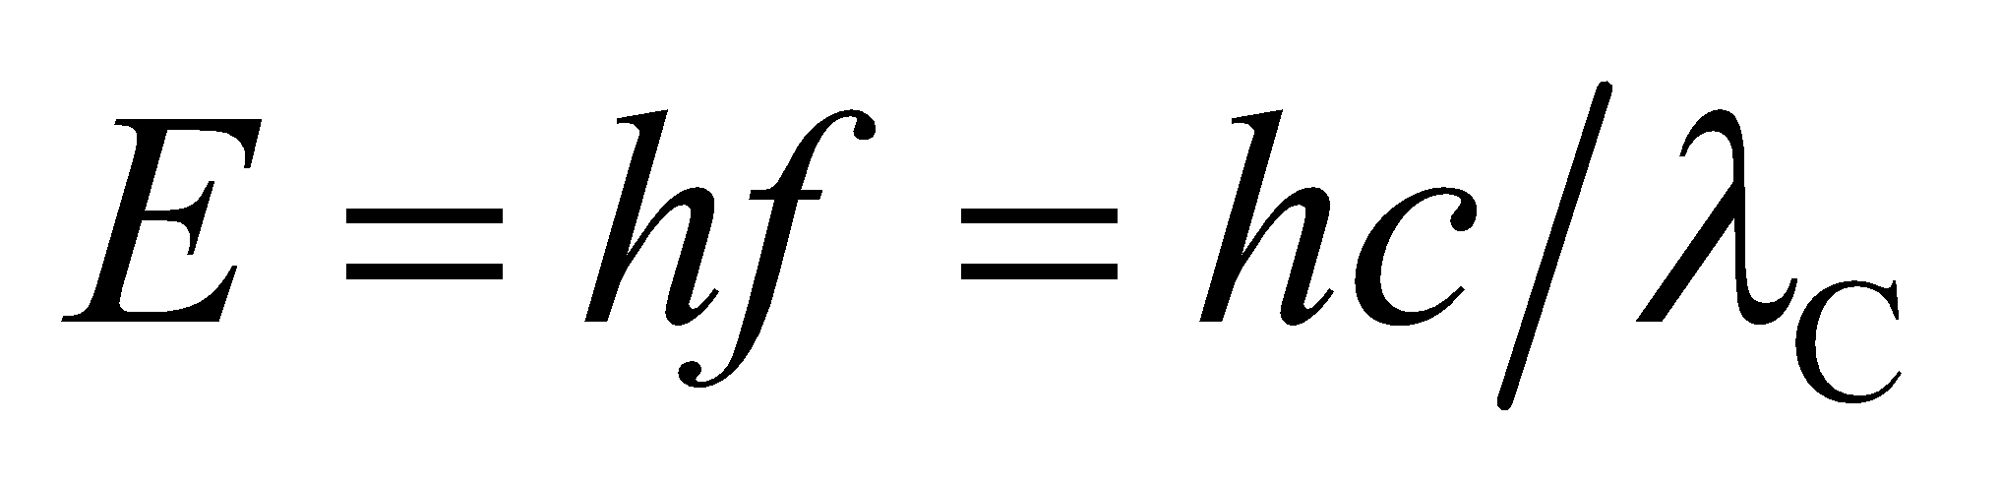, to find the energy of a photon of the same wavelength.

**Evaluate** **(a)** The proton’s Compton wavelength (the constant in Equation 34.8) is

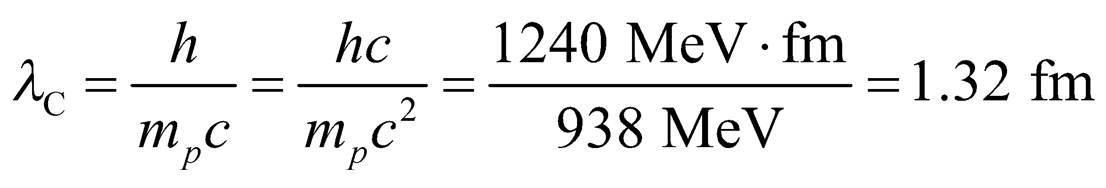

**(b)** The energy of a photon with this wavelength (Equation 34.6) is

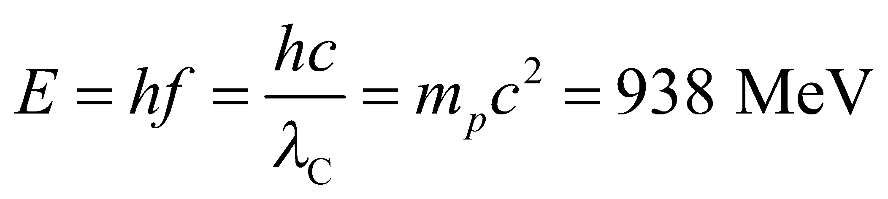

**Assess** The energy of the gamma ray is the same as the rest energy of a proton.

**43. Interpret** We are given the power output at various frequencies and asked to find the rate of photon emission.

**Develop** The rate *dN*/*dt* of photon emission is the electromagnetic power output divided by the photon energy:

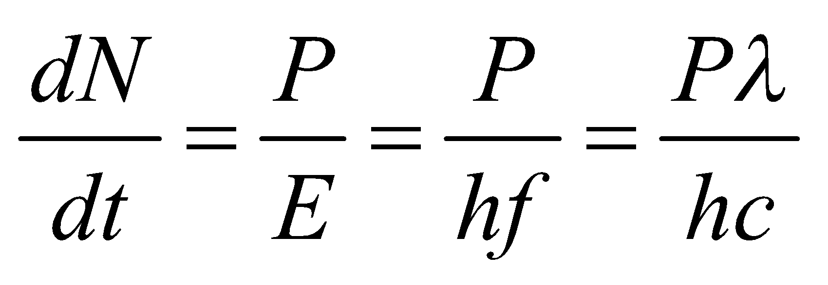

where we have used Equation 34.6 *E* = hf.

**Evaluate** **(a)** For the antenna, the rate is

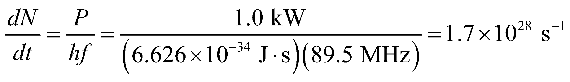

**(b)** For the laser, we have

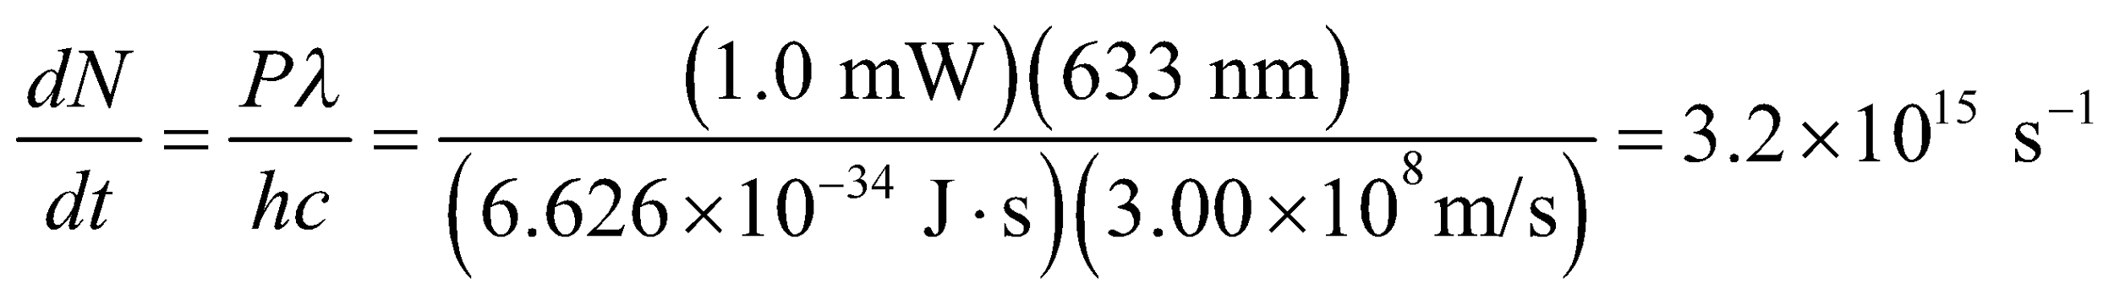

**(c)** Similarly, for the X-ray machine, the rate is

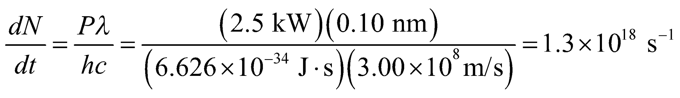

**Assess** For a general device at a given power output, the rate of photon production decreases with the energy of the photon; the more energetic the photons, the smaller the rate of production because each photon carries more energy.

**44. Interpret** This problem involves the photoelectric effect. Given the maximum kinetic energy with which electrons emerge from an aluminum surface, we are to find the wavelength of the illuminating radiation.

**Develop** Einstein’s equation for the photoelectric effect (Equation 34.7) gives

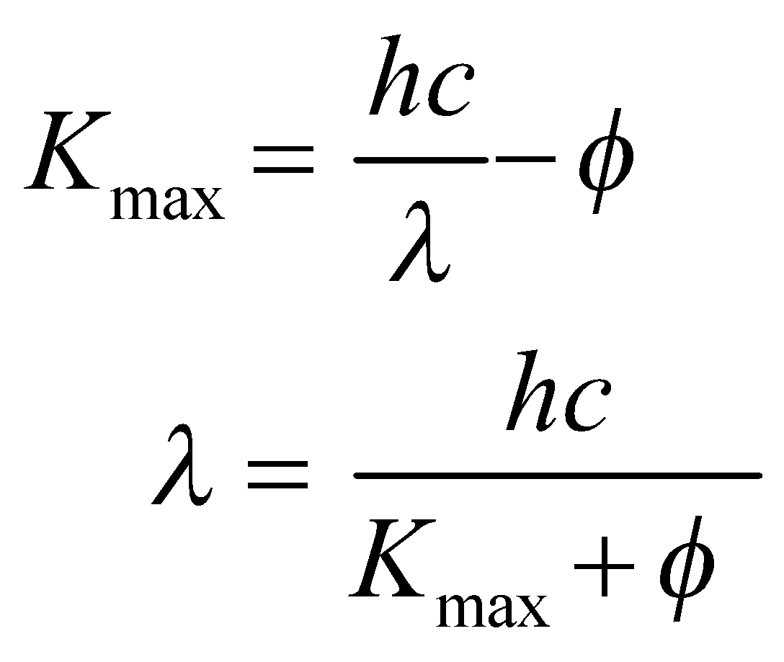

where *φ* = 4.28 eV (see Table 34.1) is the work function of Al.

**Evaluate** For *K*max = 1.3 eV, the wavelength is

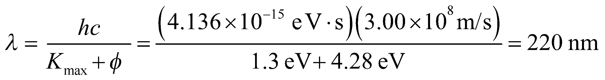

to two significant figures.

**Assess** This wavelength is in the ultraviolet portion of the electromagnetic spectrum.

**45. Interpret** This problem is about the photoelectric effect. We want to find the cutoff frequency and the maximum energy of electrons ejected by shining light with the given frequency on copper.

**Develop** At the cutoff frequency, *K*max = 0 and the photon energy equals the work function,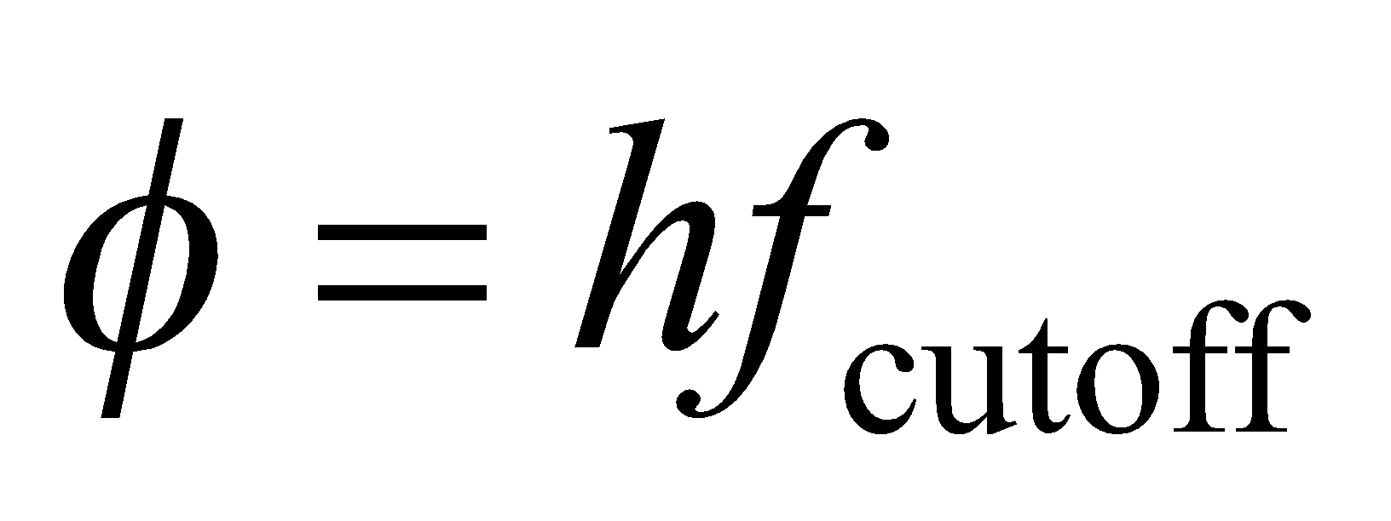 (see Equation 34.7), which we can find in Table 34.1. For part (b), apply Equation 34.7 to find the maximum kinetic energy possible for the given frequency *f*

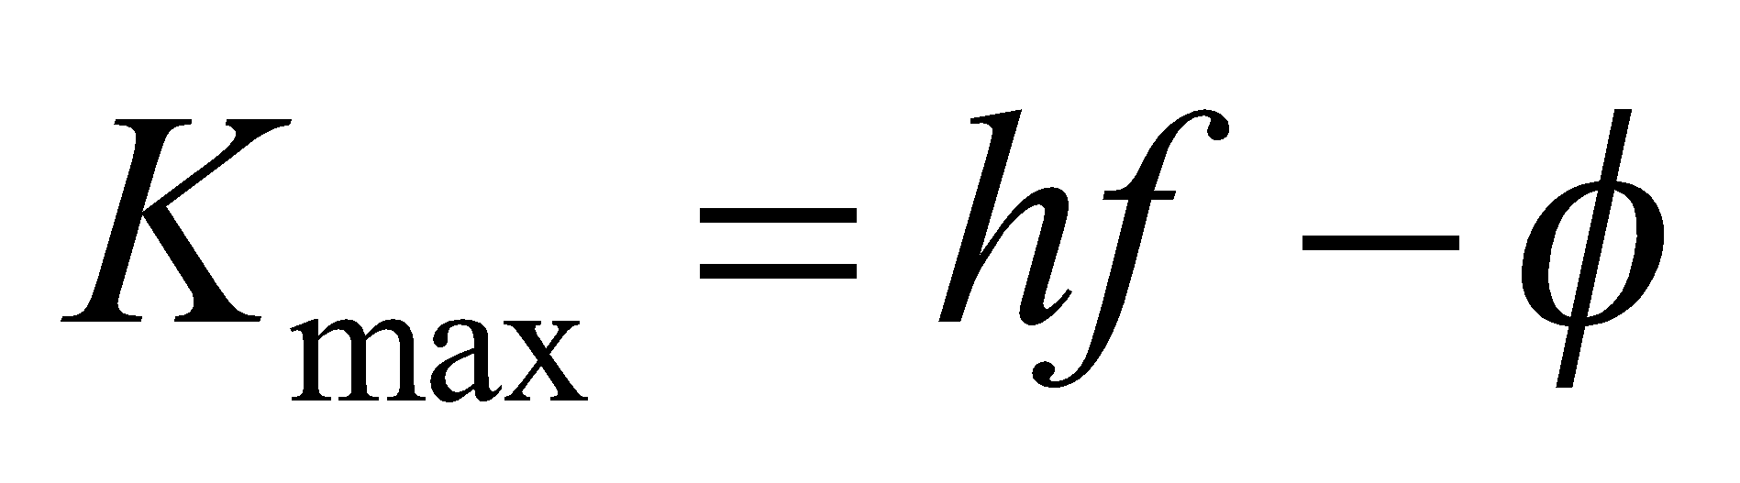

**Evaluate** **(a)** The work function of copper is 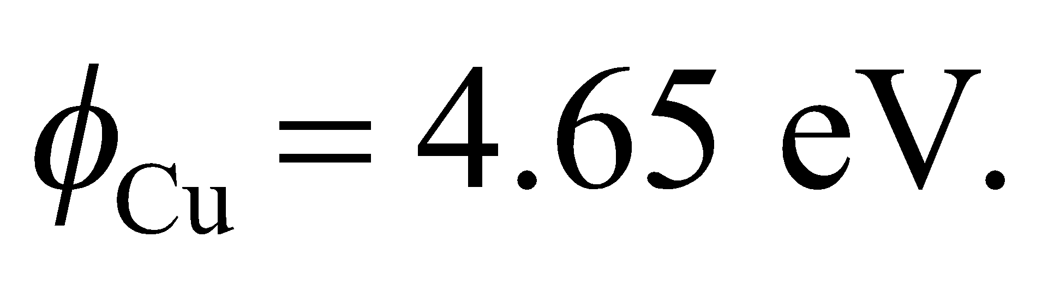 Therefore, the cutoff frequency is

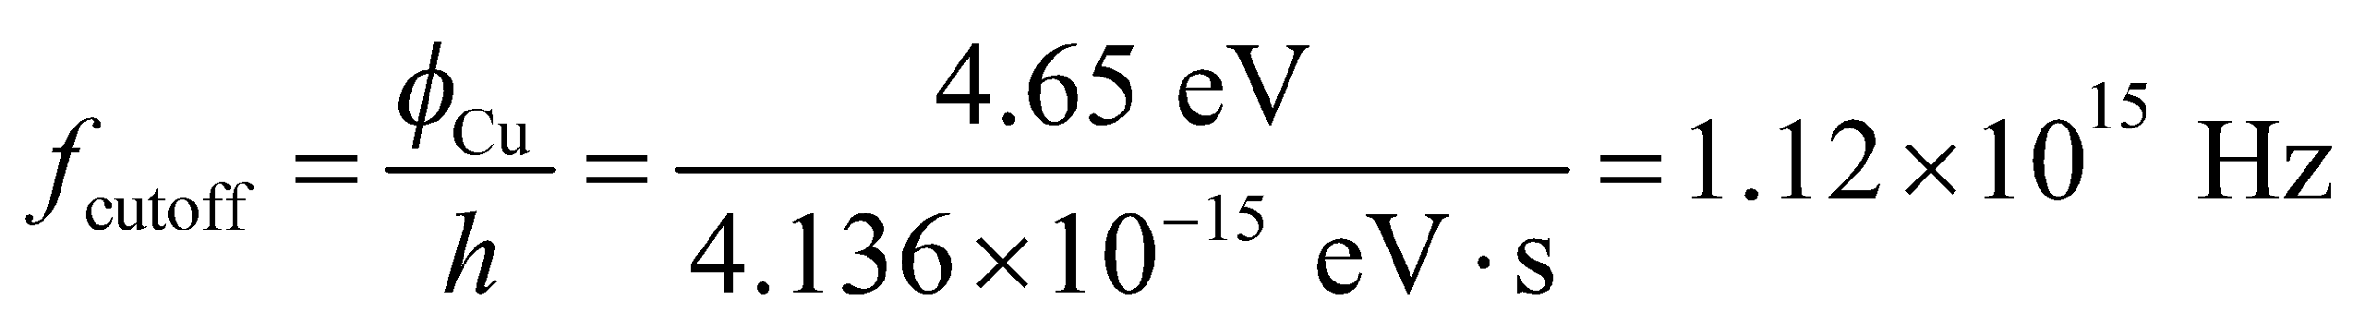

**(b)** The maximum kinetic energy of the ejected electrons is



**Assess** Upon illuminating copper with photons at 7.44 eV, it takes 4.65 eV to overcome the work function of copper, leaving the electrons with 2.79 eV of kinetic energy.

**46. Interpret** This problem involves the photoelectric effect. Given the electric potential energy difference needed to stop electrons emitted from a surface by the given radiation, we are to determine the work function of the material.

**Develop** The electron’s maximum kinetic energy is expended in crossing the stopping potential (see text), so

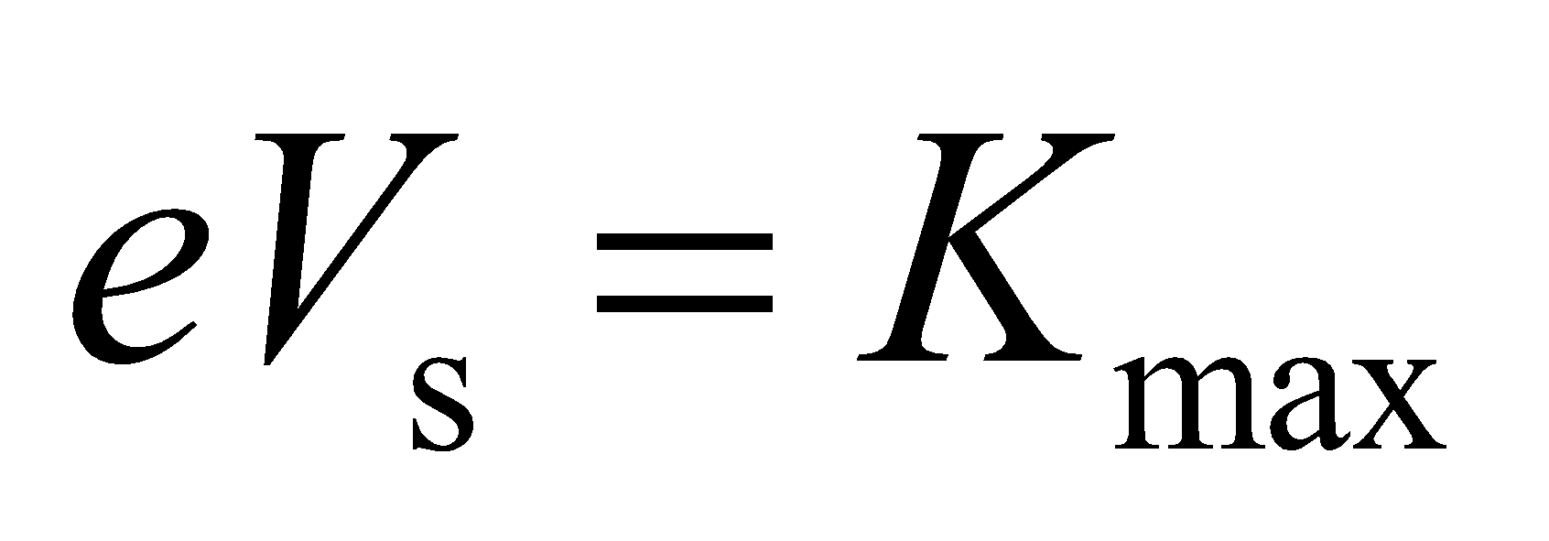

where *V*s = 1.8 V. Apply Equation 34.7 to find the work function;

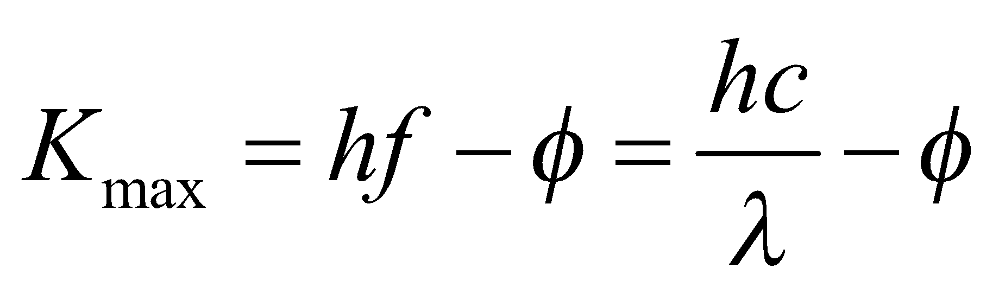

**Evaluate** **(a)** for *λ* = 365 nm, the work function is

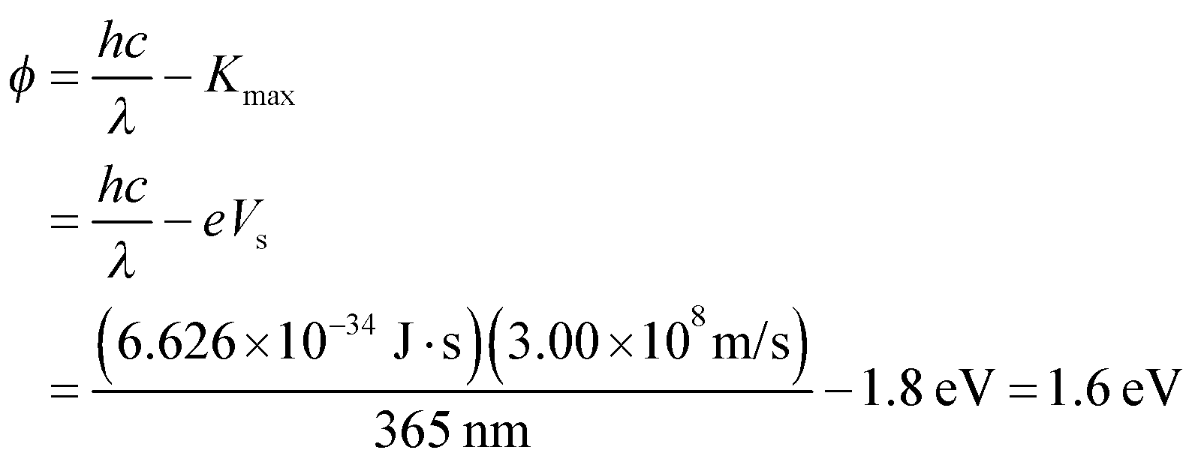

**(b)** At the new wavelength,

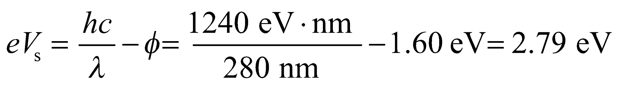

or

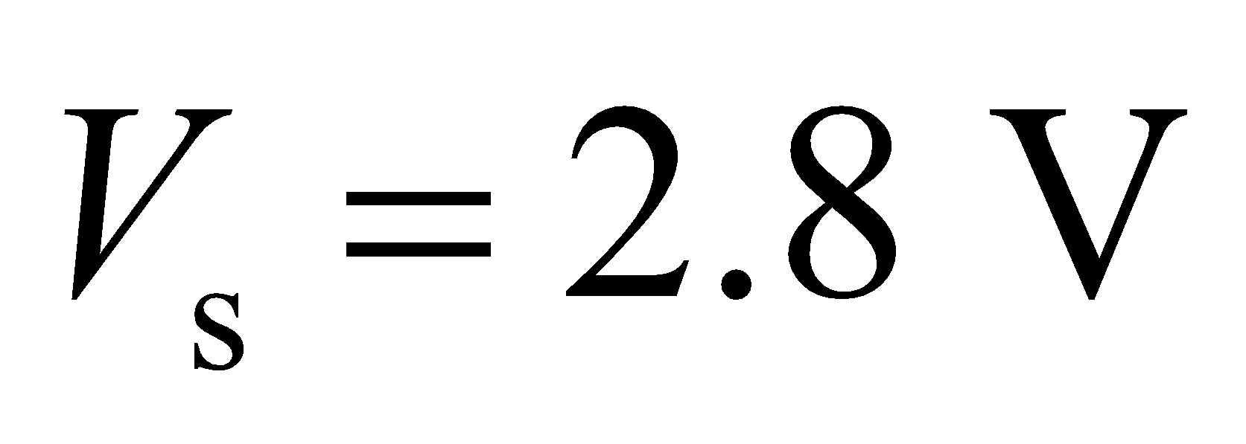

to two significant figures.

**Assess** The stopping potential increases because it takes a bigger “hill” to stop the electrons emitted by the 280-nm radiation, which contains photons of higher energy than radiation at 365 nm.

**47. Interpret** We are asked to explain why plants are green using the absorption peaks in the chlorophyll molecule.

**Develop** We can convert the wavelength peaks into energy peaks using 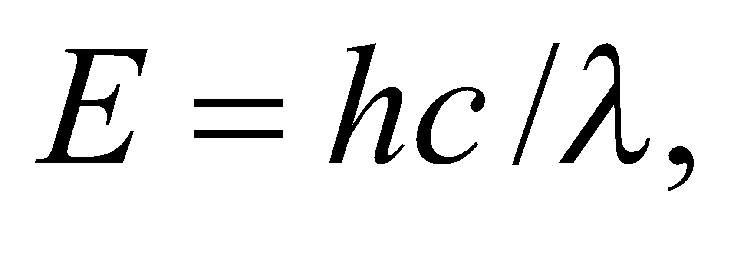and the shorthand 

**Evaluate**  (a) The energy peaks in chlorophyll's absorption spectrum are at

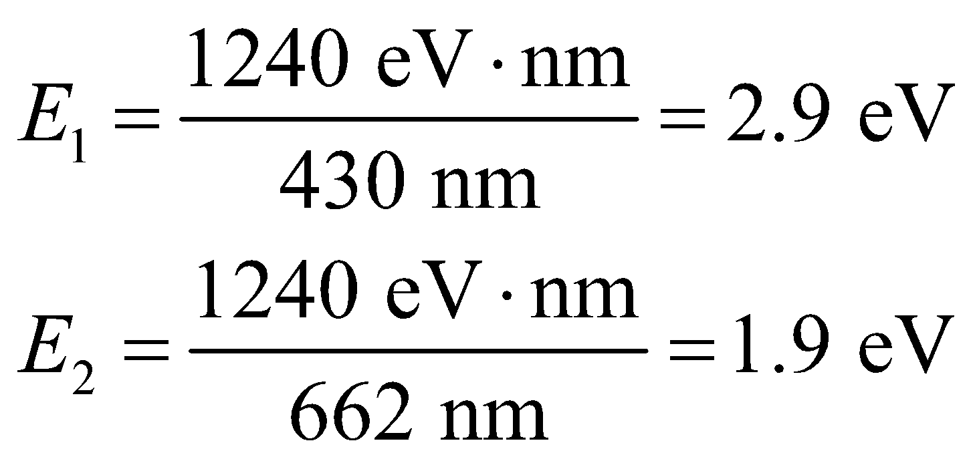

(b) These absorption peaks correspond to blue and red wavelengths, near the limits of the human visible range. The light that is not absorbed is reflected, and this is what we humans observe. Since the reflected light is primarily in the green region of the visible spectrum between blue and red, we perceive plants to be green.

**Assess** Plants also reflect a lot of infrared light with wavelengths longer than 700 nm.

**48. Interpret** This problem involves Compton scattering, which we can use to find the initial wavelength of photons that scatter at the given angle from electrons.

**Develop** Apply Equation 34.8, which describes Compton scattering (i.e., the scattering of photons off electrons). For a photon that loses half its initial energy, we have

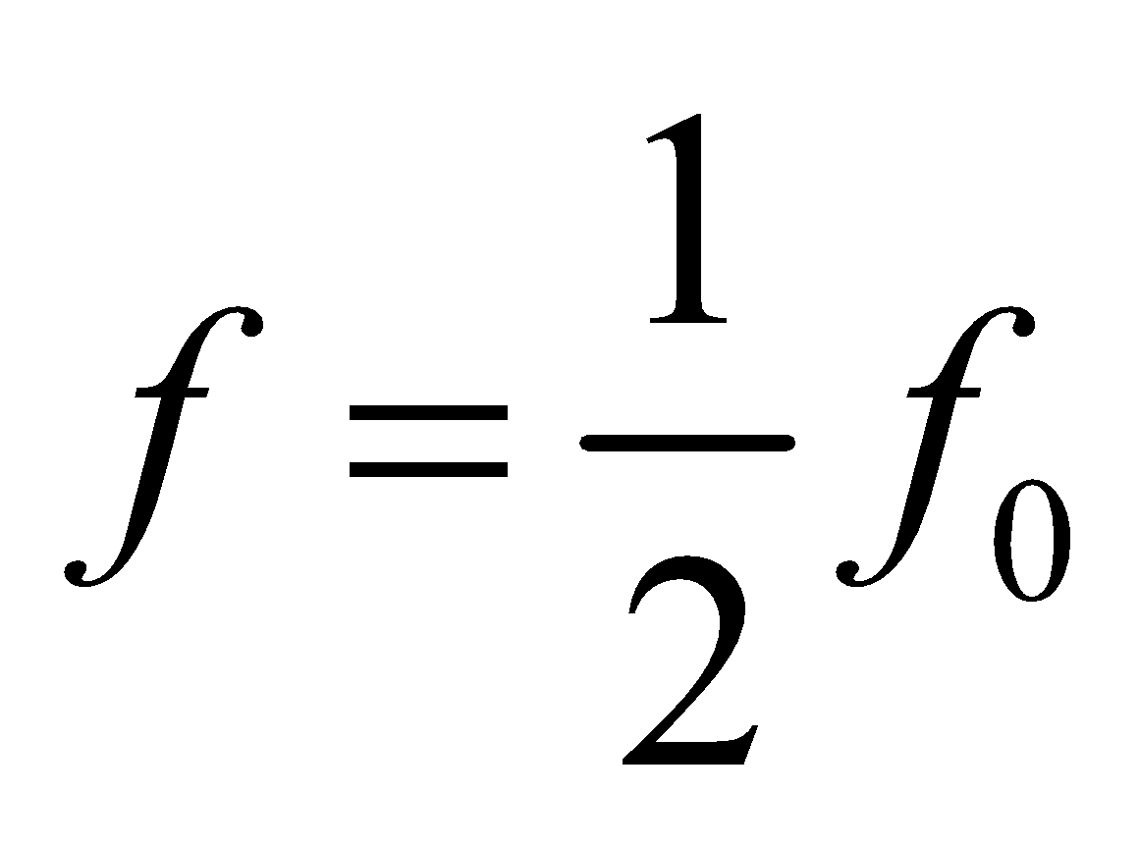

so the wavelength shift *Δλ* is

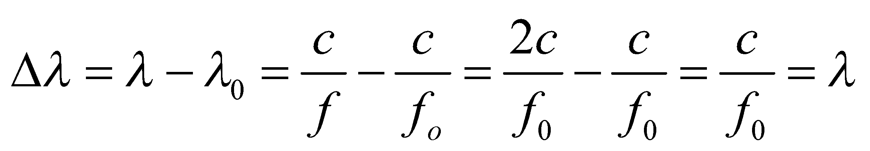

**Evaluate** Using this result for *Δλ* in Equation 34.8 gives

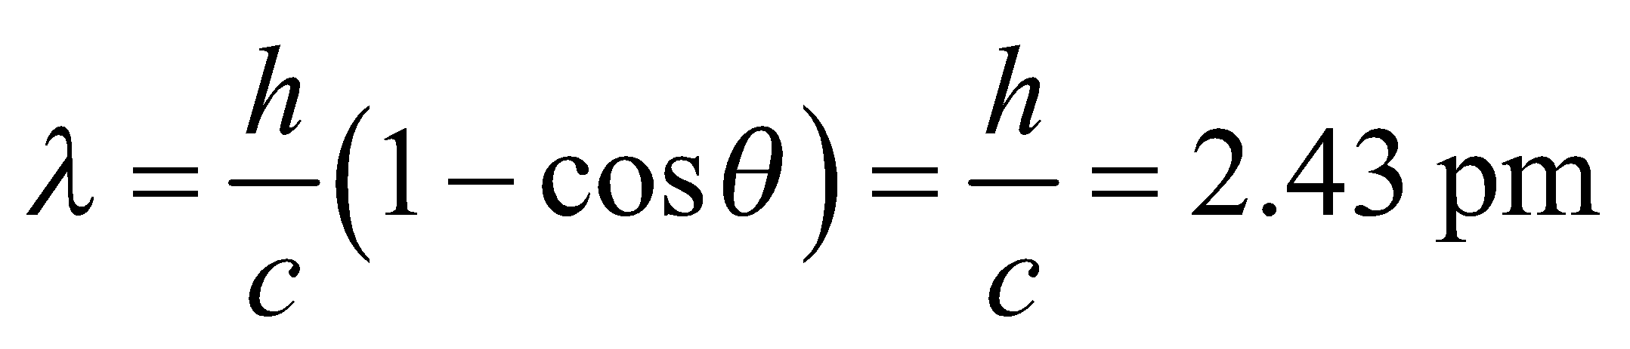

**Assess** The energy of these photons is about 0.5 MeV.

**49. Interpret** This problem is about the photoelectric effect. We are given the maximum speed of electrons ejected from potassium and asked to find the wavelength of the light that ejected the electrons.

**Develop** The maximum speed of the ejected electrons is related to the wavelength of the light by Einstein’s photoelectric effect equation (Equation 34.7):

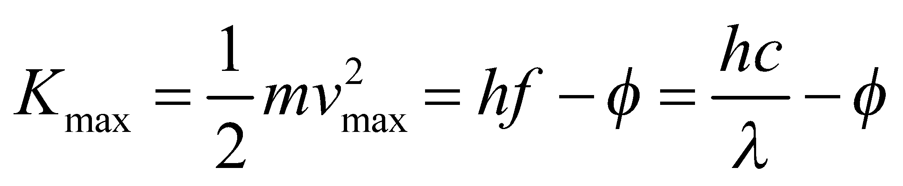

We shall use this equation to find *λ*.

**Evaluate** The maximum kinetic energy of the electron is

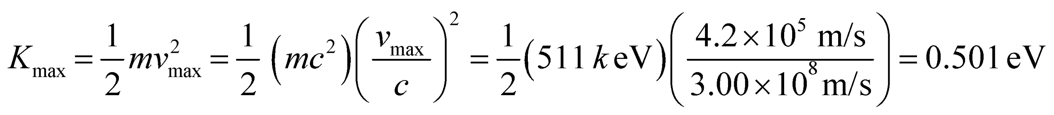

From Equation 34.7 and using Table 34.1 to find the work function *φ*, we find the wavelength to be

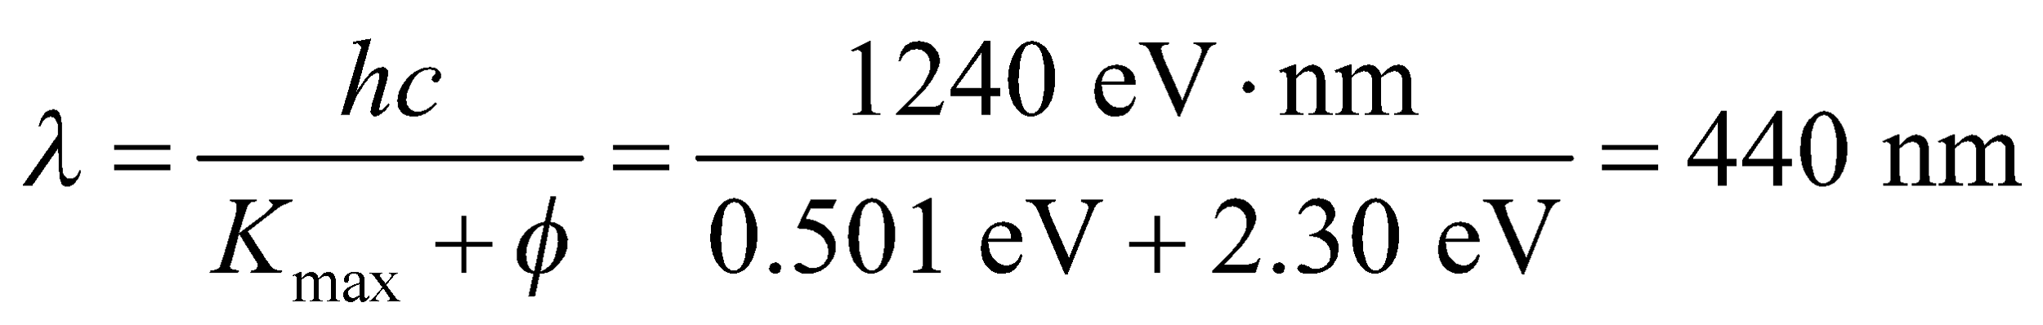

to two significant figures.

**Assess** Strictly speaking, the result should be reported as 44 ×101 nm to make the significant figures more obvious. The cutoff wavelength of potassium is



For the photoelectric effect to take place, we require 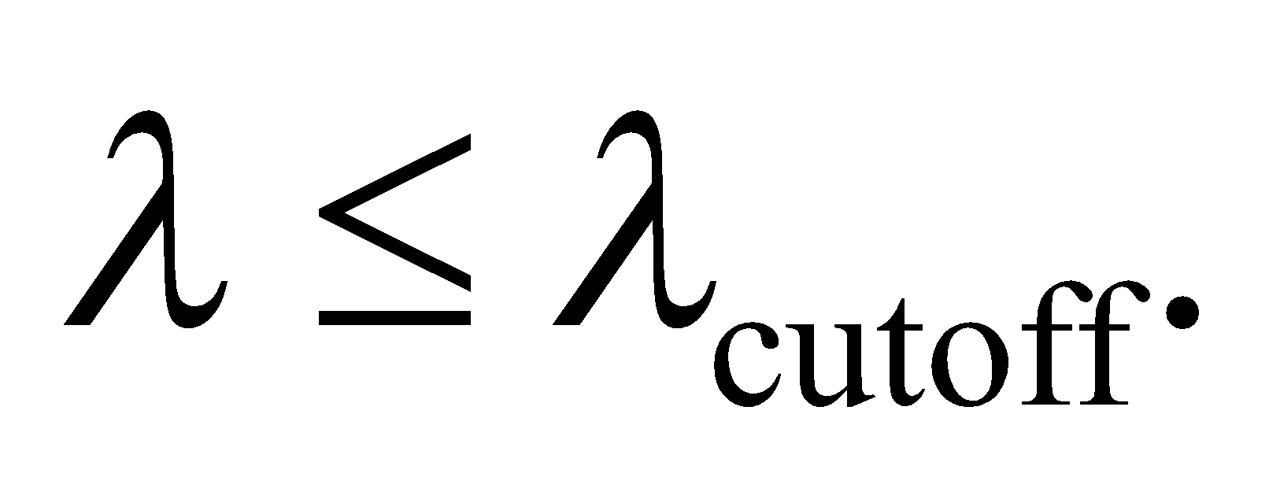

**50. Interpret** This problem involves the photoelectric effect. Given the maximum electron energy for two different illuminating wavelengths we are to find the work function of the material.

**Develop** The photoelectric effect equations (Equation 34.7) for the two experimental runs are

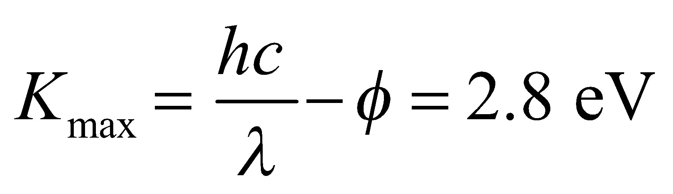

and

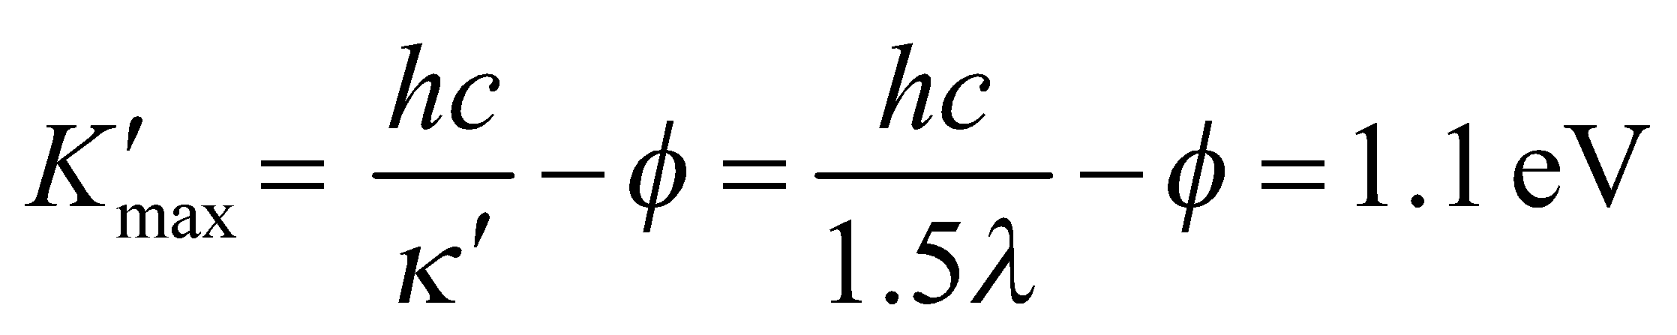

which we can solve for the work function *φ* and the initial wavelength *λ*.

**Evaluate** (a) Subtracting the two equations gives

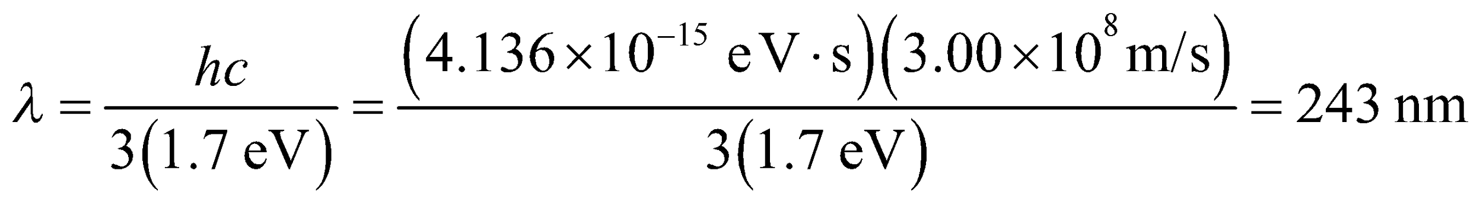

Adding the two equations gives

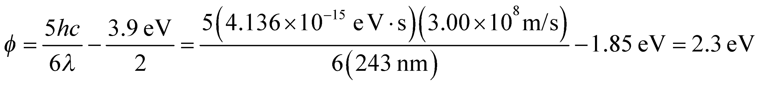

(b) From the calculation above, we find *λ* = 240 nm (to two significant figures).

**Assess** This material is probably potassium, which has a work function of *φ* = 2.3 eV.

**51. Interpret** This problem is about Compton scattering of a photon with an electron. We are interested in the wavelength of the scattered photon and the kinetic energy of the electron.

**Develop** The Compton shift of wavelength is given by Equation 34.8:

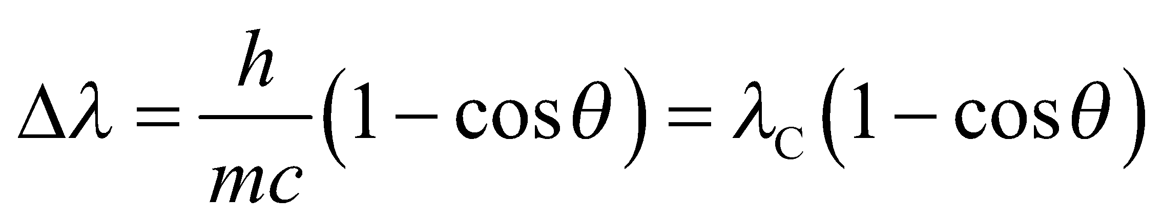

where 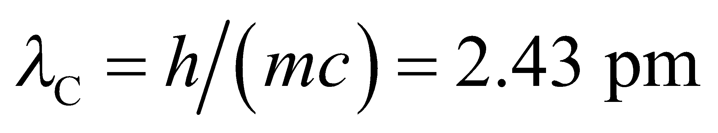 is the Compton wavelength of the electron. By conservation of energy, the kinetic energy of the scattered electron is equal to the energy lost by the photon.

**Evaluate** **(a)** From Equation 34.8, the wavelength of the scattered photon is



**(b)** The kinetic energy of the scattered electron is

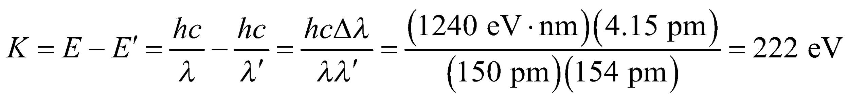

**Assess**For X rays, the wavelength is in the range 0.01–10 nm, so the detection of the Compton shift in X rays is difficult.

**52. Interpret** This problem involves Compton scattering of an X-ray at 90° from a stationary electron. We are to find the kinetic energy of the electron after the scattering event.

**Develop**  In Compton scattering, the kinetic energy of the recoil electron equals the energy lost by the photon:

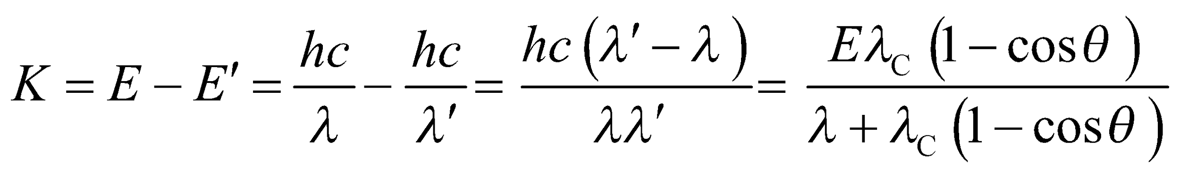

where we used Equation 34.8 for 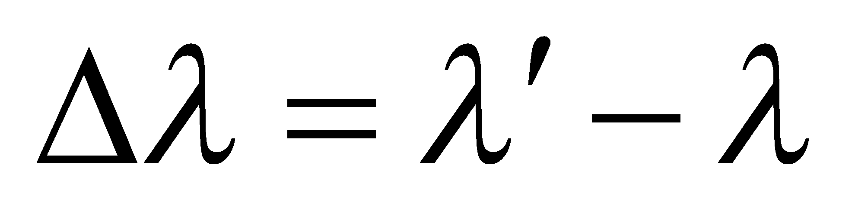.

**Evaluate** For the given datawe find

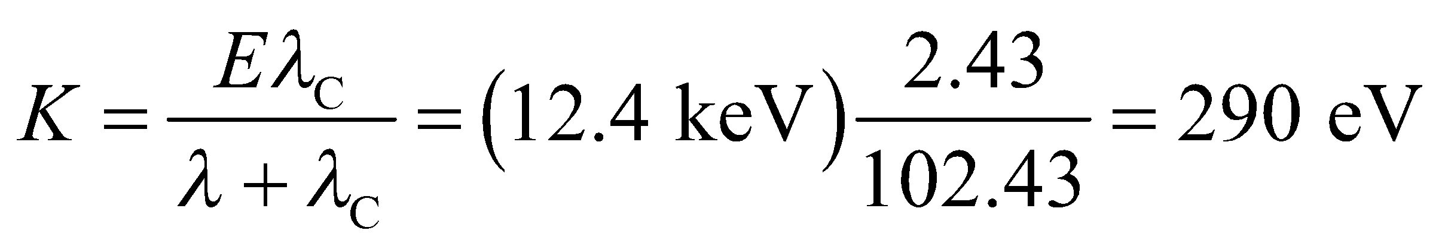

to two significant figures.

**Assess** This (nonrelativistic) energy corresponds to a speed of

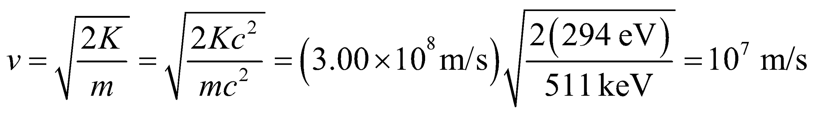

**53. Interpret** This problem involves the photoelectric effect. We are given enough information to find the work function of the material, and are asked if this material will emit electrons when illuminated with radiation at a longer wavelength and, if so, what will be the maximum electron energy.

**Develop** To determine whether or not the photoelectric effect can occur, we shall first find the work function from Einstein’s photoelectric effect equation (Equation 34.7). Using the data for the blue light, this gives the work function of the photocathode material as

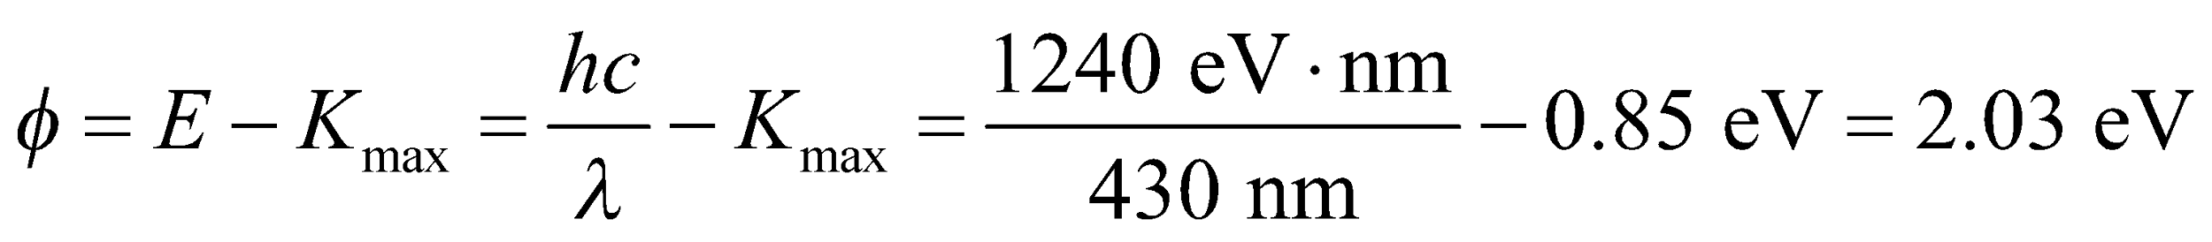

**Evaluate** The energy of a photon of the red light is only

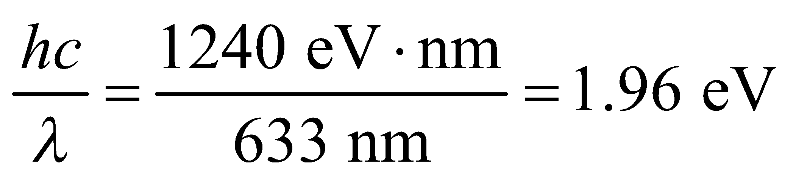

and therefore is insufficient to eject photoelectrons.

**Assess** A wavelength of 633 nm is greater than the cutoff wavelength of 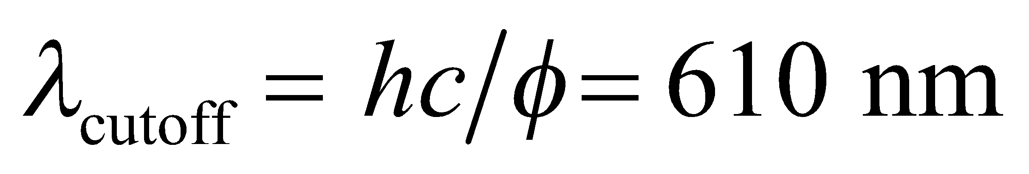 for the photocathode material.

**54. Interpret** This problem involves the Bohr atom (i.e., a hydrogen atom). We are to find the highest possible energy for a photon emitted by such an atom.

**Develop** The energy of the photon emitted in a hydrogen atom transition between adjacent states 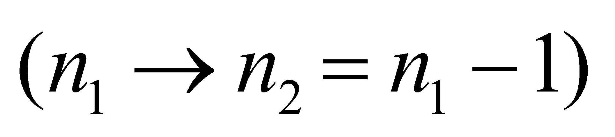 is

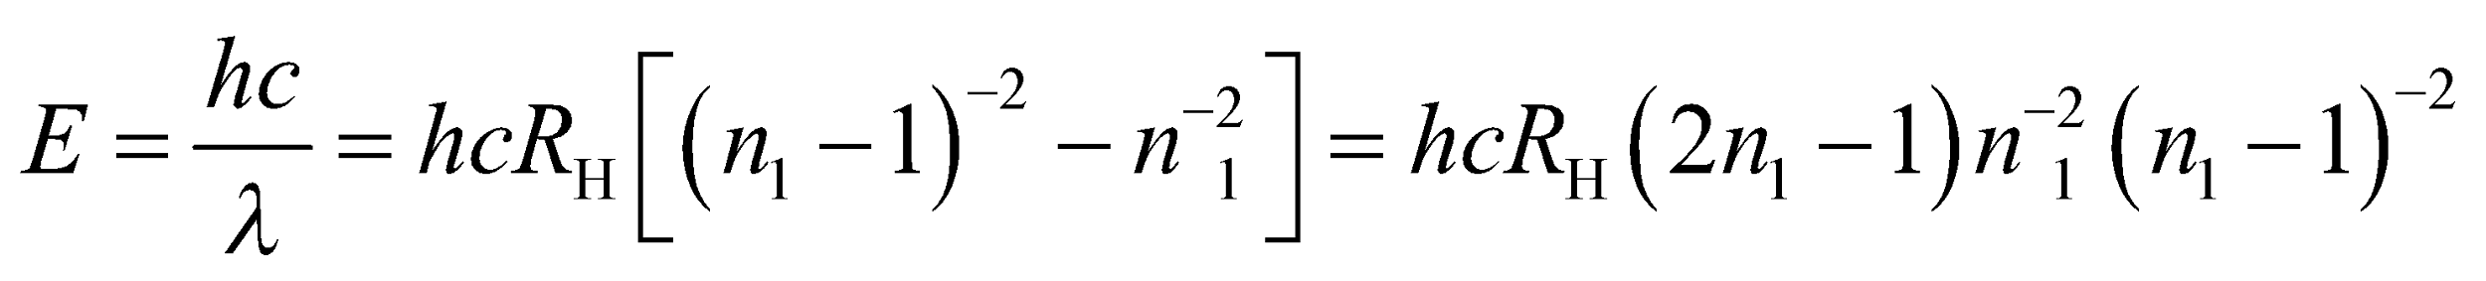

(see Equations 34.6 and 34.9 and the discussion of the Bohr atom in the text).

**Evaluate** **(a)** The maximum allowed energy occurs for *n*1 = 2, which gives

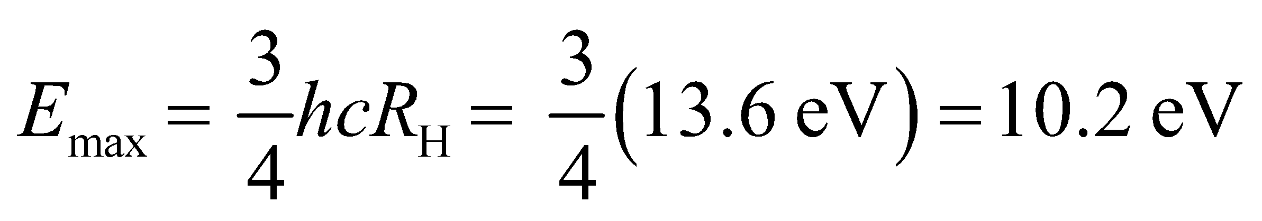

**(b)** The upper (initial) energy level is *n*1 = 2 and the lower (final) energy level is *n*2 = 1.

**Assess** This energy is in the ultraviolet portion of the electromagnetic spectrum.

**55. Interpret** This problem is about the wavelength and energy of the photon emitted when a Rydberg hydrogen atom undergoes a transition.

**Develop** The wavelength of the photon can be calculated using Equation 34.9:



where 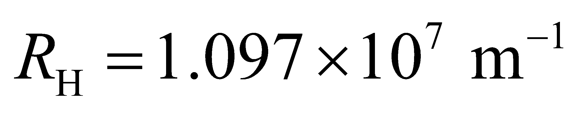 is the Rydberg constant. Once we know the wavelength, the energy of the photon may be found using .

**Evaluate** **(a)** The above equation gives

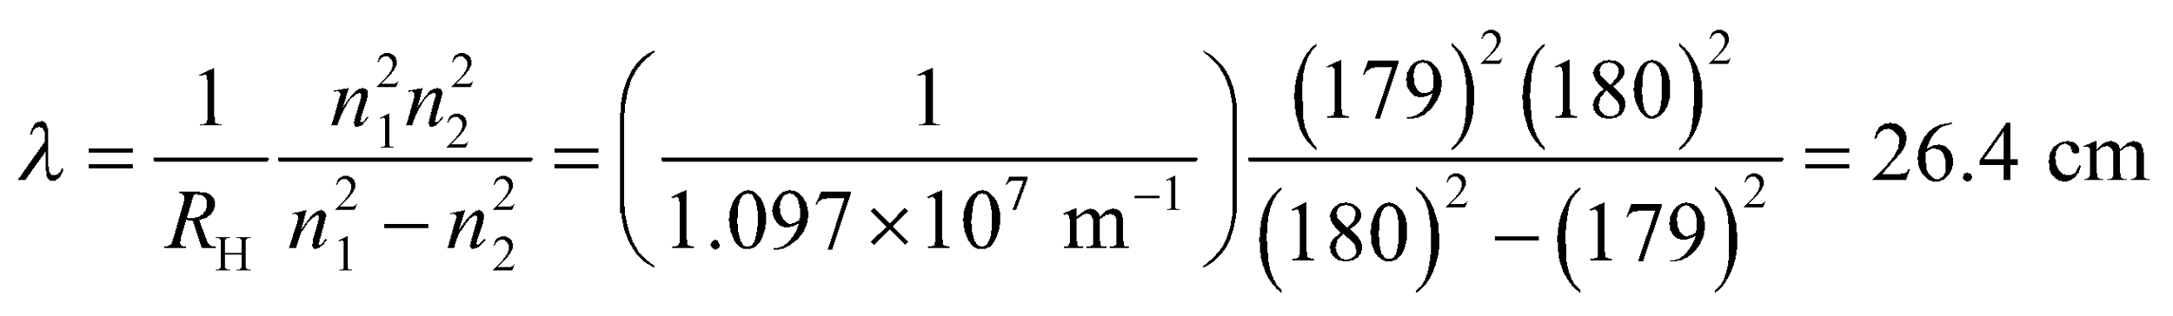

**(b)** The energy of the emitted photon is

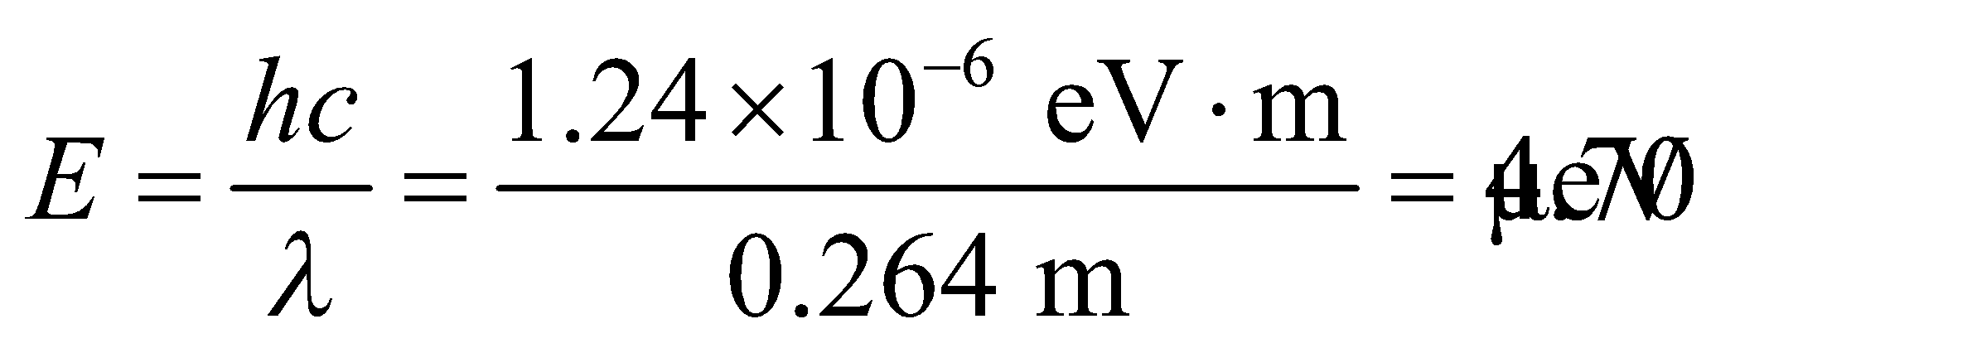

**Assess** The long wavelength corresponds to the radio region of the electromagnetic spectrum.

**56. Interpret** We are to find the maximum energy for a photon emitted by a transition in the Lyman series and in the Balmer series in a hydrogen atom.

**Develop** Apply Equation 13.12b,

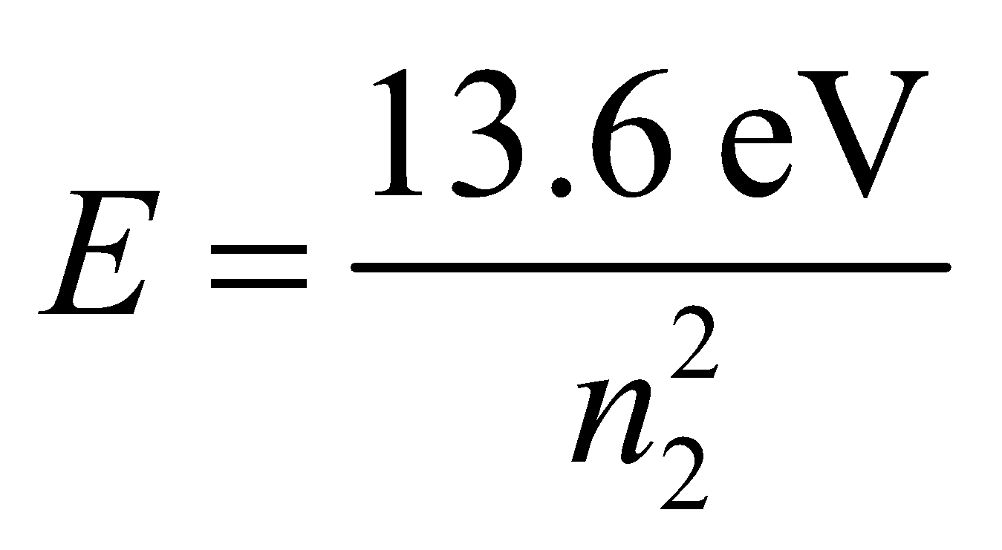

where *n*2 is lowest quantum number for the given series. From Figure 34.11, we see that *n*2 = 1 for the Lynam series and *n*2 = 2 for the Balmer series. To find the corresponding wavelength, use Equation 34.6 *E* = *hf* = *hc*/*λ*.

**Evaluate** (a) For the Lyman series, the highest energy photon is

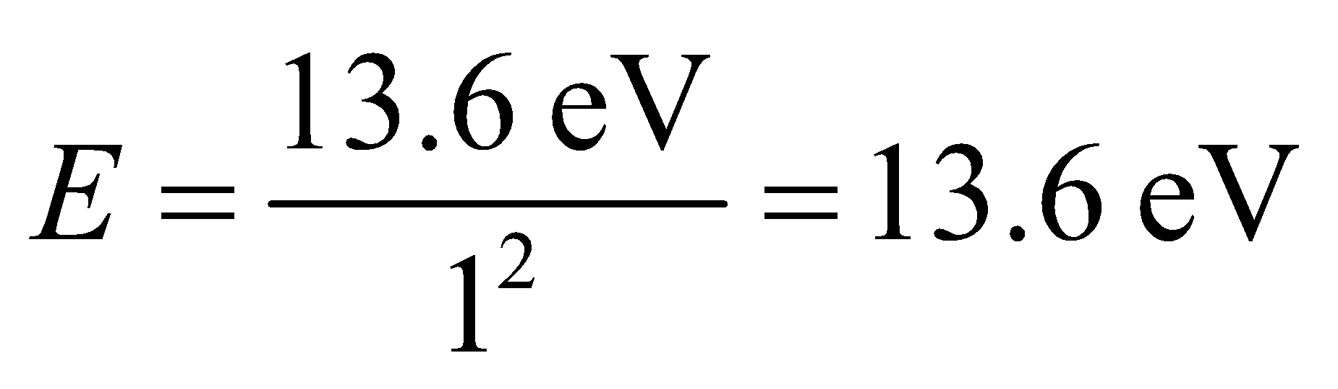

The wavelength of this is

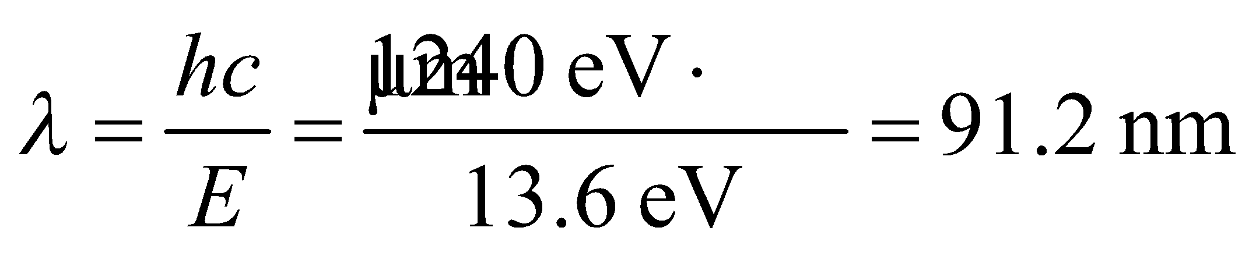

(b) For the Balmer series, the highest energy photon is

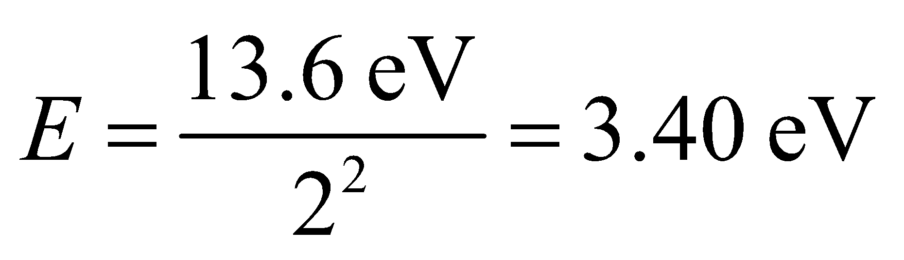

so the wavelength is

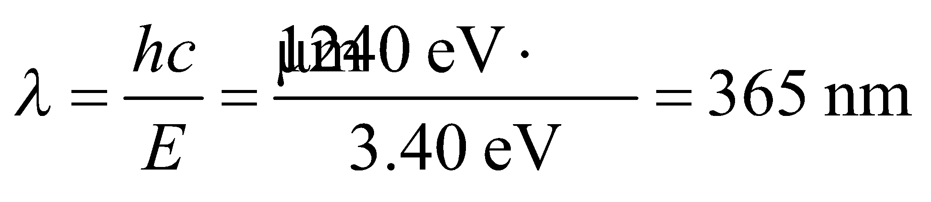

**Assess** The Lyman series limit is in the ultraviolet. The Balmer series limit is at the very high-energy end of the visible spectrum.

**57. Interpret** The hydrogen atom undergoing a downward transition emits a photon. We are interested in the original state of the atom, given the energy of the photon and the quantum number of the final state of the atom.

**Develop** The wavelength of the photon can be calculated using Equation 34.9:



where  is the Rydberg constant. Once we know the wavelength, the energy of the photon may be found using Equation 34.6:

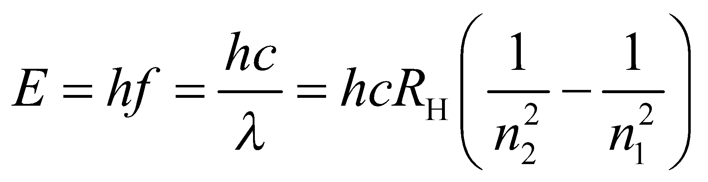

**Evaluate** Solving for *n*1 gives



Note that 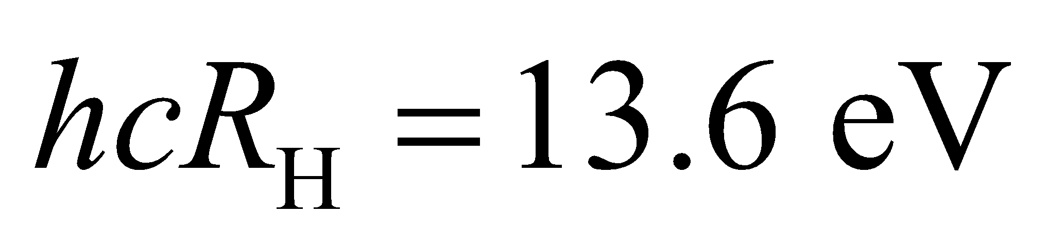 is the ionization energy.

**Assess** The wavelength of the emitted photon is 0.133 m, which falls into the radio wave spectrum.

**58. Interpret** This problem involves conservation of energy and the Bohr model of the atom. We can use these two concepts to find the energy of an electron ejected from the ground state of a hydrogen atom by a 48-eV photon.

**Develop** Energy must be conserved, so the final kinetic energy is the original (ground state) energy plus the absorbed photon energy.

**Evaluate** The final kinetic energy is thus

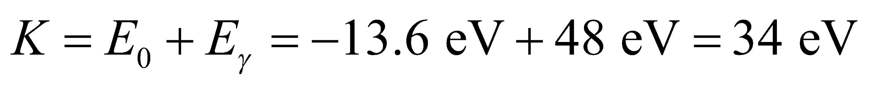

**Assess** This energy is much less than the electron’s rest mass, so relativistic effects do need to be considered.

**59. Interpret** This problem involves the Bohr model of the atom. We are to find the ionization energy of a hydrogen atom in its first excited state.

**Develop** Using Equation 34.12b, the energy of the first excited state (*n* = 2) is

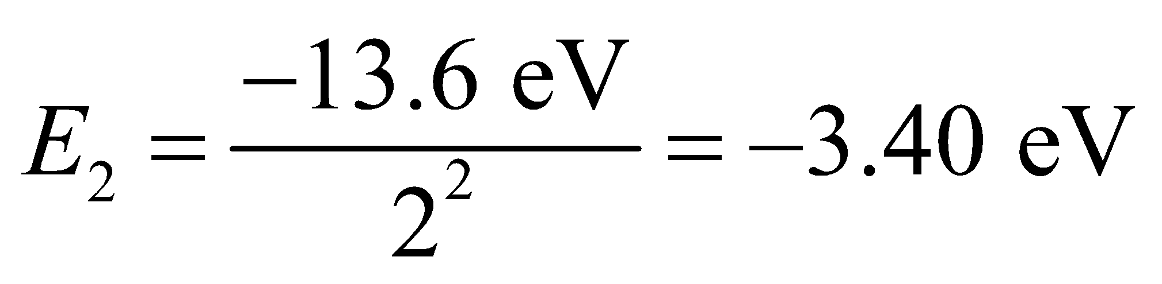

whereas an ionized atom (with zero electron kinetic energy) has energy zero.

**Evaluate** Thus, we must supply an energy *E*I such that

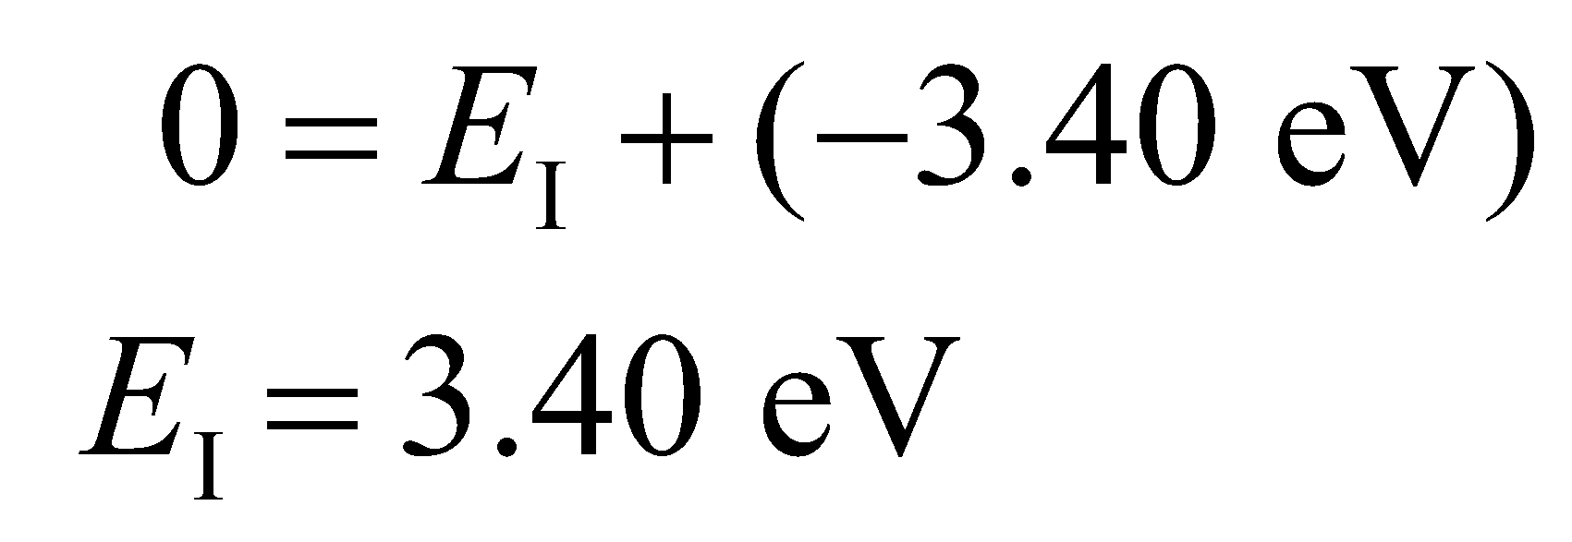

**Assess** The ionization energy here is only ¼ of the case where the atom is in the ground state. The higher the value of *n*, the smaller the ionization energy because the electron is less tightly bound to the nucleus.

**60. Interpret** We are to find the final energy of electrons ejected from ground-state hydrogen atoms by ultraviolet radiation. We will apply conservation of energy and use the Bohr model of the atom.

**Develop** By conservation of energy, the final kinetic energy of the electron (actually, the ionized atom with the nucleus assumed to be at rest) is its initial ground state energy (−13.6 eV) plus the energy *E* = *hf* = *hc*/*λ* (see Equation 34.6) absorbed from the photon.

**Evaluate** Summing the two energies, we find the kinetic energy of the electron to be

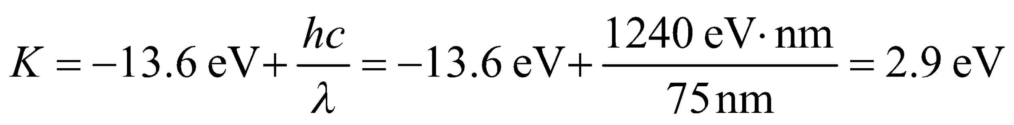

**Assess** The photon supplies a total energy of 13.6 eV + 2.9 eV = 15.5 eV.

**61. Interpret** 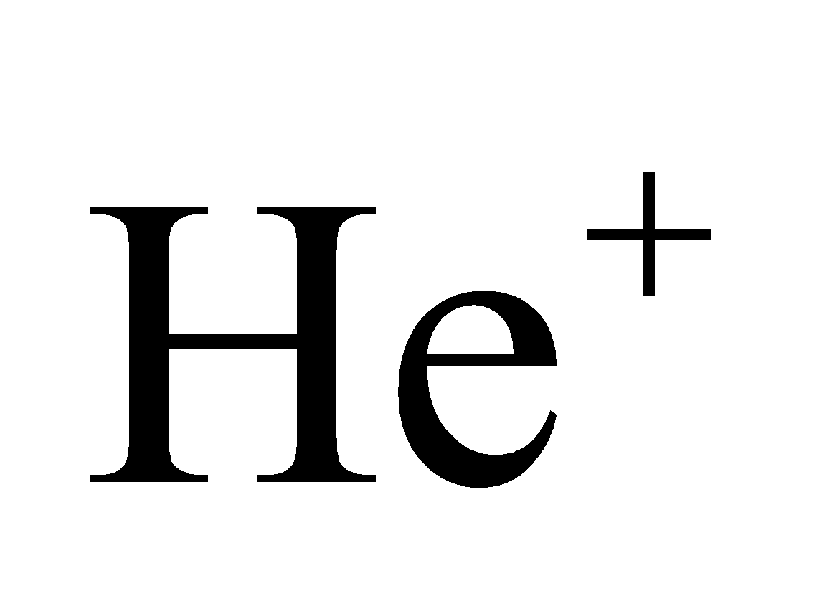is a hydrogen-like atom with a nuclear charge +2*e*. We are to apply the Bohr model to this system to find the ground-state electron radius and the energy difference between the *n* =2 and *n* = 1 state.

**Develop** Modifying the treatment of the Bohr atom in the text (see derivation of Equations 34.11 and 34.12) for singly ionized helium (He+) by replacing the nuclear charge with 2*e*, one gets 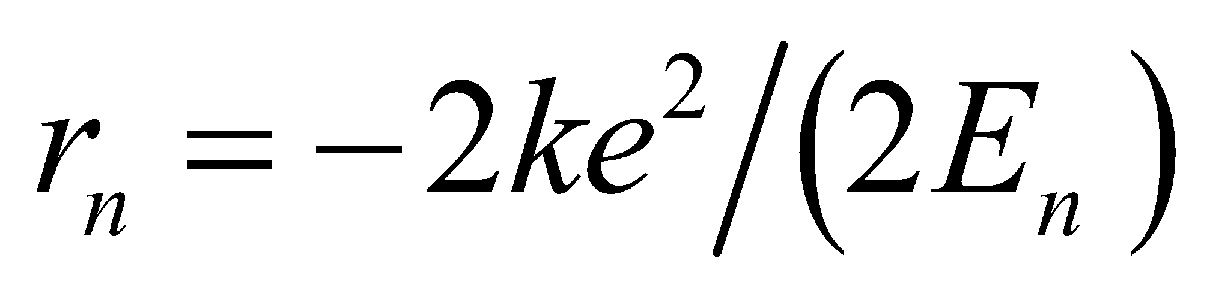 and 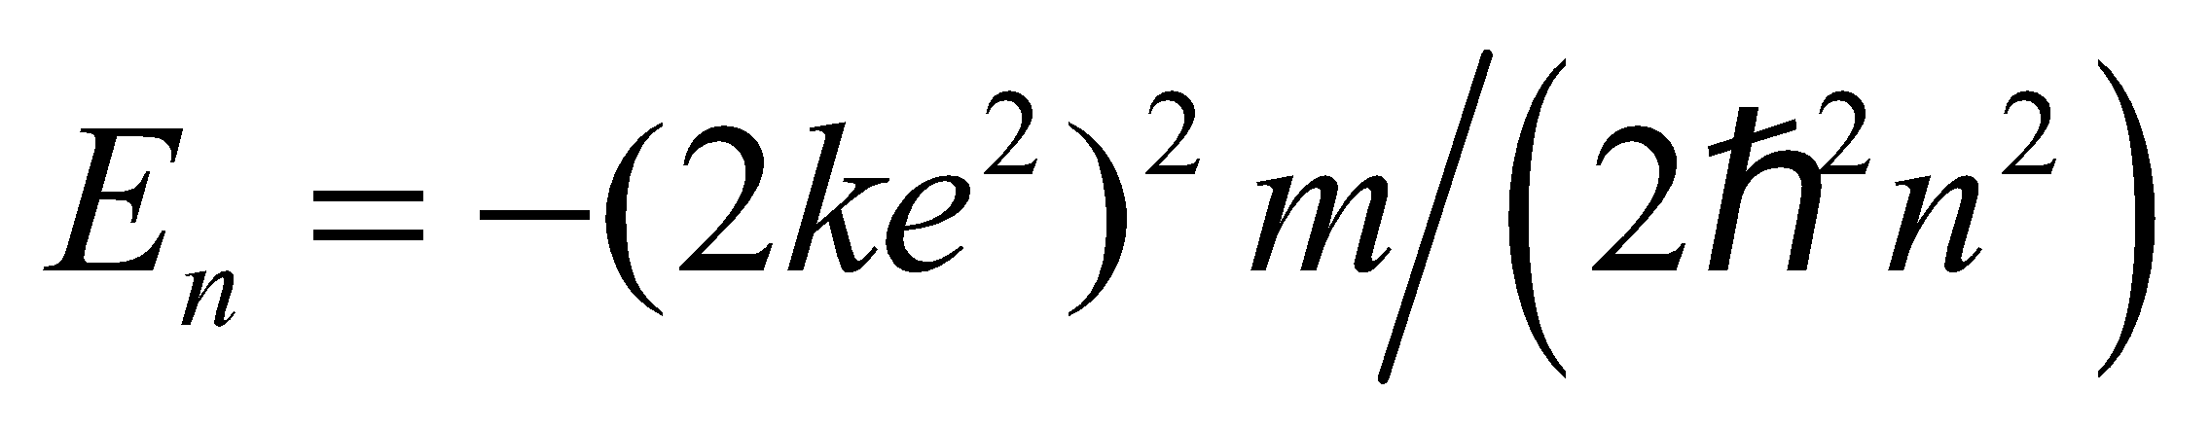. Thus,

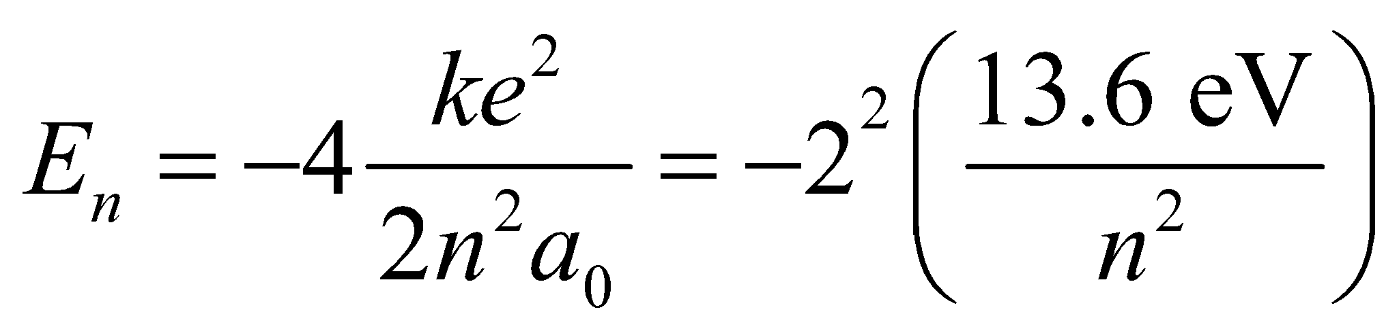

and

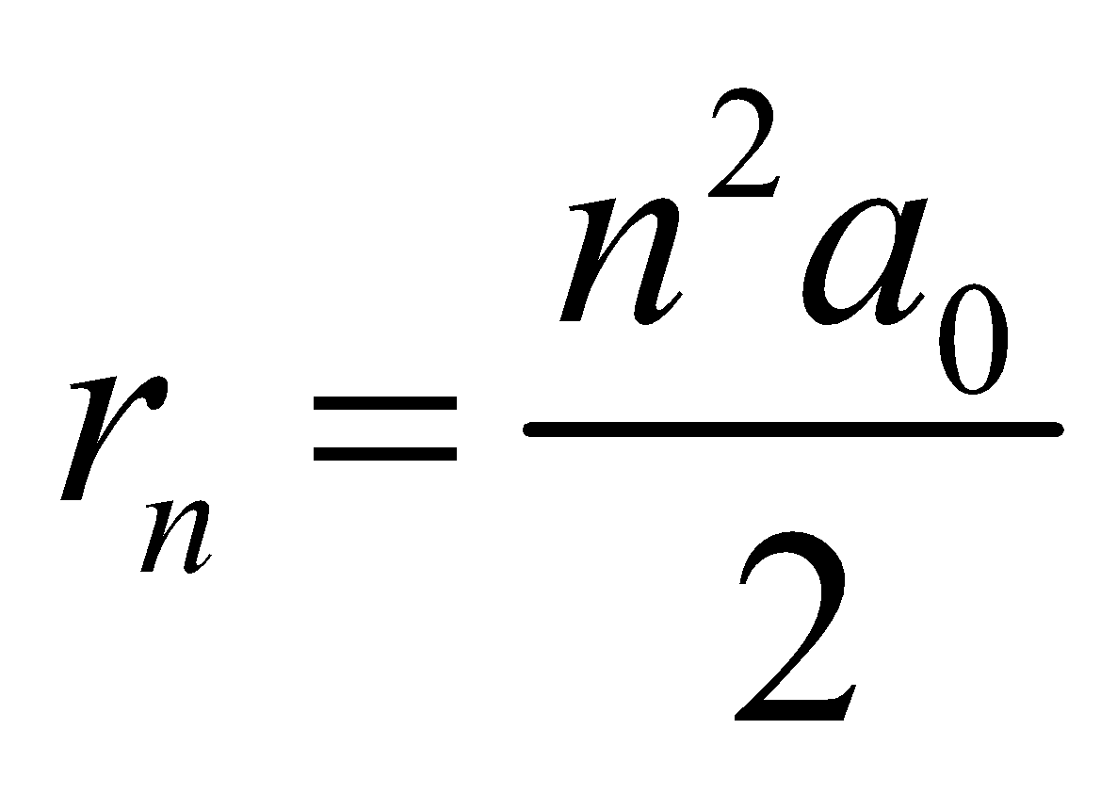

**Evaluate** **(a)** The radius of the ground state of He+ is

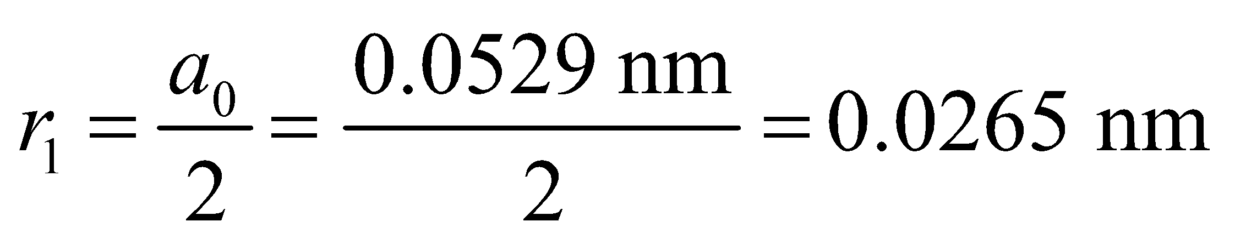

**(b)** The energy released in the transition from *n* = 2 to *n* = 1 is

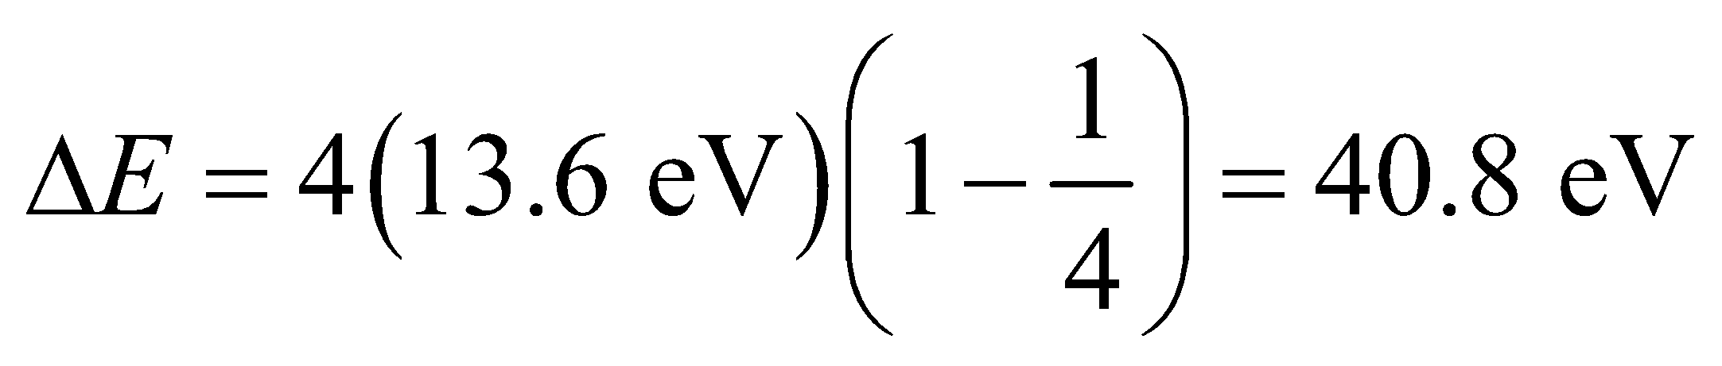

Note that there is also a small change in *m* for helium, different from the correction in hydrogen, for the motion of the nucleus.

**Assess** In general, replacing the nuclear charge with *Ze* gives results for any one-electron Bohr atom, where *Z* is the number of protons for the atom (i.e., the atomic number).

**62. Interpret** This problem involves the de Broglie wavelength. We are to find the kinetic energy needed for an electron to have a de Broglie wavelength the size of a hydrogen atom.

**Develop** Since 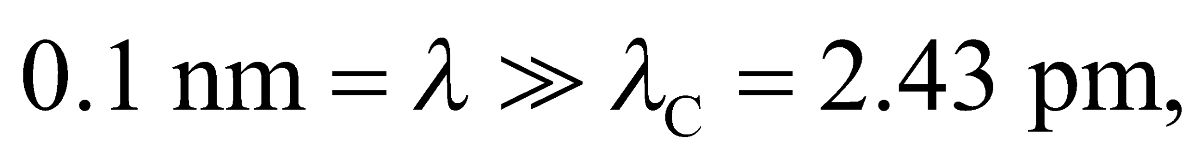 nonrelativistic expressions can be used to write the kinetic energy in terms of the de Broglie wavelength:

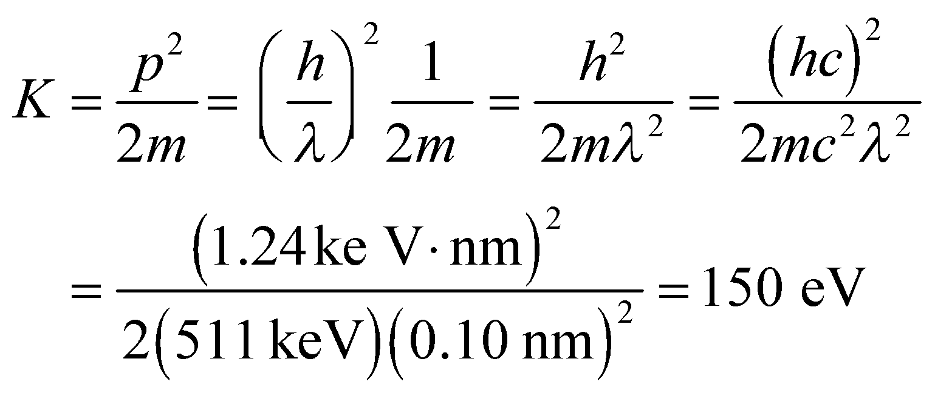

**Evaluate** Because the kinetic energy gained in an acceleration from rest equals the potential energy difference, 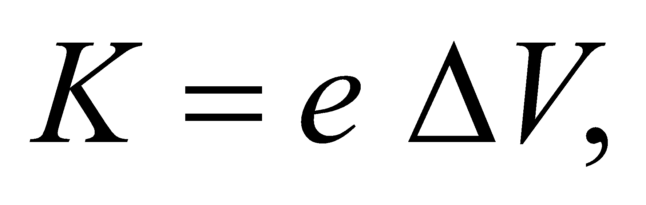 and 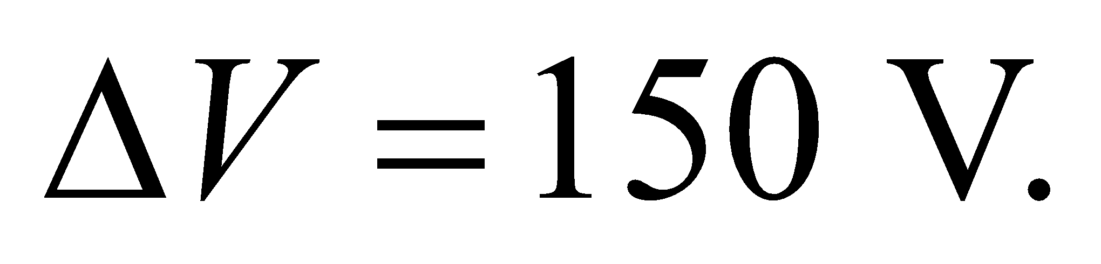

**Assess** Recall that *λ*C = *h*/(*mc*) = 2.43 pm for an electron. The result of 150 V is an easily accessible potential difference.

**63. Interpret** The resolution of a microscope depends on the wavelength used. A smaller de Broglie wavelength will improve the resolution of an electron microscope. We are to find the minimum electron speed that will make its de Broglie wavelength less than 450 nm.

**Develop** The resolution of the electron microscope is better than the optical microscope with 450-nm light if the de Broglie wavelength *λ* of the electrons is less than 450 nm. Thus,

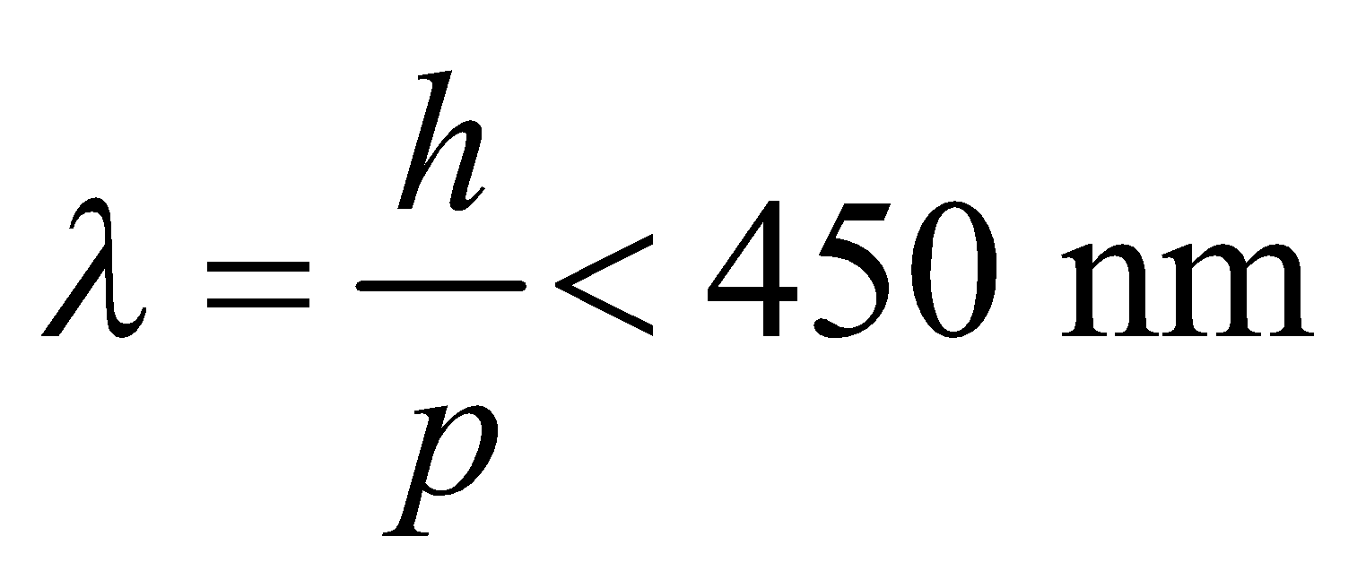

Since *p* = *mv* (for nonrelativistic electrons), the above condition allows us to obtain the minimum electron speed.

**Evaluate** The above inequality gives

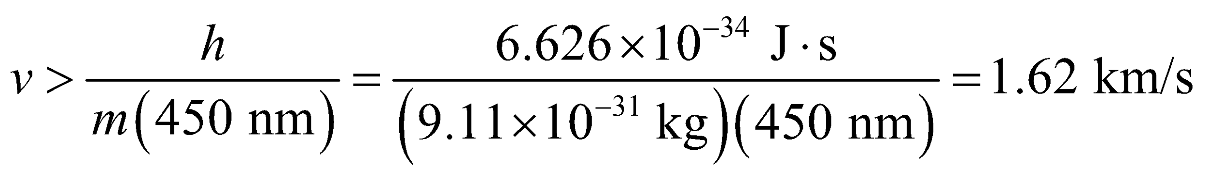

So the minimum speed is 1.62 km/s.

**Assess** Since  (Compton wavelength of the electron), our use of the nonrelativistic momentum was justified. The electron microscope can provide resolutions down to about 1 nm and magnifications of 106.

**64. Interpret** You want to see what energy of electrons is needed to resolve microtubules. You'll need to consider the de Broglie wavelength of the particles.

**Develop** To resolve the microtubules, the electron microscope that you buy will need electrons with de Broglie wavelength less than or equal to the size of the microtubules (25 nm). This corresponds to a momentum of 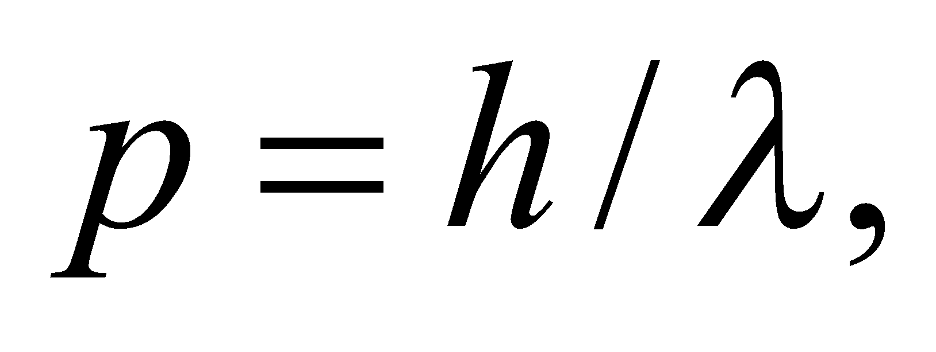and a kinetic energy of 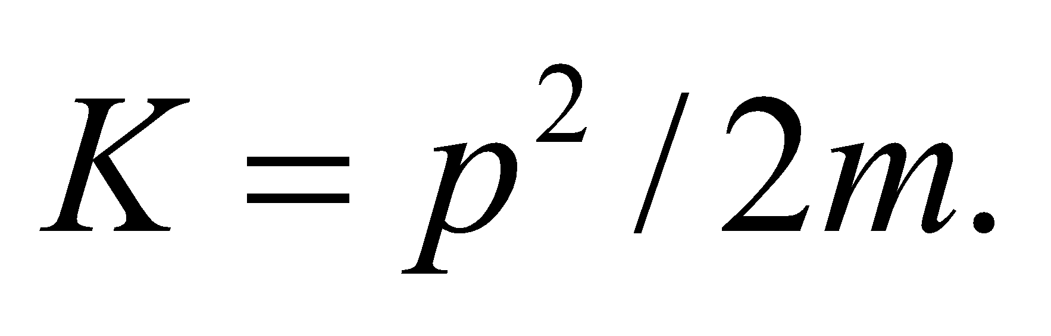 With these equations, you can calculate the minimum energy you need for an electron microscope.

**Evaluate** The minimum electron kinetic energy needed is

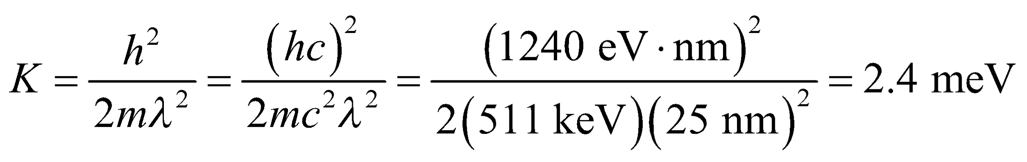

where we have used the rest-energy of the electron,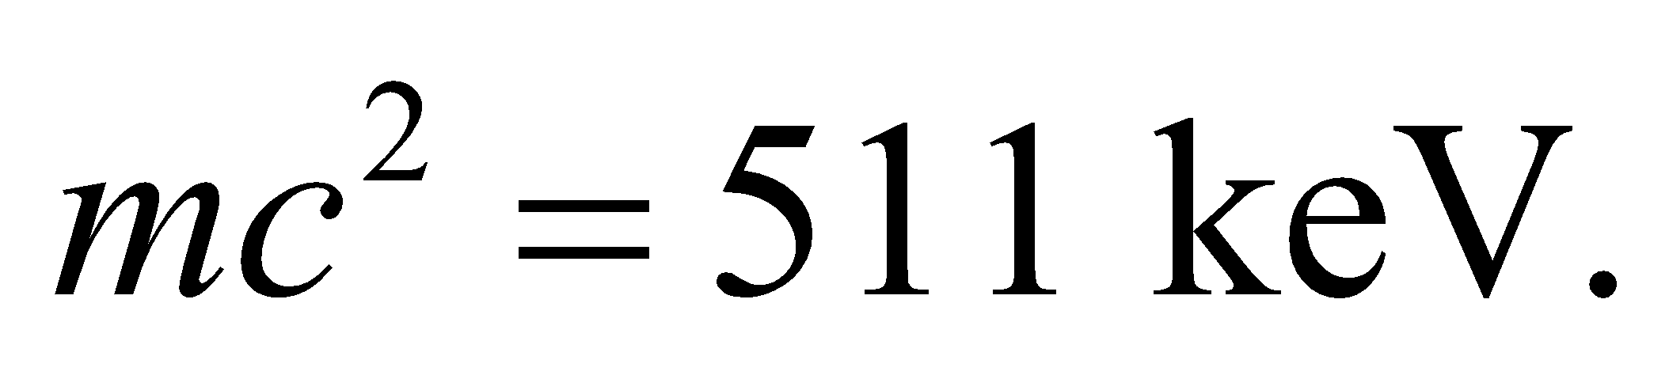The minimum kinetic energy is far below 40 keV, so you don't need to buy the more expensive microscope, since the less expensive microscope will work.

**Assess** By the above arguments, the 40 keV electron microscope should have resolution of around 6 pm, since that is the corresponding de Broglie wavelength of the electrons. However, there are complications involved in focusing a beam of electrons, so most electron microscopes have resolutions around a nanometer.

**65. Interpret** This problem involves the uncertainty principle. We want to find the minimum velocity of an electron based on its uncertainty in position.

**Develop** Using the uncertainty principle given in Equation 34.15 with *Δx* = 20 nm (the width of the well), we have

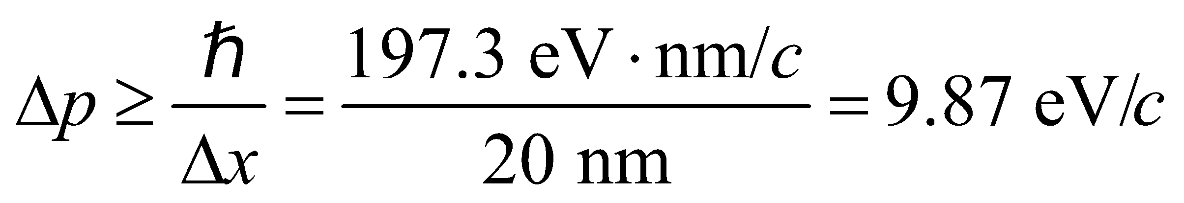

This is small compared to 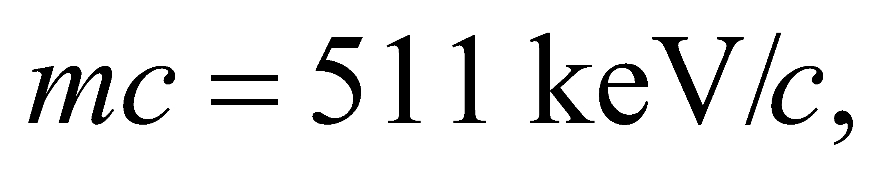 so nonrelativistic formulas are sufficient (see Example 34.6). Therefore, 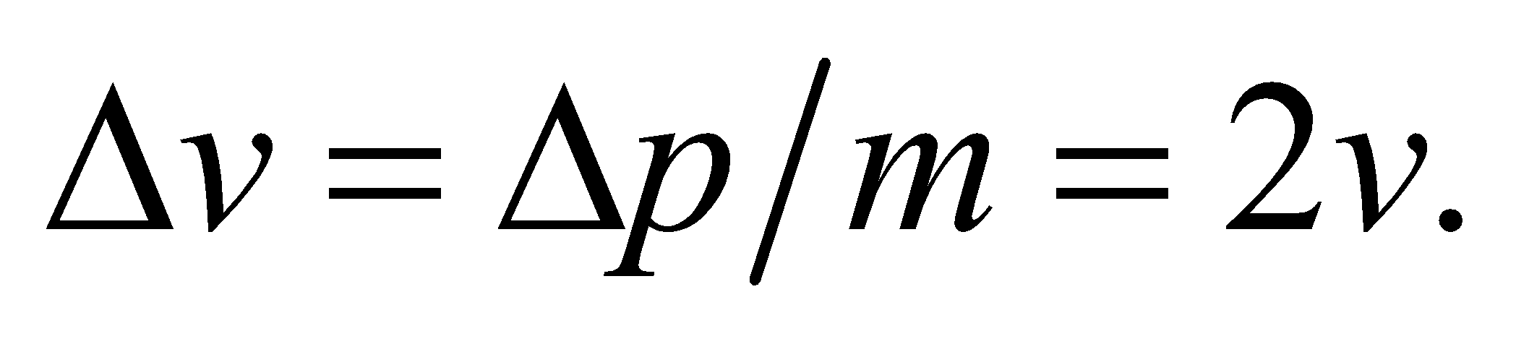

**Evaluate** The above conditions lead to

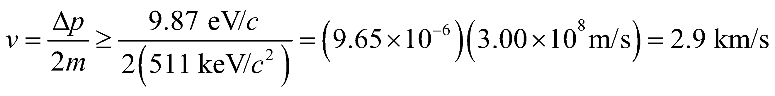

Thus, the minimum speed is *v*min = 2.9 km/s.

**Assess** Quantum wells have important applications in the field of semiconductor fabrication. Note that the result is given to two significant digits, as warranted by the data.

**66. Interpret** This problem involves the uncertainty principle applied to the variable energy and time. We shall use this to find the uncertainty in energy in a typical atomic transition given the lifetime of the excited atomic state.

**Develop** The uncertainty principle (Equation 34.16) for energy and time is

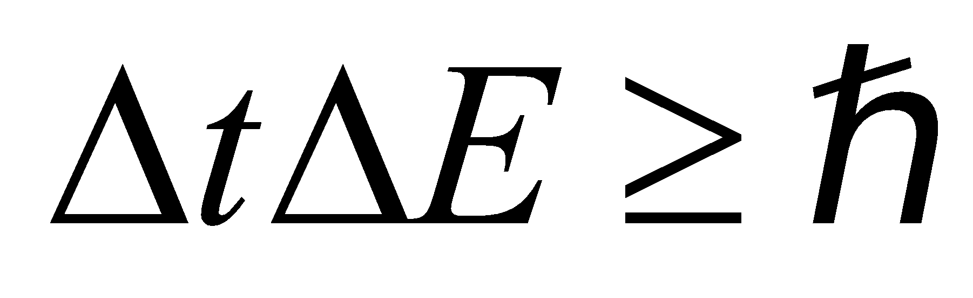

(note that the units of  are time-energy). Apply this to find the minimum energy given the uncertainty in time of *Δt* = 10−8 s.

**Evaluate** The uncertainty in energy is

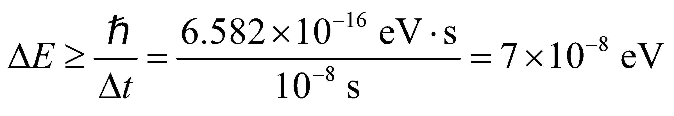

**Assess** This energy uncertainty is called the natural linewidth.

**67. Interpret** This problem involves energy-time uncertainty. We are interested in the minimum measurement time needed to measure the energy with the desired precision.

**Develop** The electron is nonrelativistic 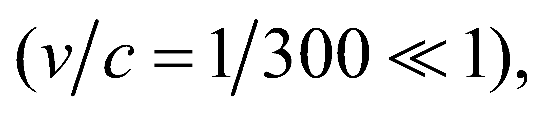 so we can use the nonrelativistic expression *K* = *mv*2/2 for kinetic energy. The desired uncertainty in the kinetic energy is



The minimum time can then be calculated using Equation 34.16, 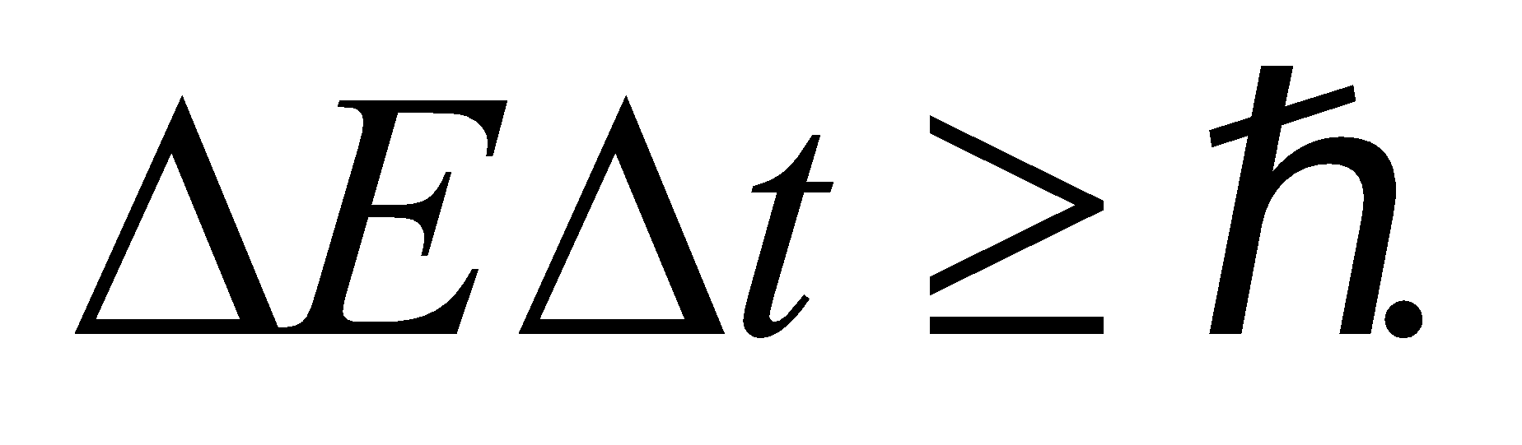

**Evaluate** An energy measurement of this precision requires a time

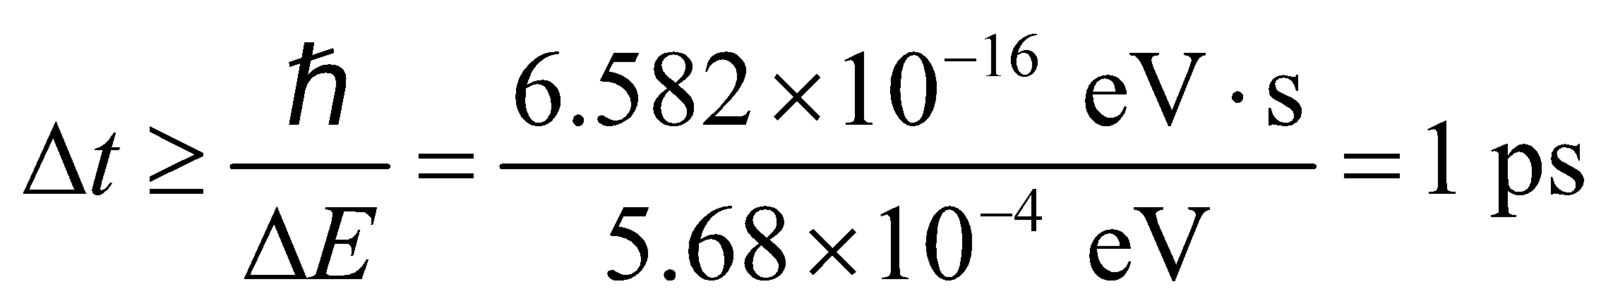

to a single significant figure.

**Assess** The energy-time uncertainty principle implies that the minimum measurement time must necessarily go up in order to achieve a greater accuracy in energy measurement.

**68. Interpret** We are to derive the classical Rayleigh–Jeans law (Equation 34.5) for blackbody radiation from Planck’s law (Equation 34.3).

**Develop** For 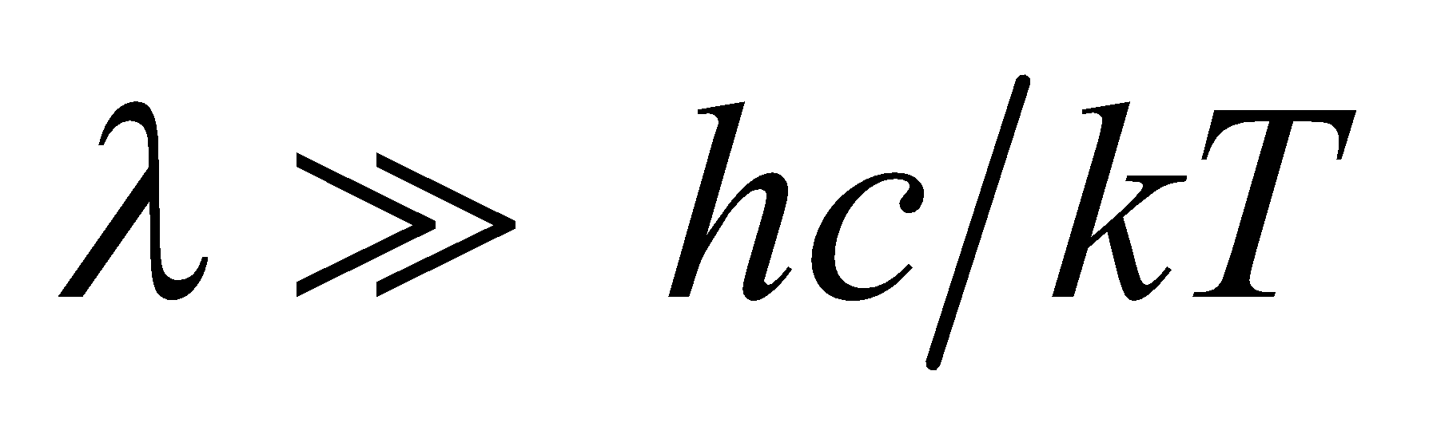, the exponent in Planck’s law (Equation 34.3) is much, much less than unity, so we can express the exponential function as

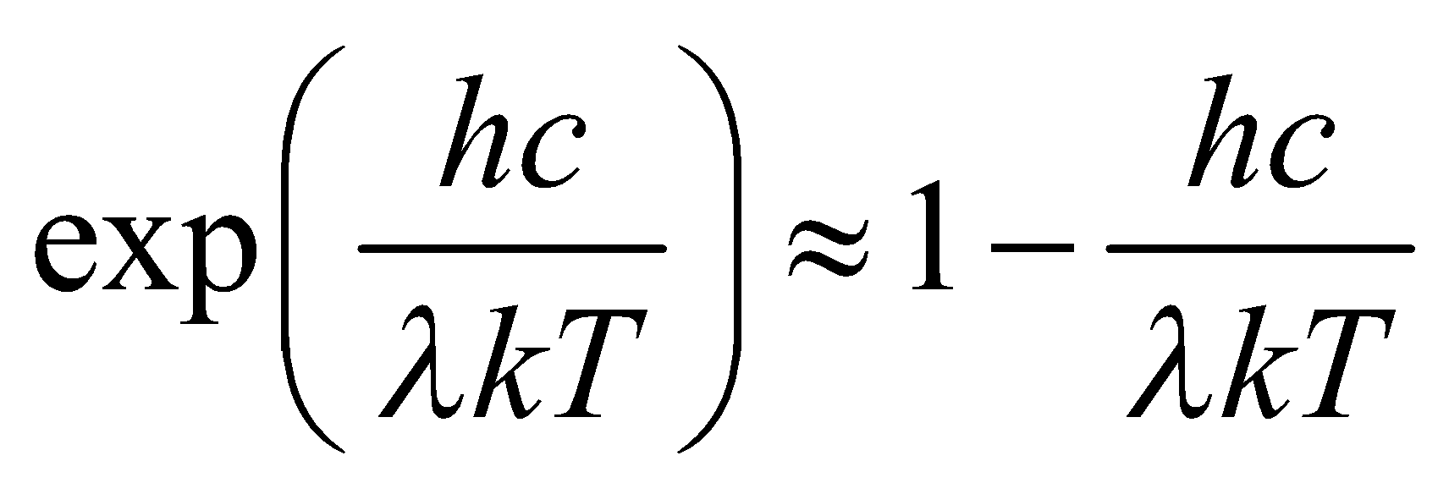

Insert this result into Planck’s law.

**Evaluate** With the above approximation, Planck’s law takes the form

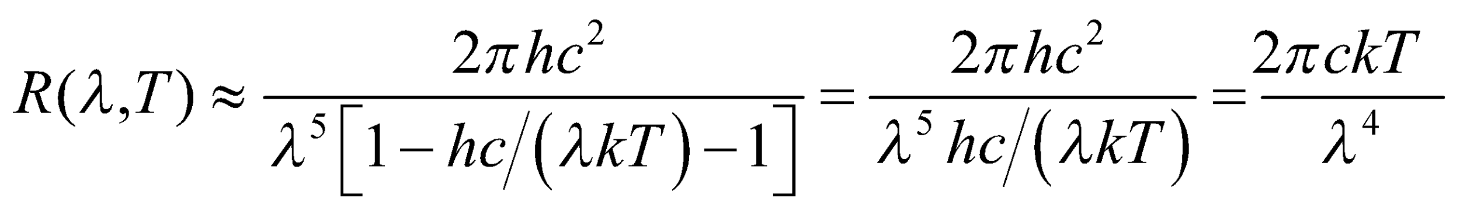

which is the Rayleigh–Jeans law.

**Assess** Thus, the Rayleigh–Jeans law is an approximation of the more accurate Planck law.

**69. Interpret**In this problem, we want to show that if a photon’s wavelength is equal to a particle’s Compton wavelength, then the photon’s energy is equal to the particle’s rest energy.

**Develop**From Equation 34.8, we see that the Compton wavelength of a particle is 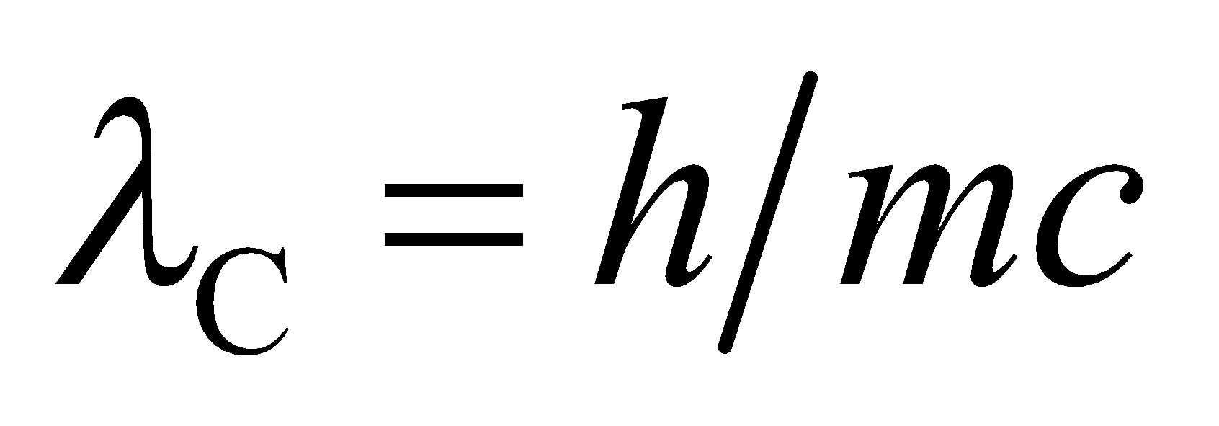. The rest energy of a particle is *E* = *mc2* (see discussion preceding Equation 33.9). From Equation 34.6, we see that the energy of a photon is *E* = *hf* = *hc*/*λ*.

**Evaluate** When the wavelength of the photon is *λ* = *λ*C, its energy is

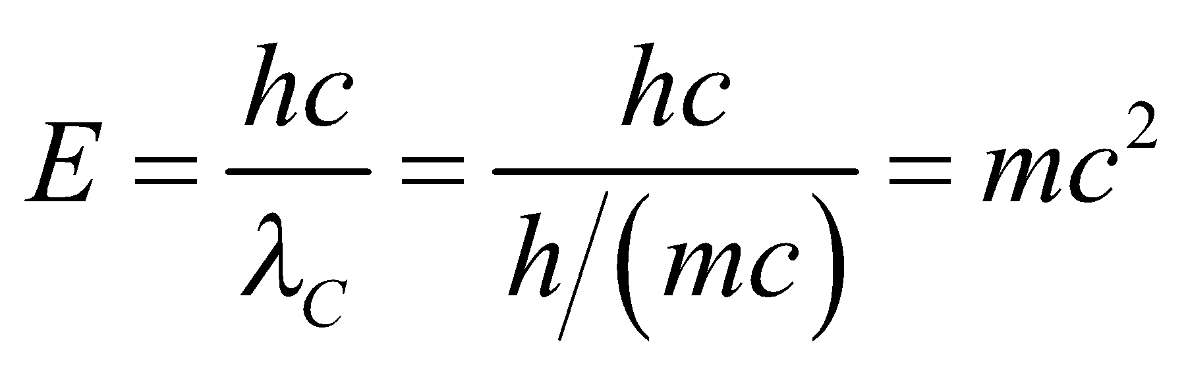

which is the same as the particle’s rest energy.

**Assess** This result is not surprising because photons have zero rest mass, so their energy is completely kinetic. Have you ever seen a photon that is not moving at the speed of light?

**70. Interpret** This problem involves the frequencies (i.e., energies) of the electronic transitions in hydrogen. We are to show that transitions to a level n from all higher levels cover the given frequency range.

**Develop** From Equation 34.9, we see that the frequency of a transition in which the electron is initially in state *n*1 and ends up in state *n*2 = *n* is

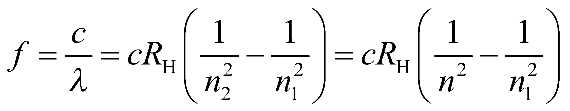

The possible values for *n*1 are *n* + 1, *n* + 2, 😐, so the lowest possible frequency occurs for *n*1 = *n* + 1 and the highest possible frequency occurs for .

**Evaluate** The frequency range is

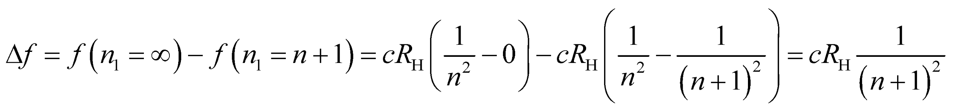

**Assess** This agrees with the formula given in the problem statement.

**71. Interpret** This problem involves Compton scattering of a photon off an electron that is initially at rest (zero kinetic energy). We are to find an expression for the initial photon energy given the final total energy (kinetic energy plus rest energy) of the electron.

**Develop** For Compton scattering at 90°, Equation 34.8 reduces to 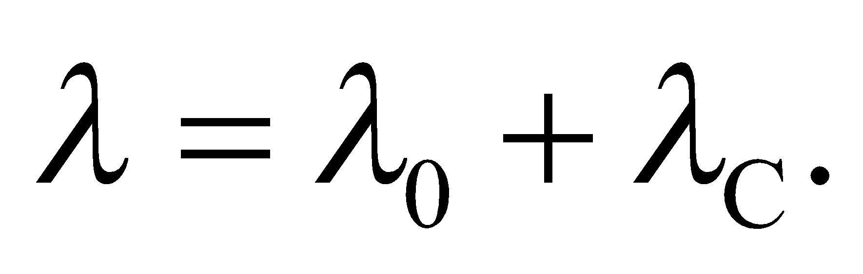 In terms of the photon energy (Equation 34.6) *E* = *hf* = *hc*/*λ* and the electron’s Compton wavelength [Equation 34.8, 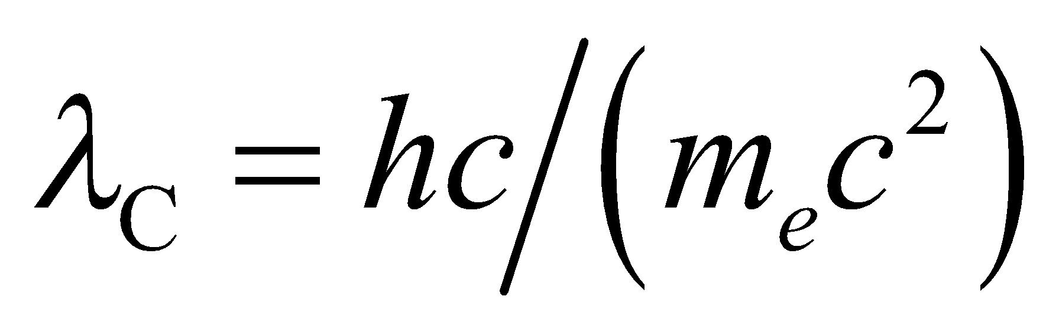], this can be written as

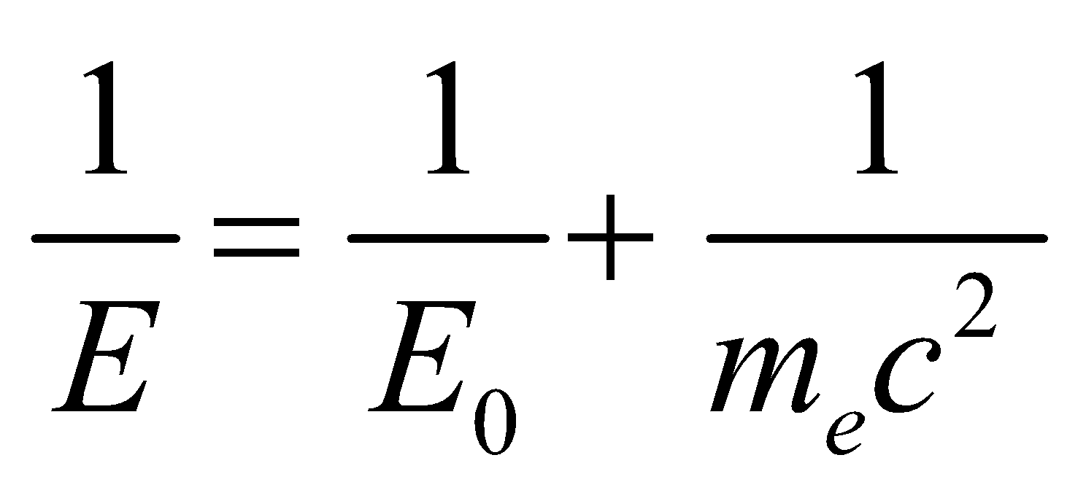

or

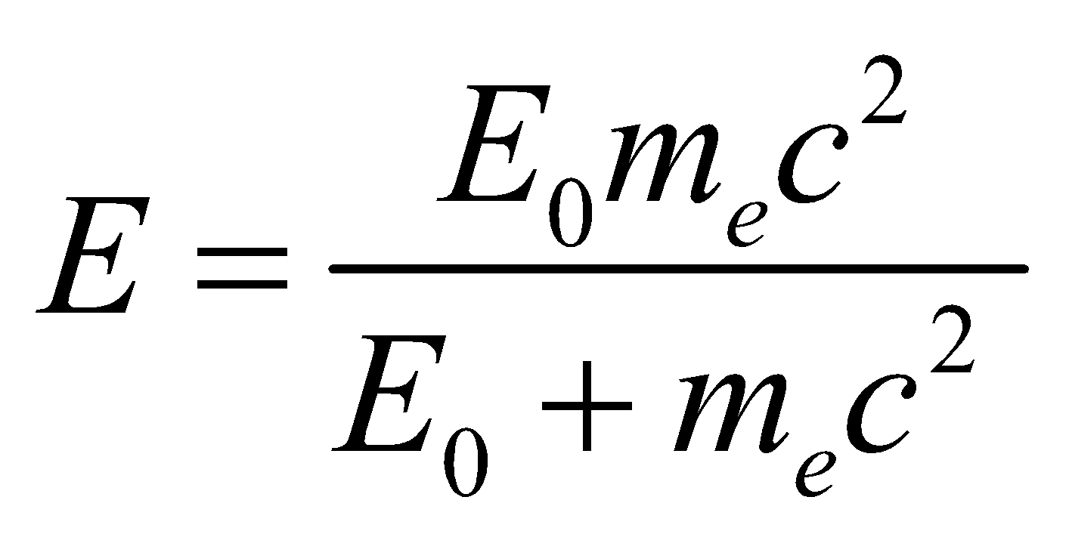

The recoil electron’s kinetic energy is

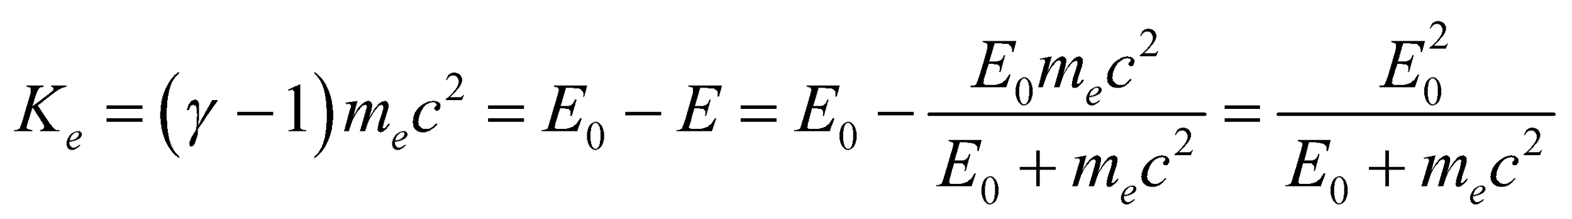

This is a quadratic equation in *E*0, namely 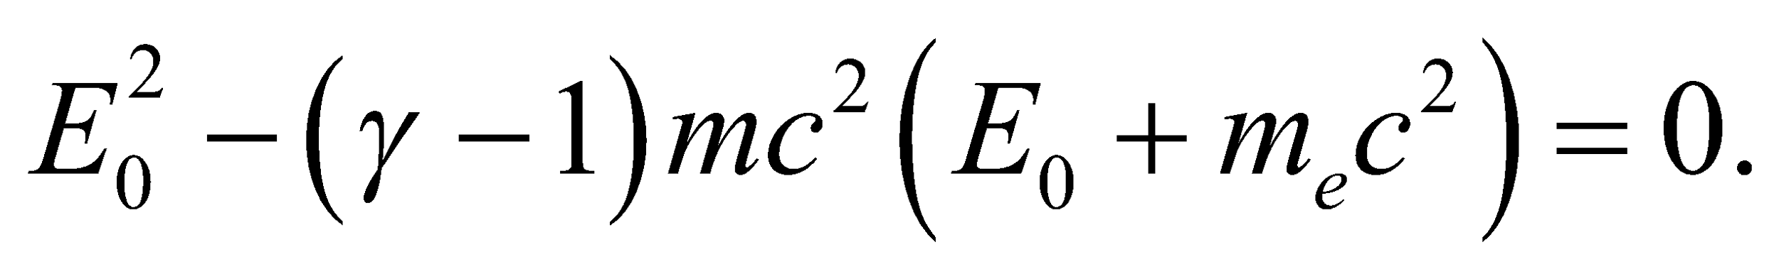 The positive solution corresponds to the initial photon energy that we seek.

**Evaluate** The positive solution for *E*0 is



**Assess** With some algebra, the kinetic energy of the recoiled electron can be written as

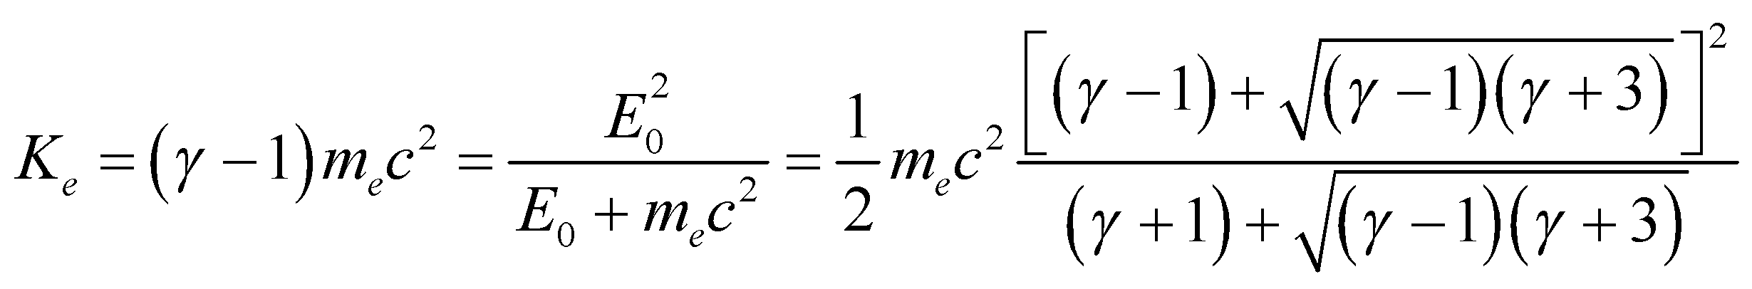

In the nonrelativistic limit where 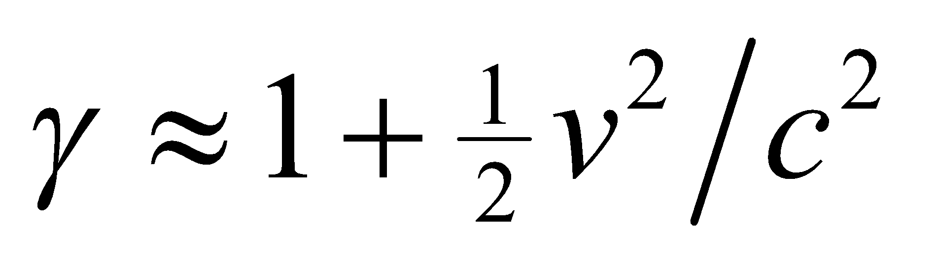, the above expression reduces to the expected result 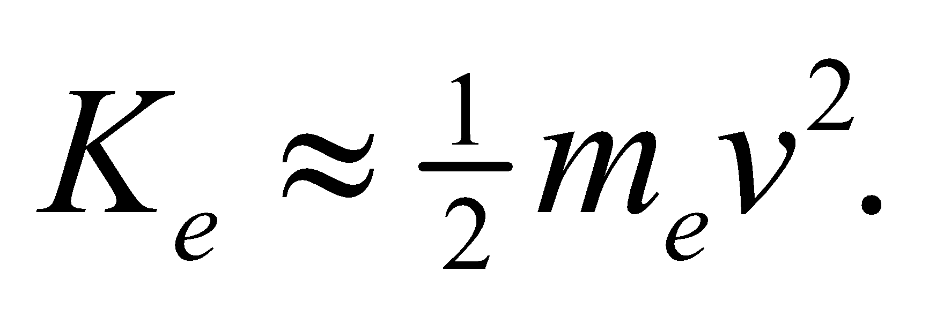

**72. Interpret** We are to derive Wien’s law (see Section 34.2 on blackbody radiation) from Planck’s law.

**Develop** If we introduce the dimensionless variable *x* = *hc*/(*λkT*) into Planck’s law, R(*λ*, *T*) is proportional to 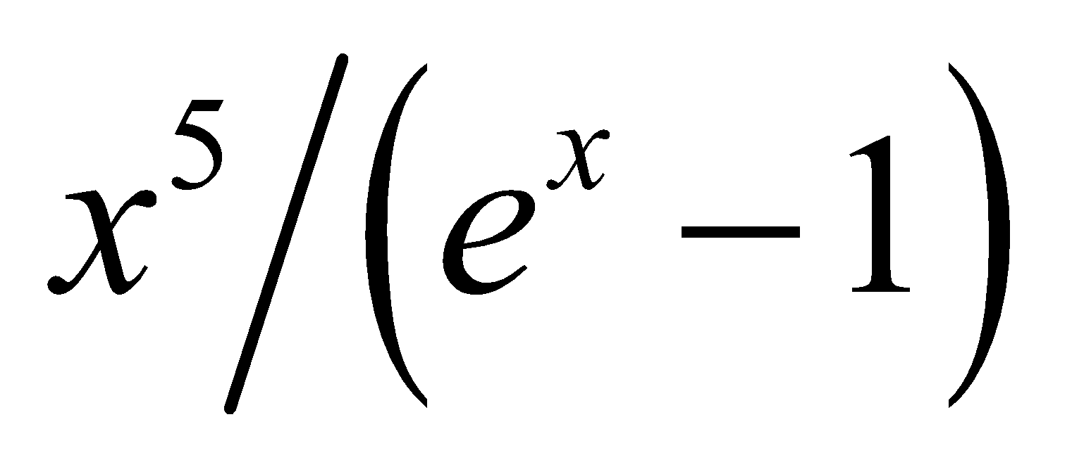. This can be a maximum when its derivative with respect to *x* is zero, which leads to the equation 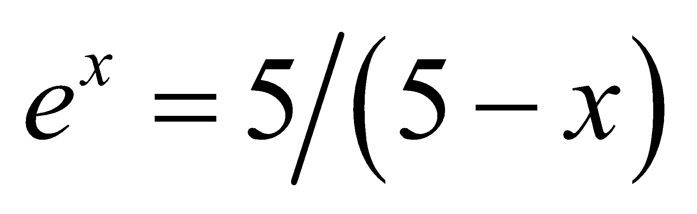.

**Evaluate** For a maximum, this condition is satisfied by a value of *x* nearly equal to 5 (since *x* = 0 corresponds to a minimum radiance). The value *x*max can be found numerically to be about 4.965, so

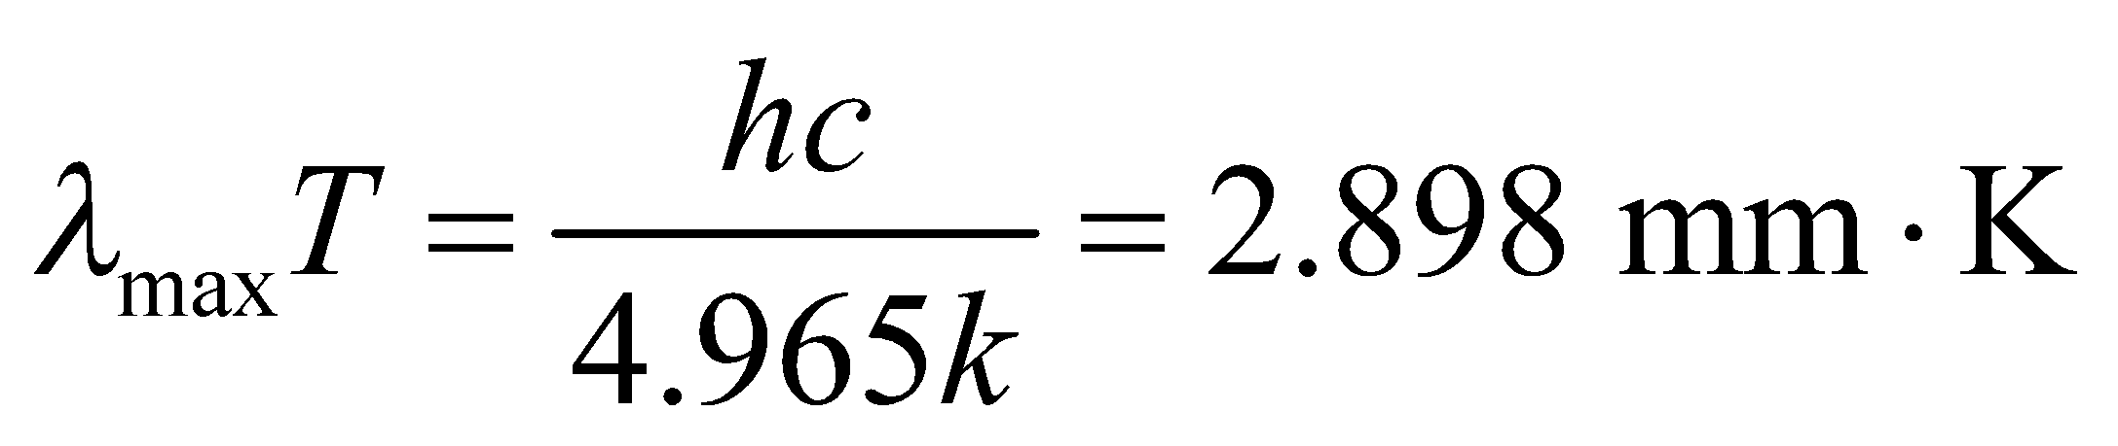

which is Equation 34.2.

**Assess** We have shown the desired relationship. Notice that Wien’s law is not a classical approximation, as is the case for the Rayleigh–Jeans law.

**73. Interpret** We shall use conservation of energy and conservation of momentum (with relativistic expressions for both energy and momentum) to derive equations related to Compton’s equation, and then derive the equation for the Compton shift.

**Develop** The energy of a photon is  (Equation 34.6) and for a particle it is 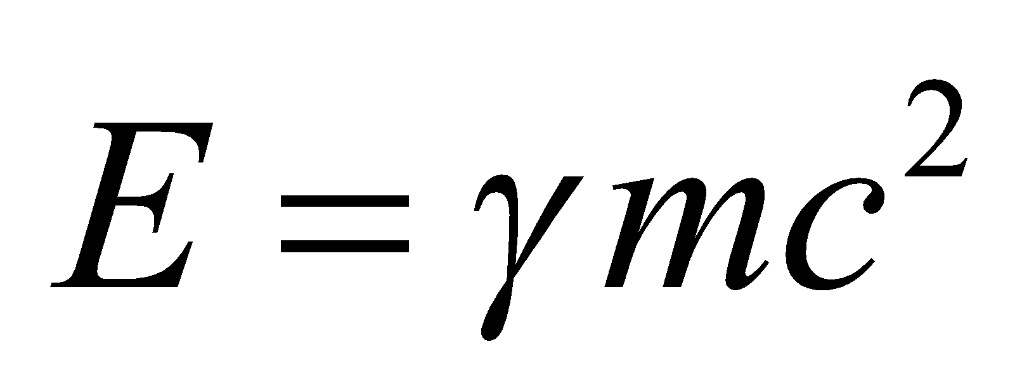 (Equation 33.9). The relativistic momentum is 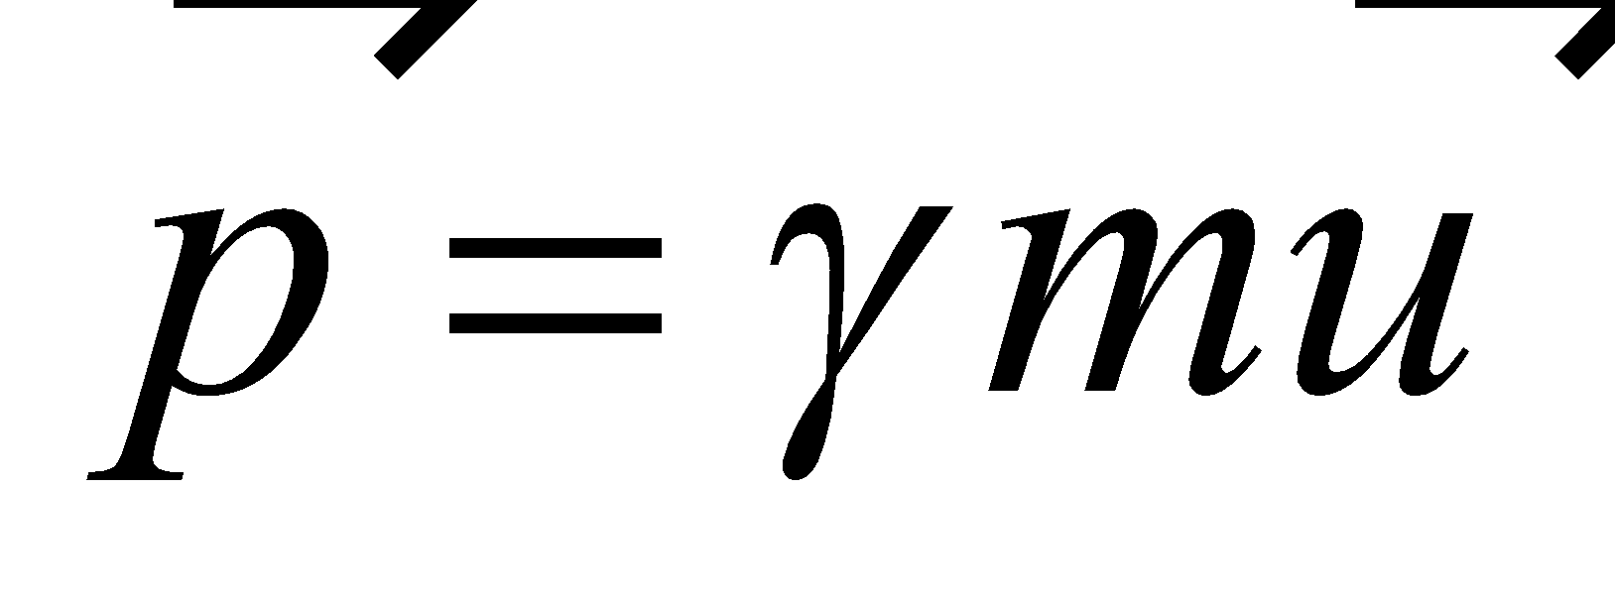 for the electron and 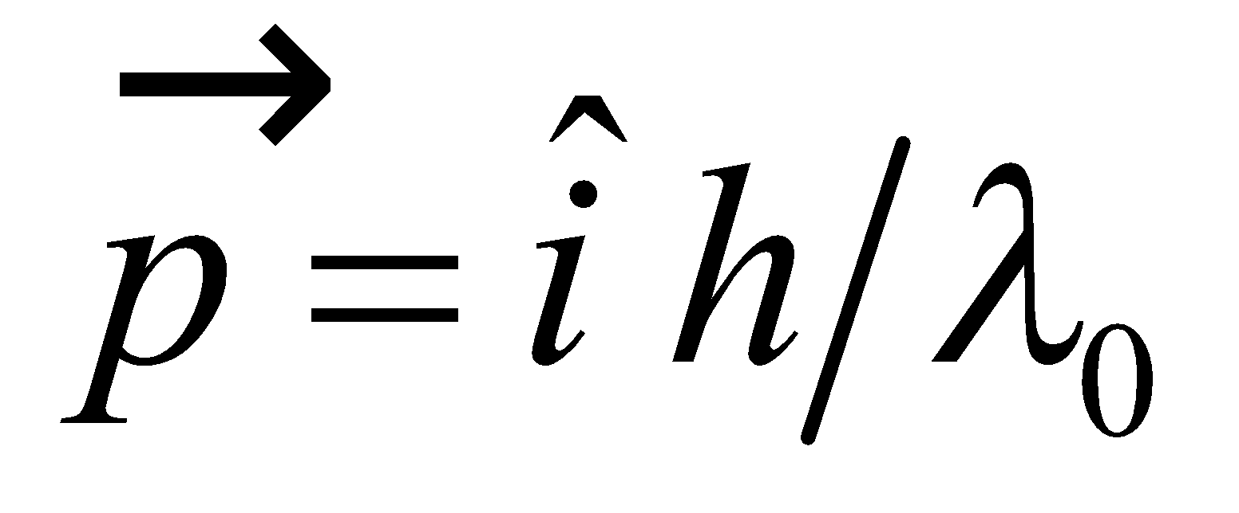 for the photon, where  is the direction of the photon’s motion. We will use conservation of energy to obtain one of the desired equations, and conservation of momentum in two dimensions to obtain the other two equations.

**Evaluate** The initial energy is the energy of the photon plus the rest energy of the electron:

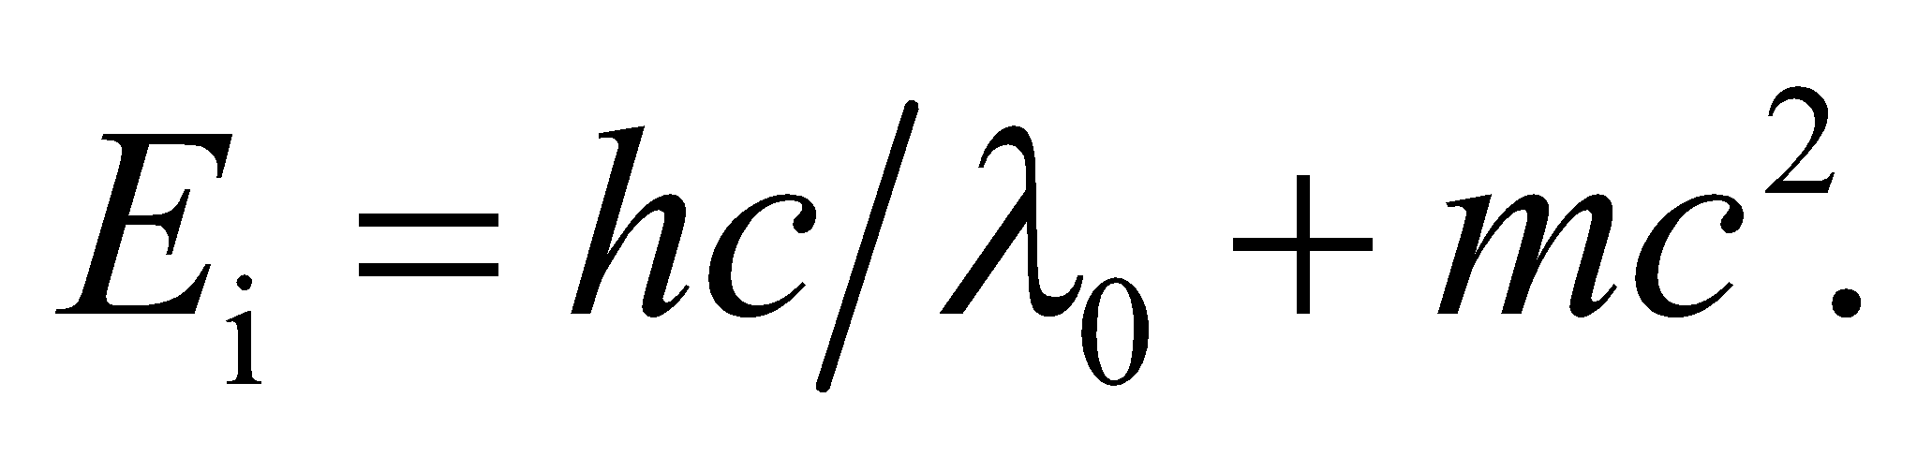

The final energy is the energy of the new photon plus the relativistic energy of the moving electron:

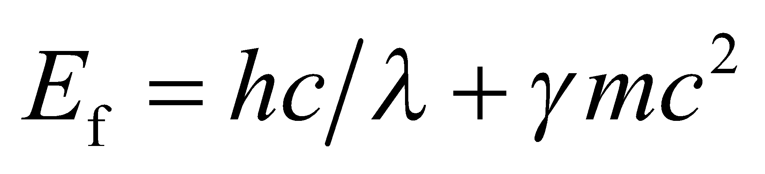

Equating these two energies (by conservation of energy) gives us the first of the three desired equations:

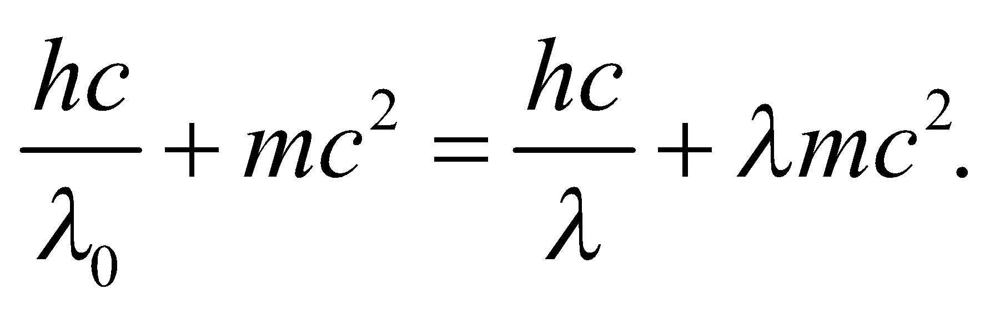

The next two equations come from the initial momentum,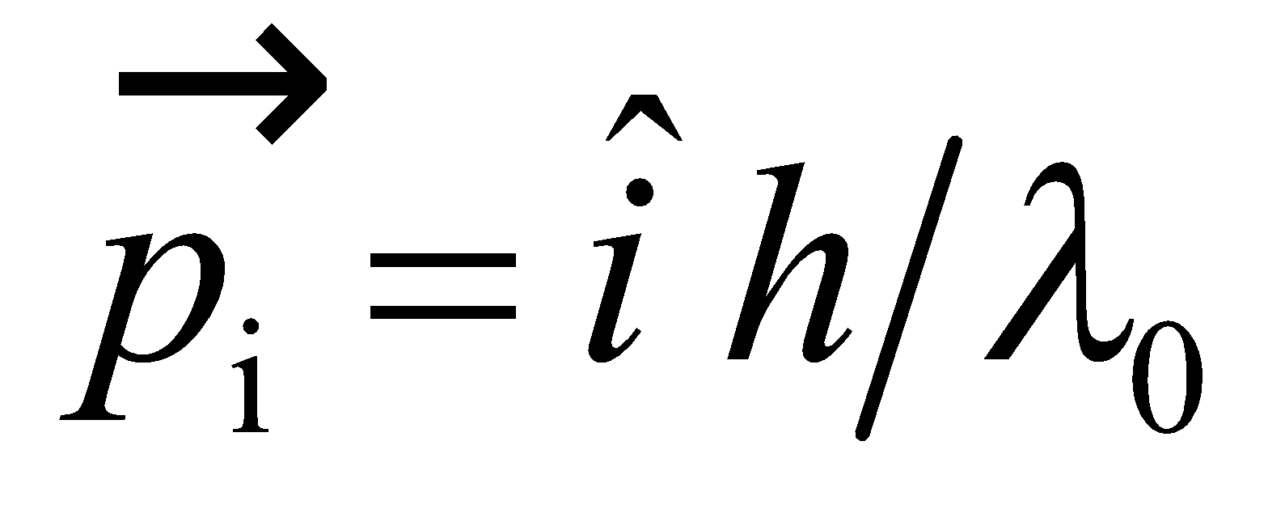 and the components of final momentum 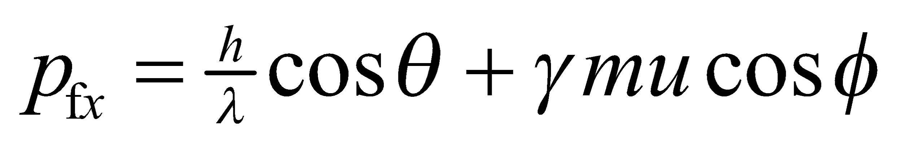 and 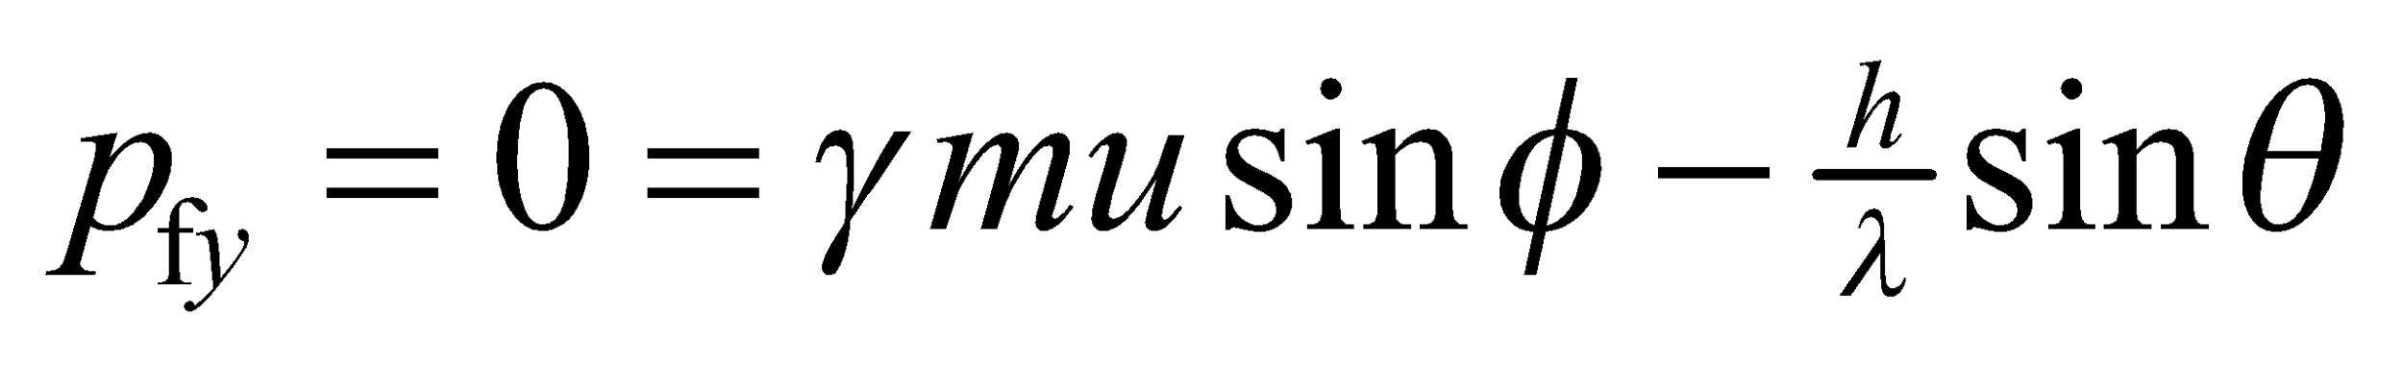. By conservation of momentum, we can equate the initial and final momentum in each direction, which leads to

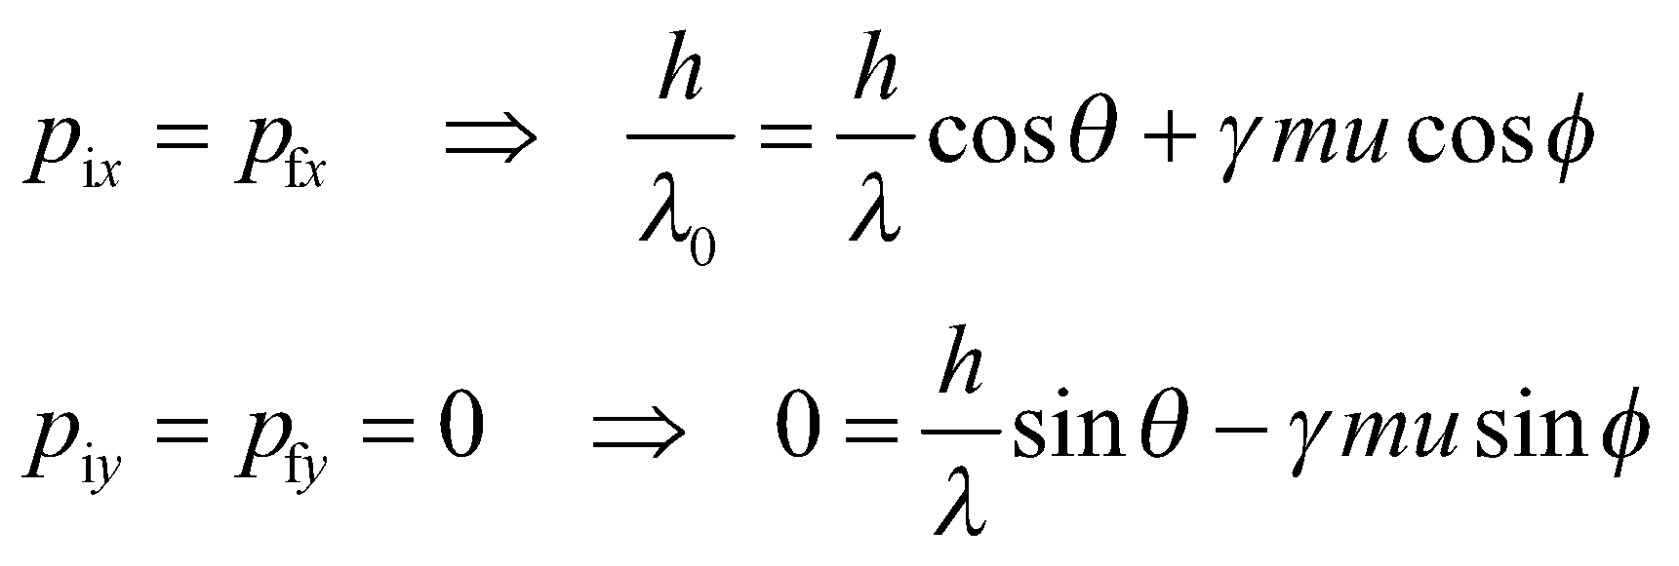

These are the second two of the desired relationships we were to derive. Solving these three equations for 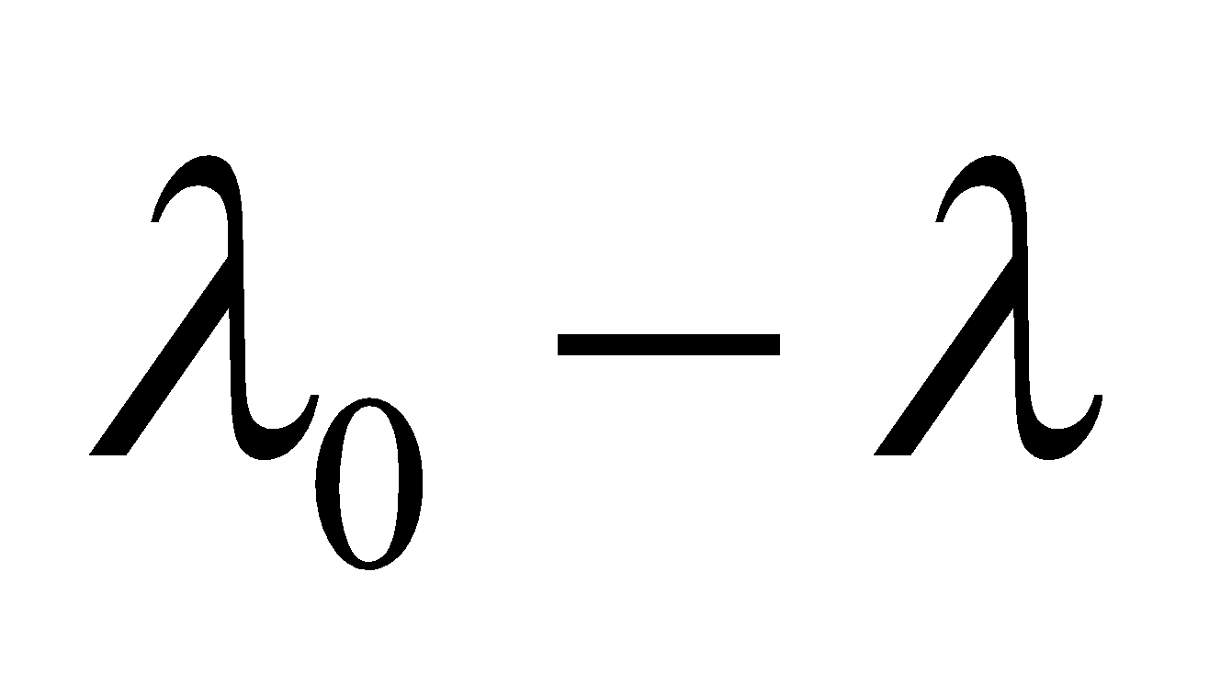 directly is a lengthy algebraic process. An easier approach is to start with the momentum in vector form and use the law of cosines:

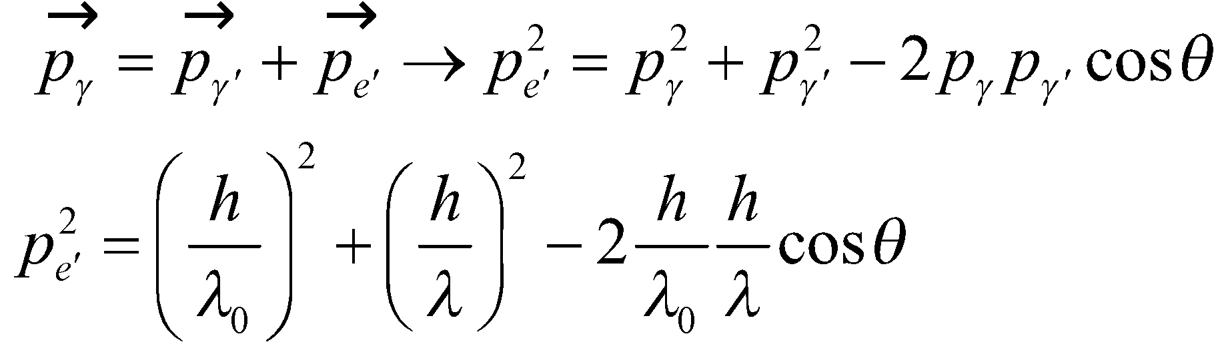

We now use conservation of energy in the form 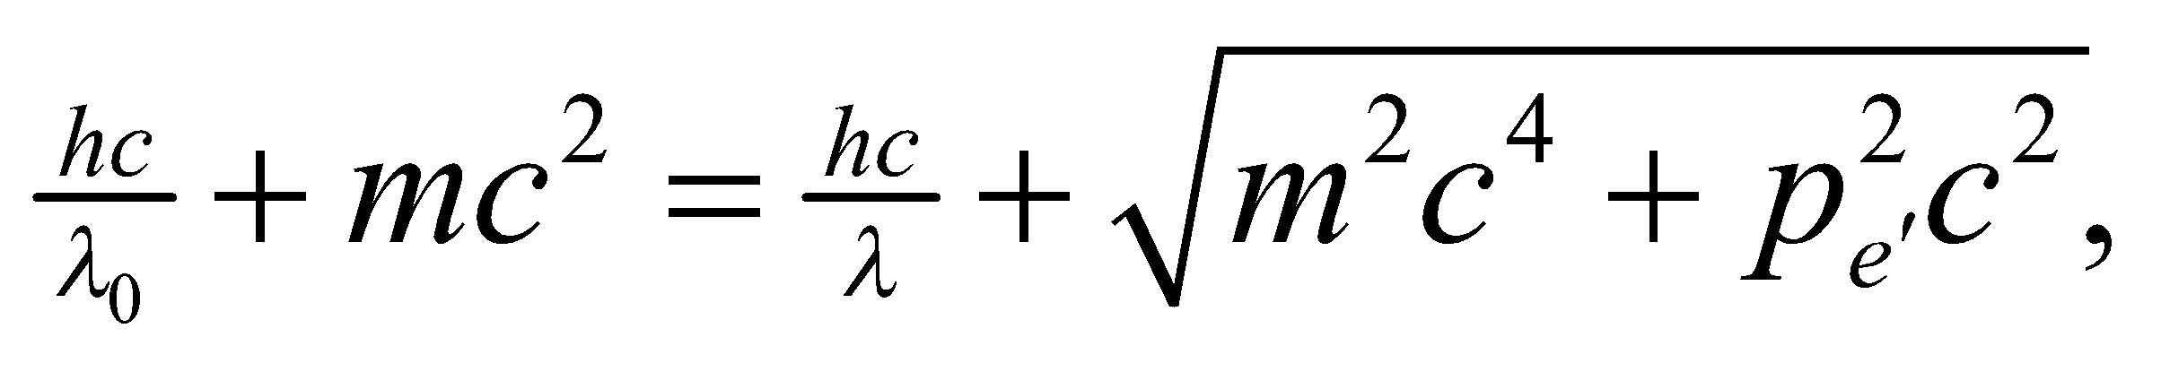 and solve for 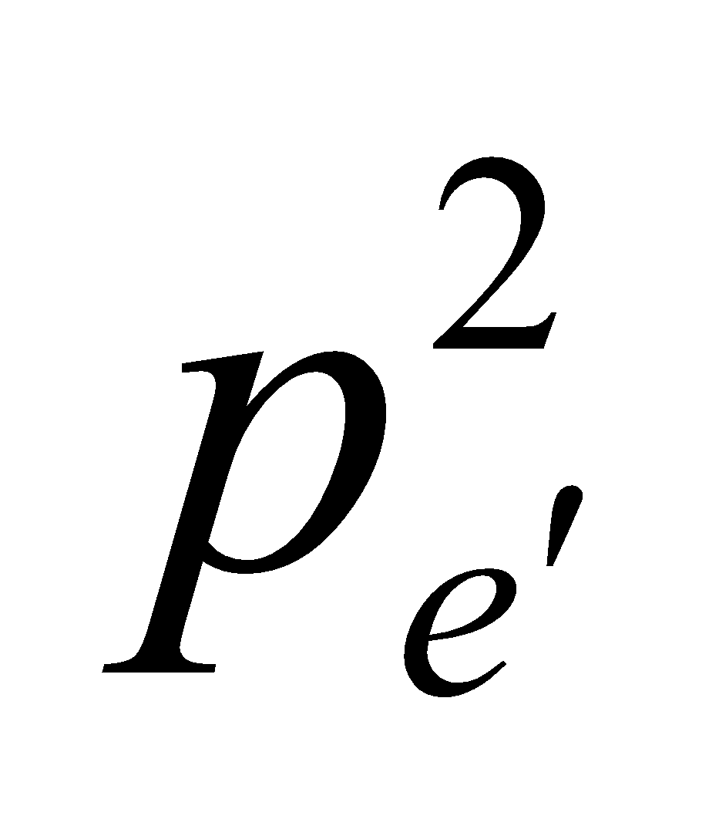 to obtain

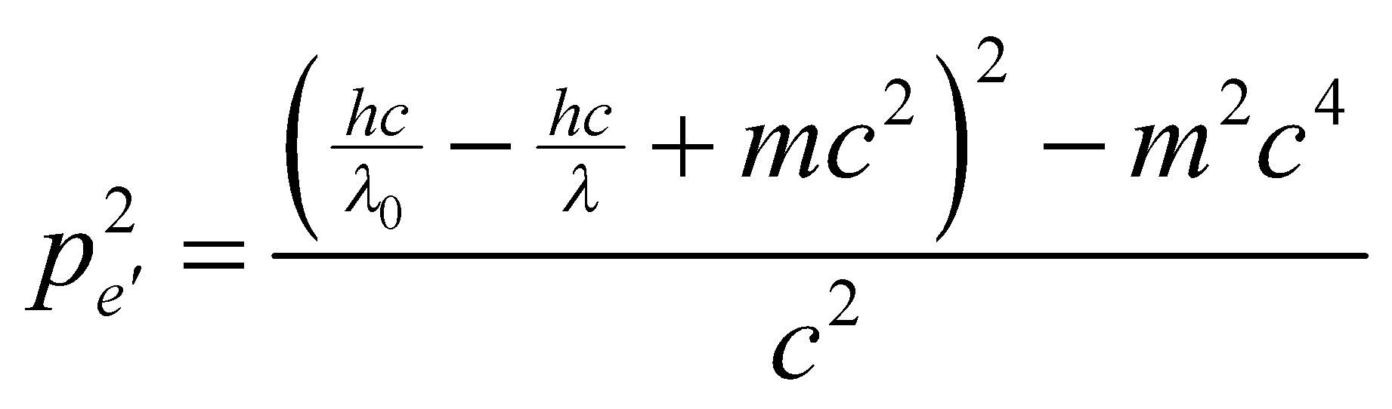

We equate the two equations for  to obtain

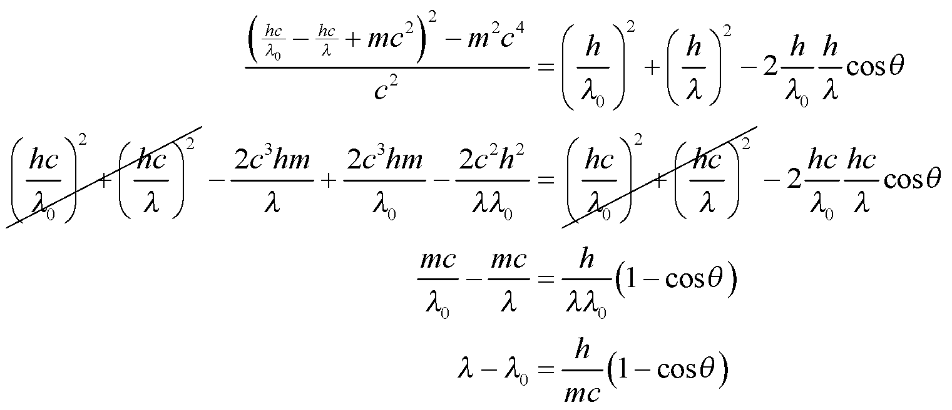

**Assess** We have derived the equation for the Compton shift, using conservation of energy and momentum.

**74. Interpret** We are to find the peak of blackbody radiation (i.e., Wien’s law, Equation 3.42a), looking at frequency intervals rather than wavelength intervals.

**Develop** We start with the radiance curve (Equation 34.3, Planck’s law)

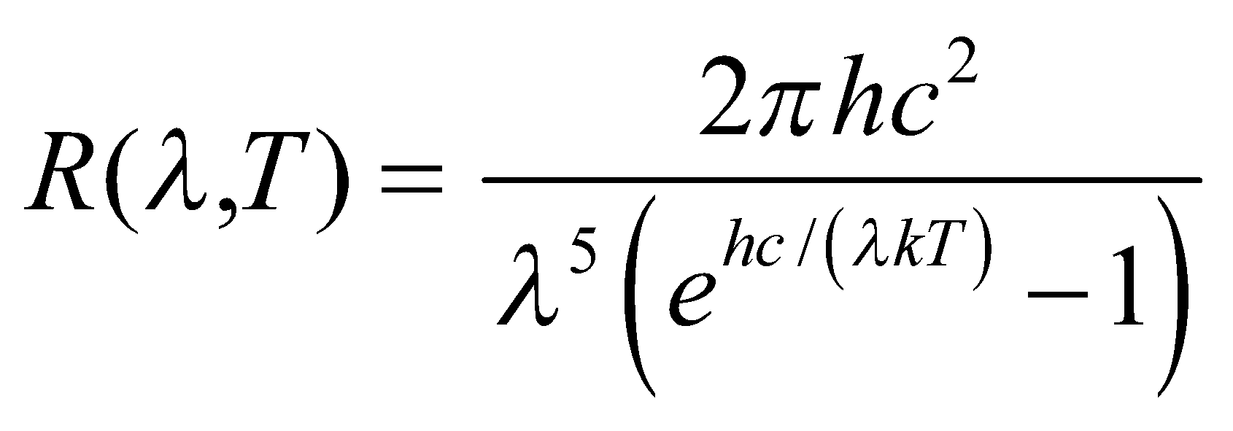

use *λ* =*c*/*f* and differentiate with respect to *f* to find the maximum. We’ll have to solve 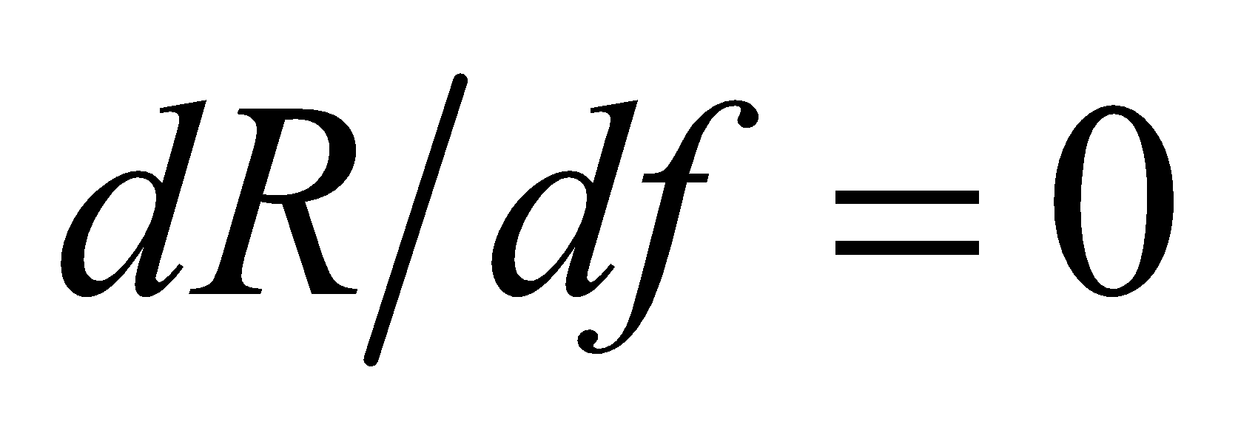 numerically.

**Evaluate**

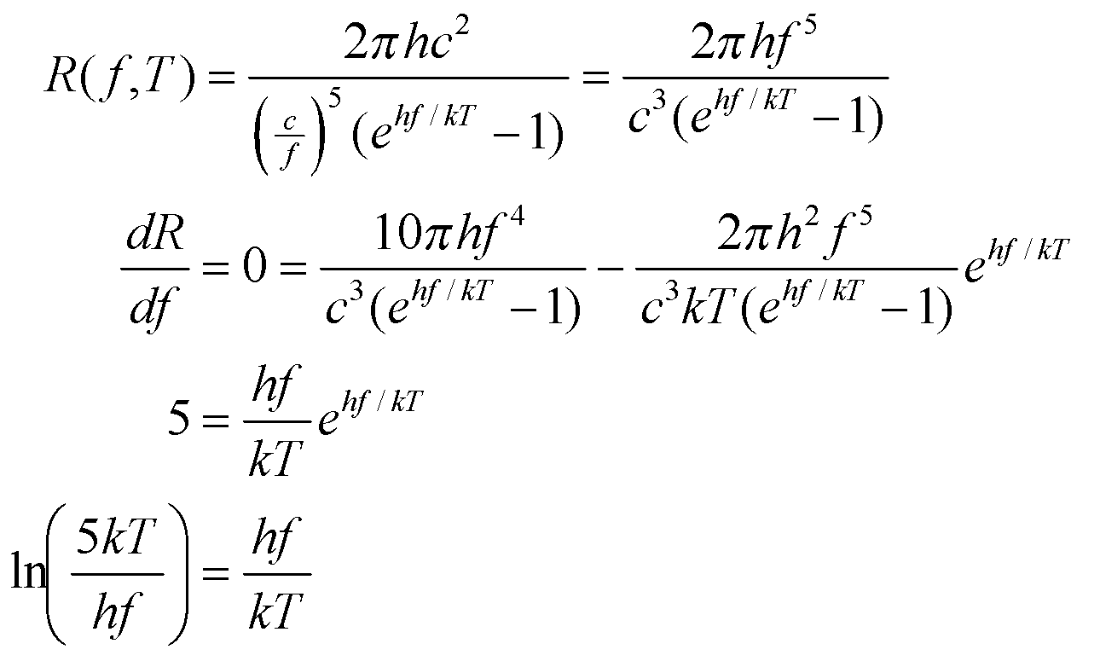

We solve this numerically for *T*/*f* to obtain *T*/*f* = 3.617 × 1011 K·s.

**Assess** If we use this formula to find the peak frequency for the Sun (*T* = 5800 K), we obtain *f* = 1.6 × 1014 Hz. This corresponds to a wavelength of *λ* = 1.87 mm. Compare this with the wavelength peak found in Problem 34.19—it’s quite different!

**75. Interpret** We are to integrate the radiance equation (Equation 34.3, Planck’s law) over all wavelengths and show that the resulting total power radiated per unit area is equivalent to the Stefan-Boltzmann law (Equation 34.1).

**Develop** The Stefan-Boltzmann law gives the power per area as 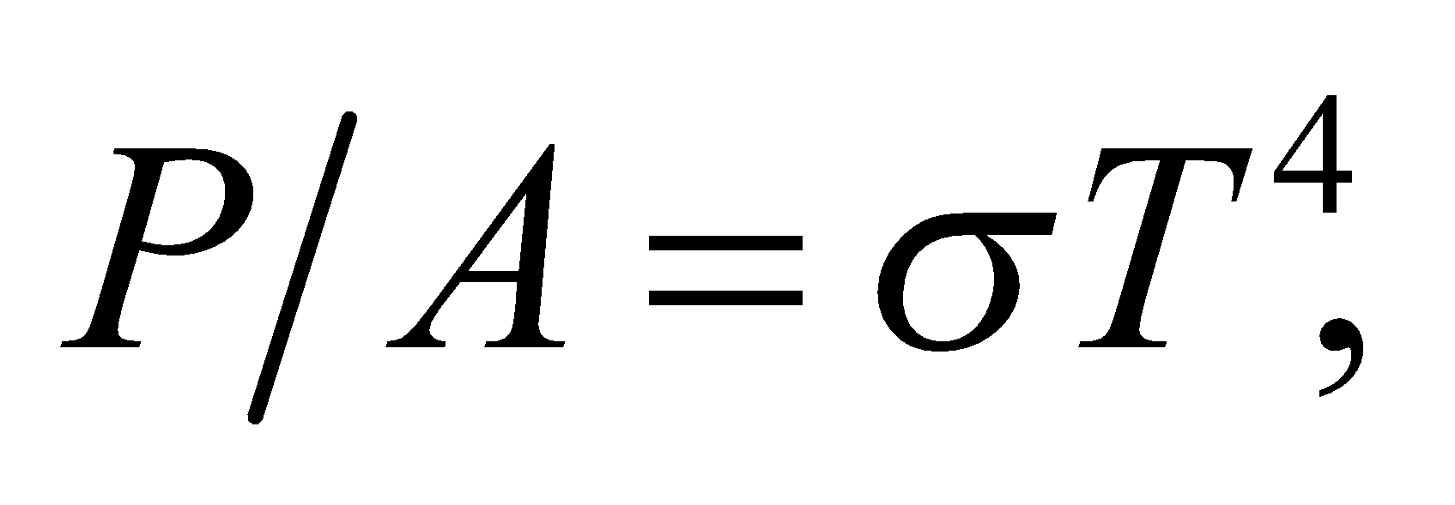 and the radiance equation is



Substituting *hc*/(*λkT*) by the integration variable *x* gives

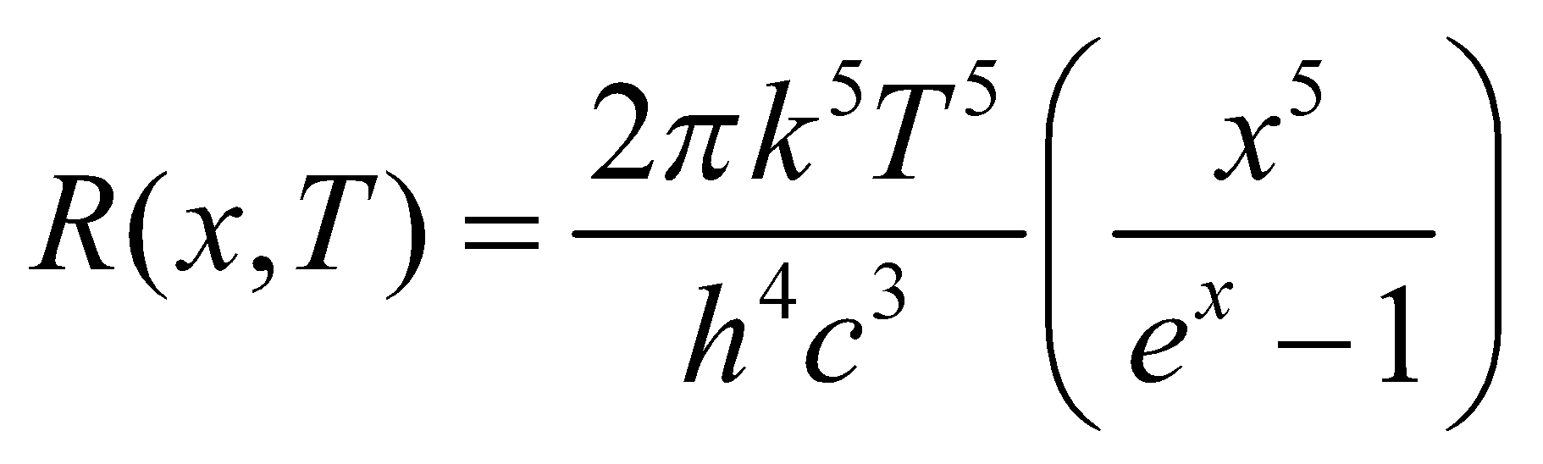

The differentials *dx* and *dλ* are related by

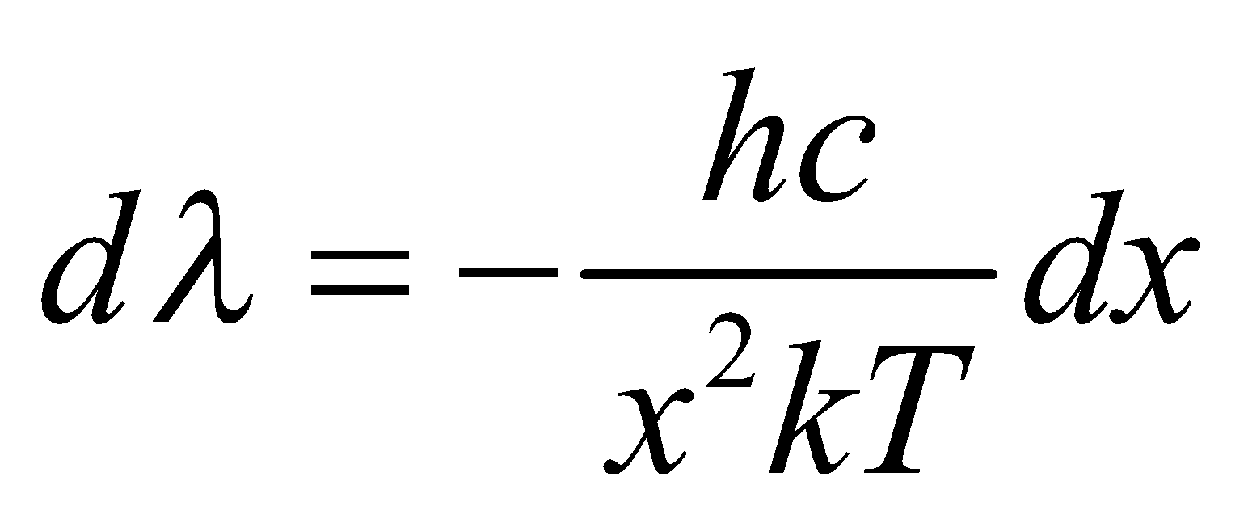

We will integrate *R*(*x*, *T*)*dλ* over all *λ*.

**Evaluate** Performing the integration gives

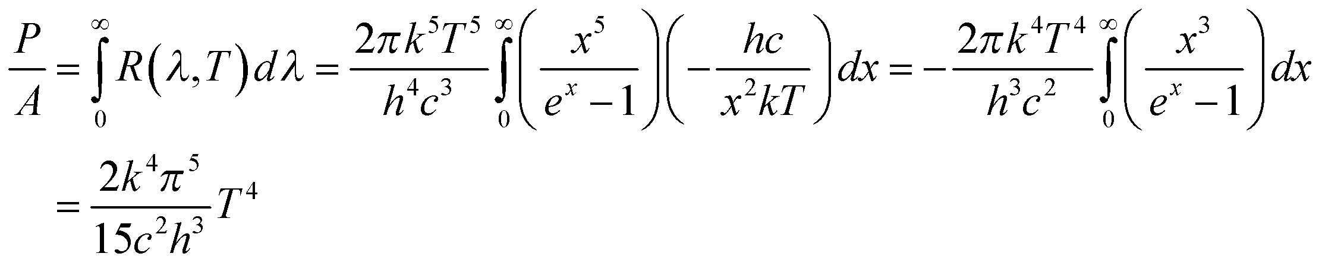

**Assess** This is equivalent to the Stefan-Boltzmann law, with 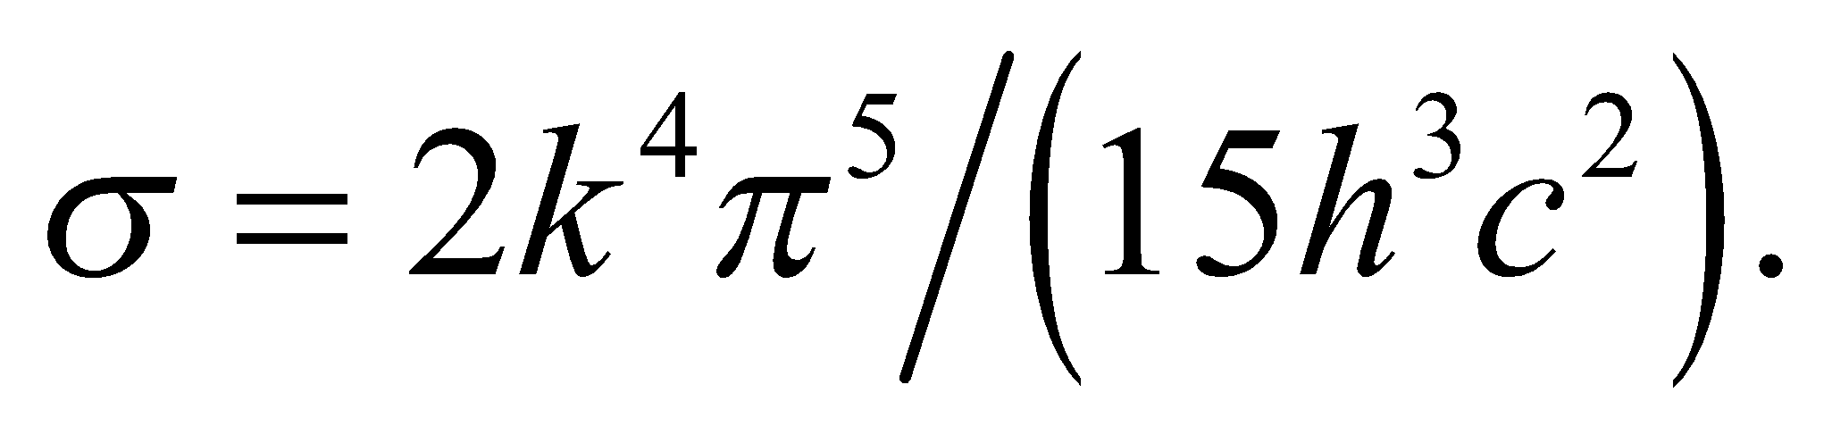

**76. Interpret** We are to numerically verify the median wavelength as given by Equation 34.2b by numerically integrating the radiance equation from zero to the value given by 34.2b—the result should be 1/2.

**Develop** We shall numerically integrate Equation 34.3

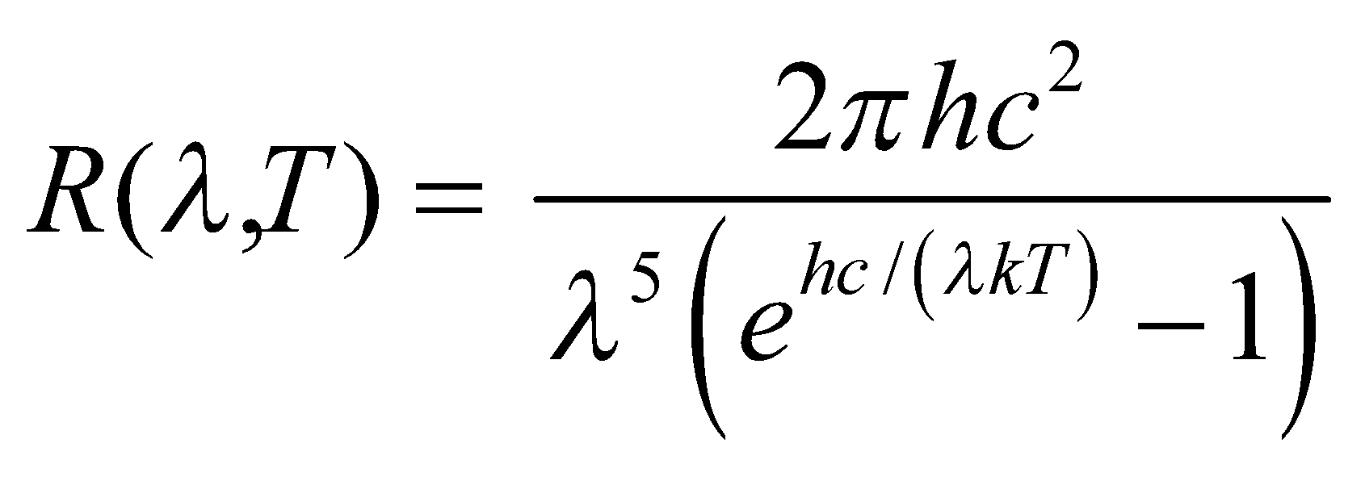

from *λ* = 0 to *λ*median = 0.00411/T. If the value we get is half the value obtained when numerically integrating to “infinity”, then we will have verified that *λ*median is indeed the median wavelength.

**Evaluate** With most numeric software packages or simple integration routines, it is easiest to substitute some value of *T*. For example, for *T* = 1000 K, the integral to *λ*median is 28,379 and the integral to some approximately “infinite” number is 56,704. Other values of *T* give different values, but in each case the integral to *λ*median is approximately half the integral over all values of *λ*.

**Assess** The median wavelength is given to only three significant figures. The numeric value of the integral taken to *λ*median is half the numeric value of the entire integral to more than three significant figures, so we have verified that the median wavelength given is correct.

**77. Interpret** We use conservation of momentum to find the recoil angle of the electron in Compton scattering.

**Develop** The momentum conservation equations from problem 34.73 are

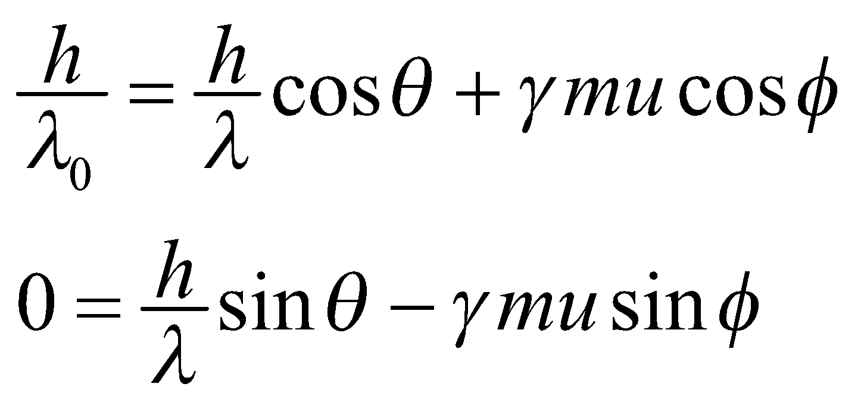

The Compton scattering equation is 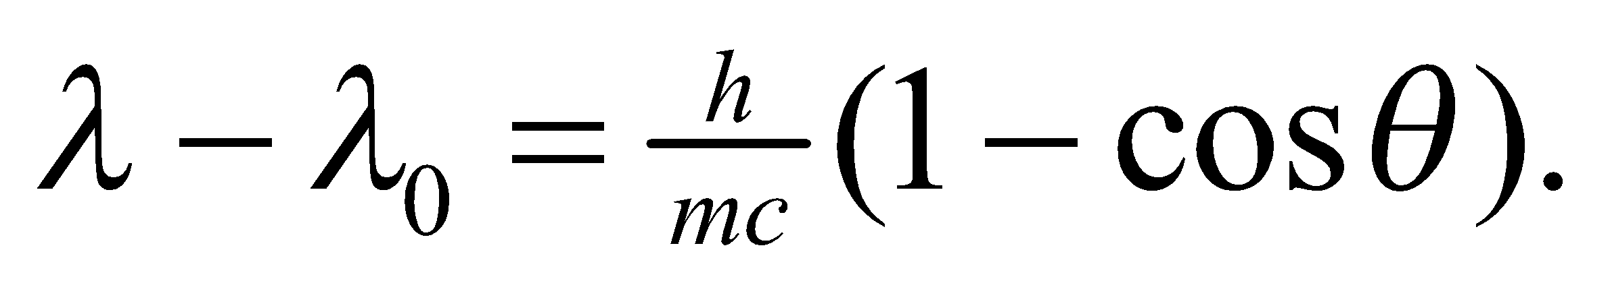 We will solve the momentum equations for 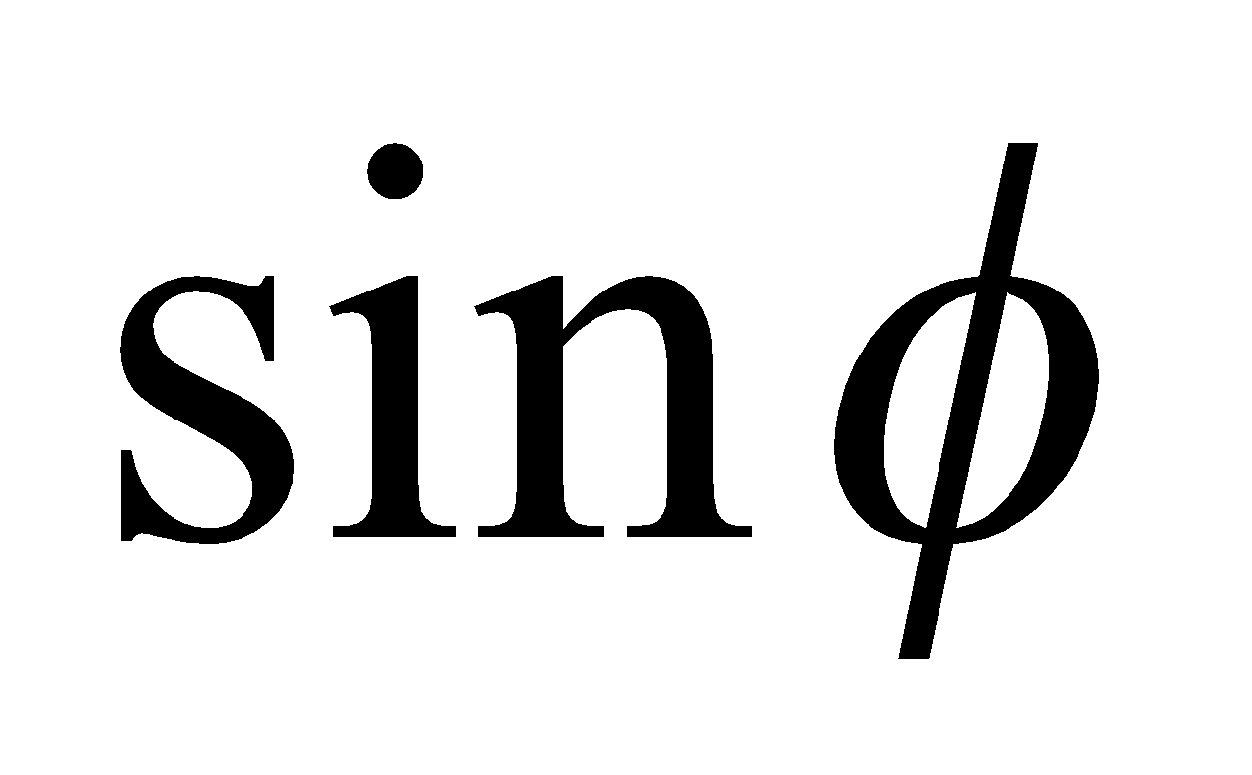 and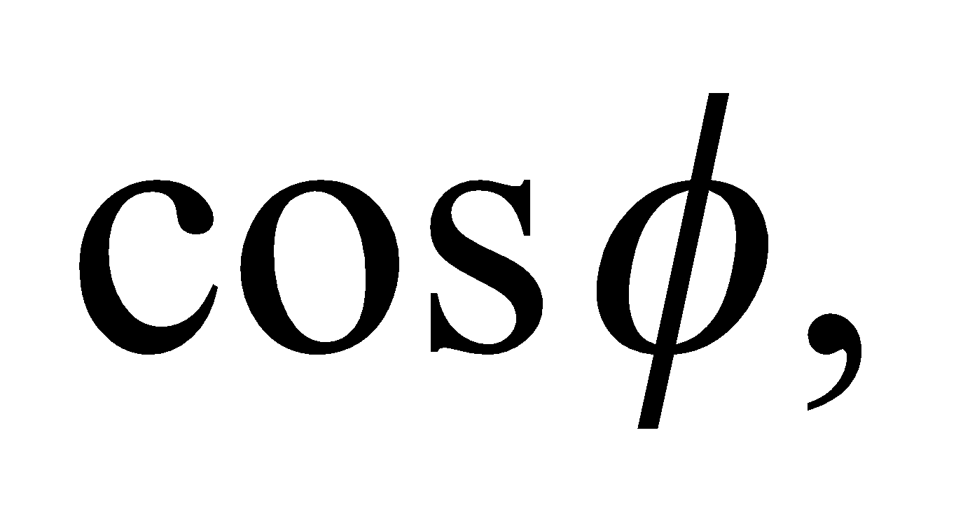 and then take the ratio to see if we can get the desired equation.

**Evaluate** First solving for  and we get

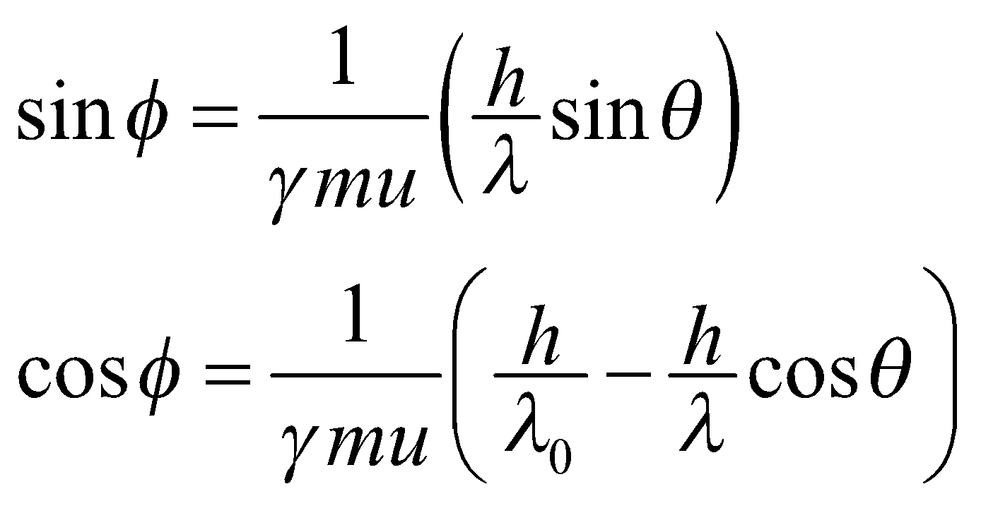

Taking the ratio and multiplying the numerator and denominator by 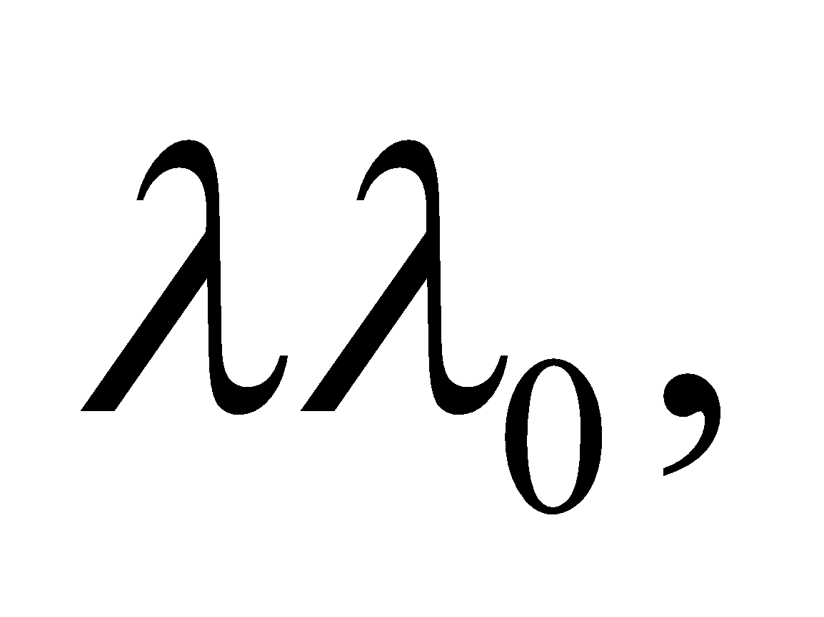 we arrive at the desired result:

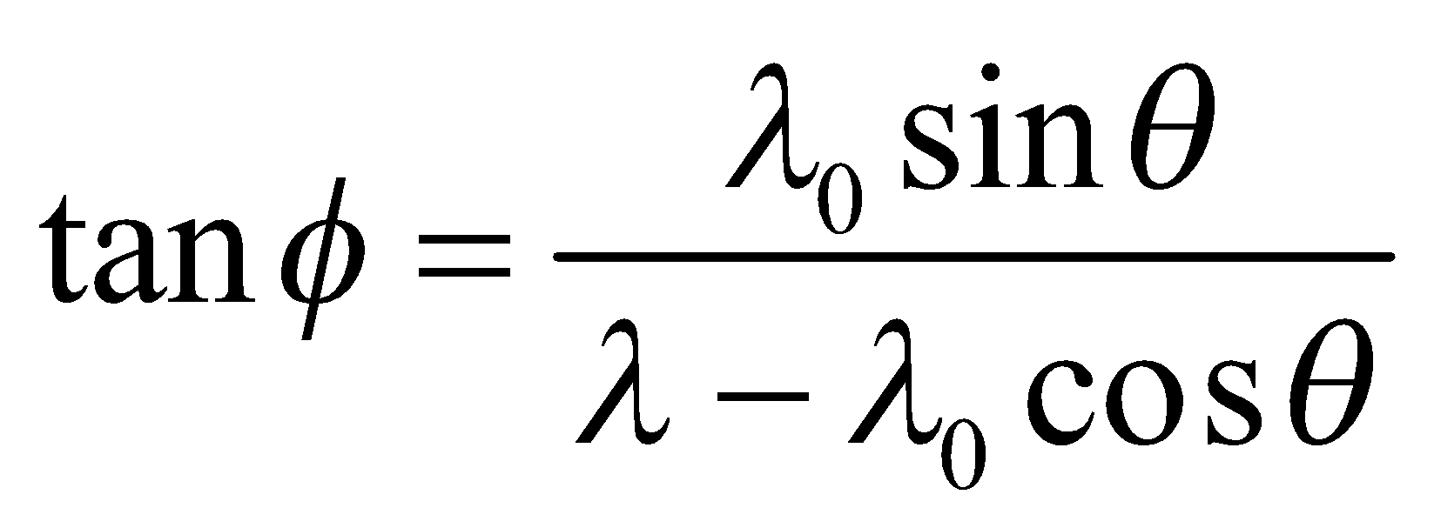

**Assess** To remove the dependence on the final wavelength, 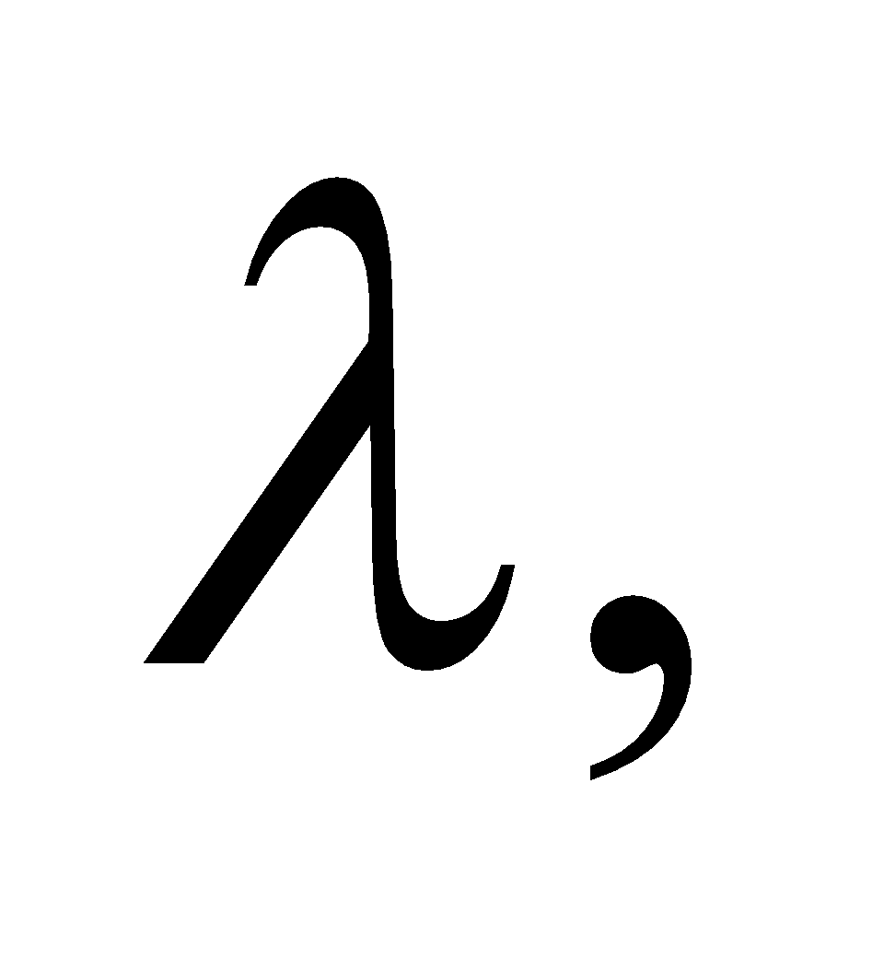we use the Compton shift equation:

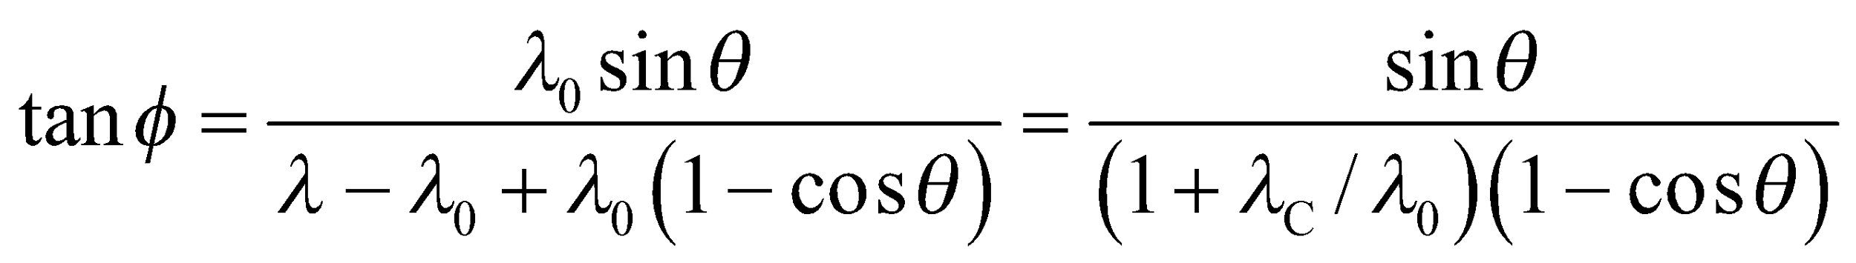

where 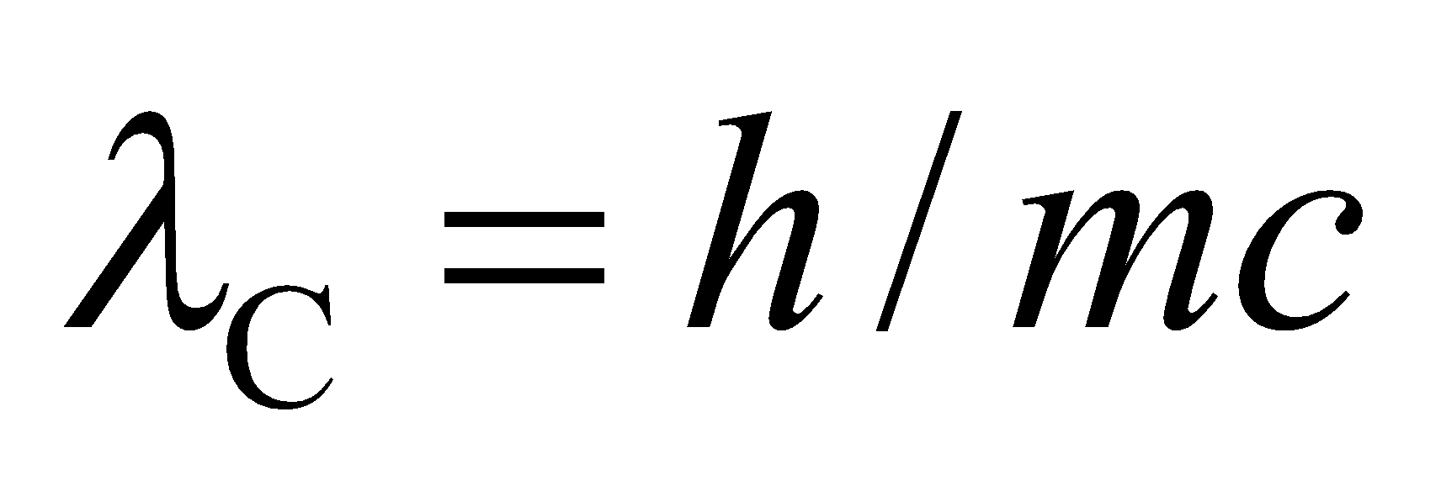is the Compton wavelength. This shows that as you decrease 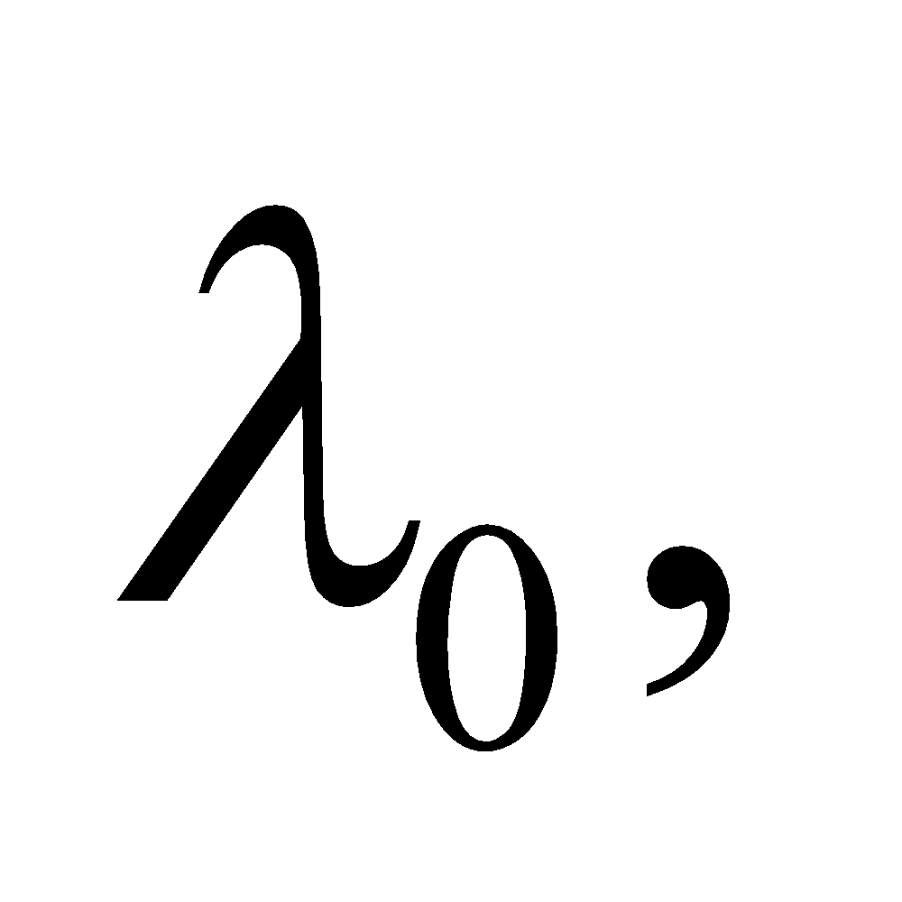i.e., as you go towards higher energy photons, the recoil angle, 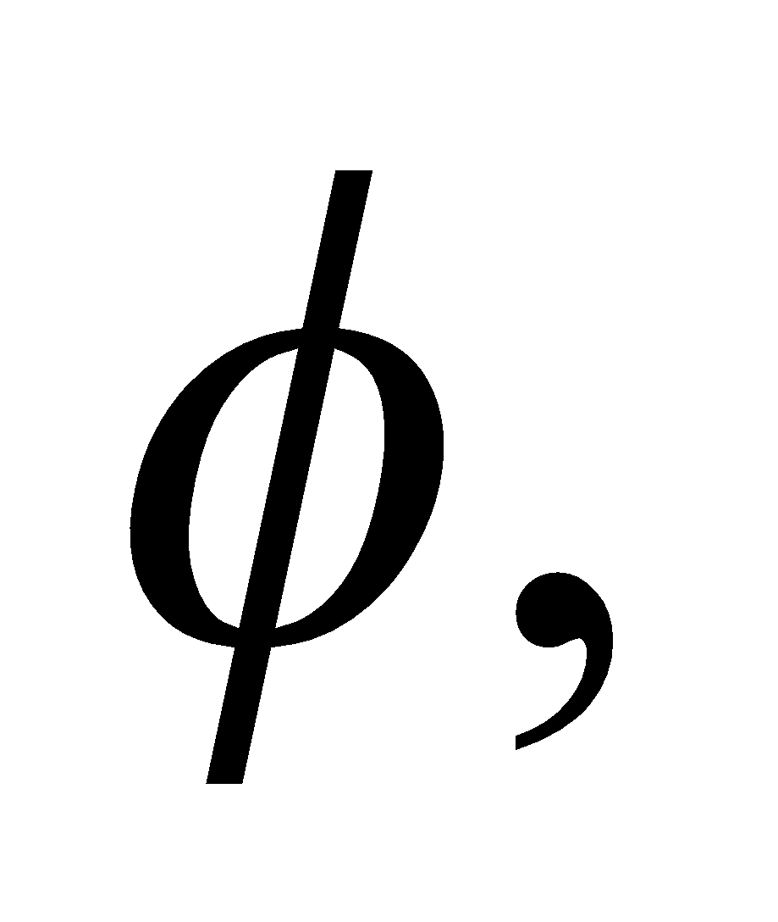of the electron decreases (for a given recoil angle, 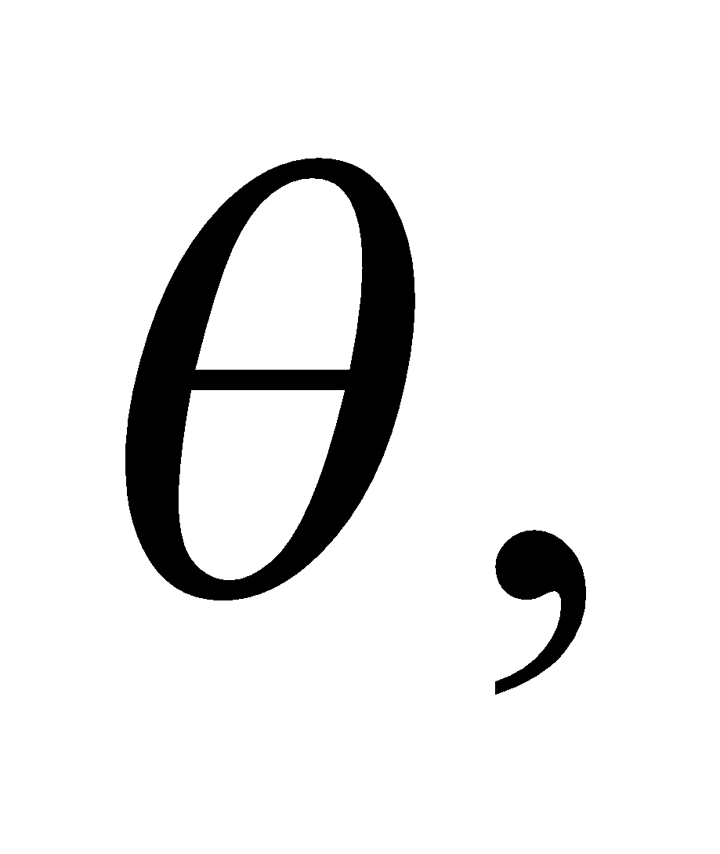for the photon).

**78. Interpret** We are to show that the correspondence principle (see Section 34.7) holds for the Bohr model in that the frequency of a photon emitted in a 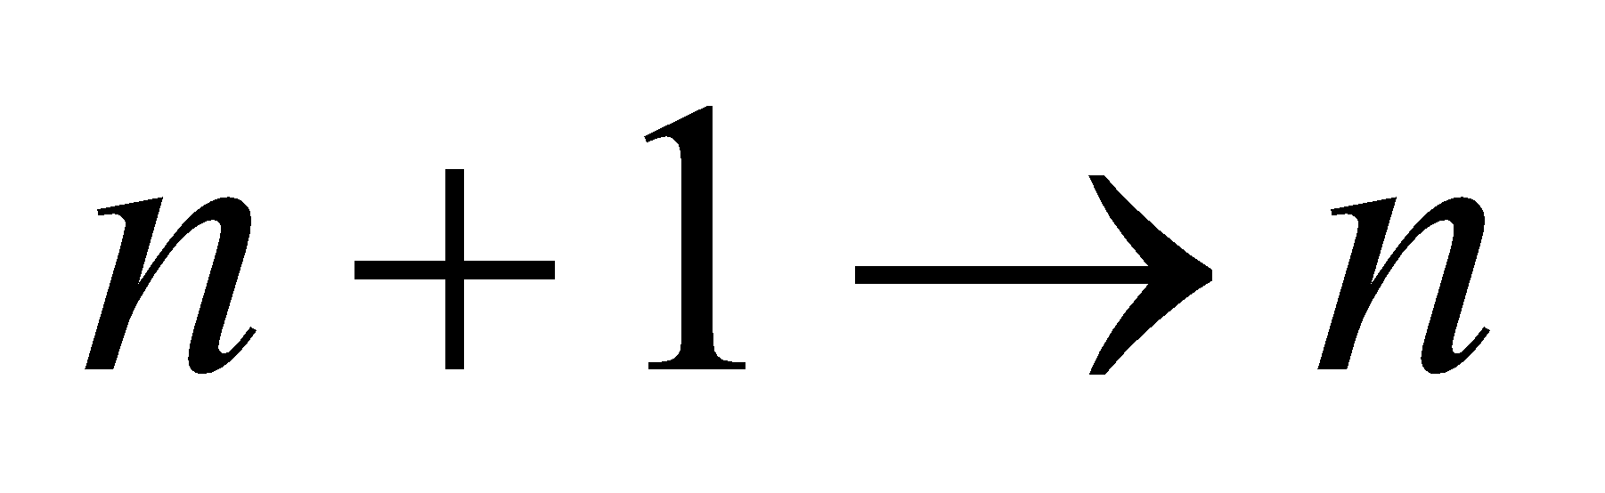 transition for large *n* equals the orbital frequency of the electron. We shall do this by taking the limit of both the transition energy and the orbital frequency as 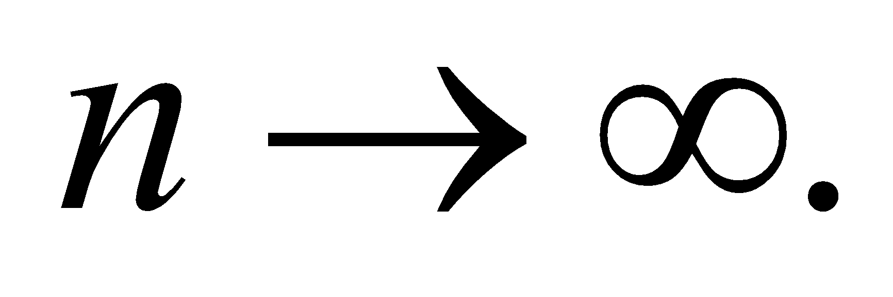

**Develop** The energy of the photon emitted in a transition from *n*1 to *n*2 is 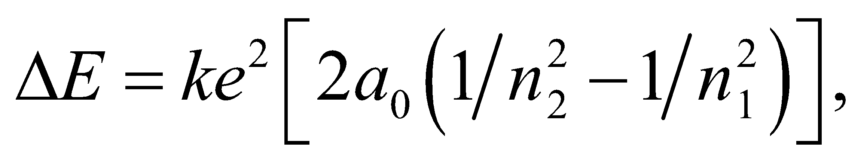 where *n*2 = *n* and *n*1 = *n* + 1. The frequency of the photon is *ΔE*/*h*. The orbital frequency can be calculated from the orbital radius 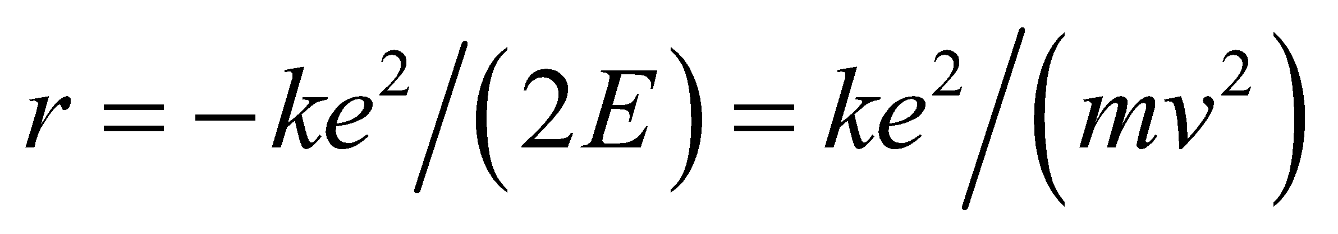 and the orbital velocity 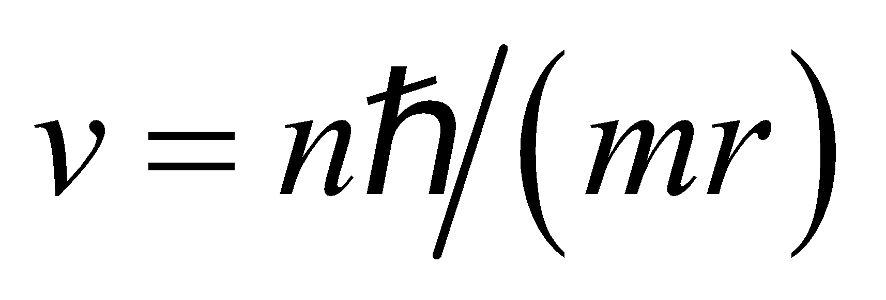 using 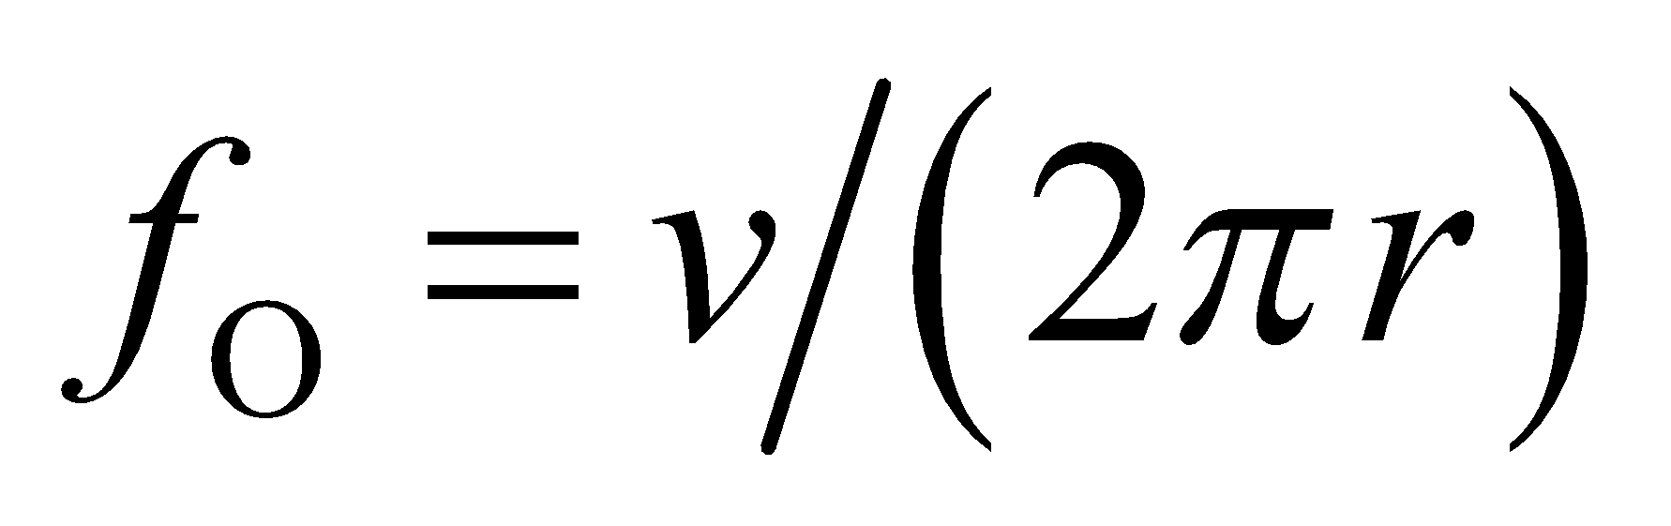.

We will use the binomial expansion to approximate 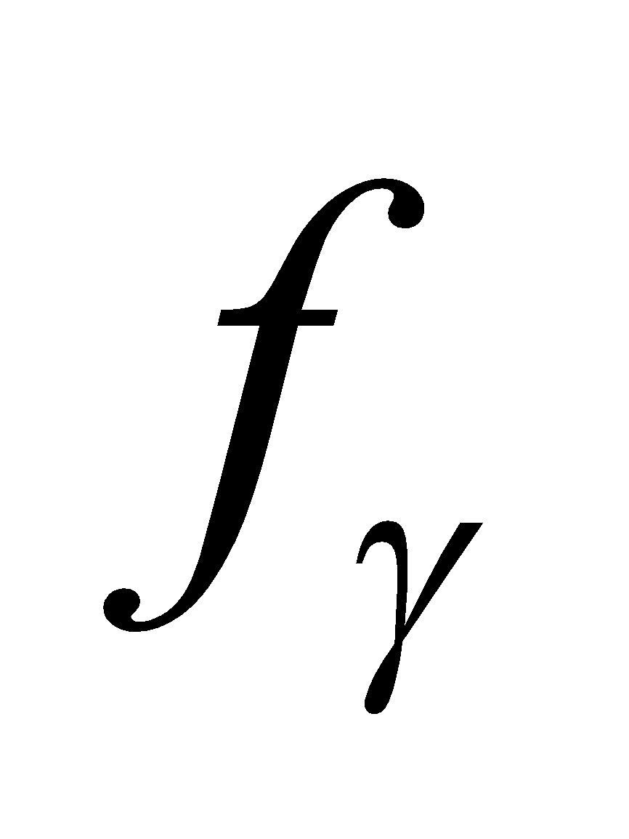 and compare the result with the orbital frequency 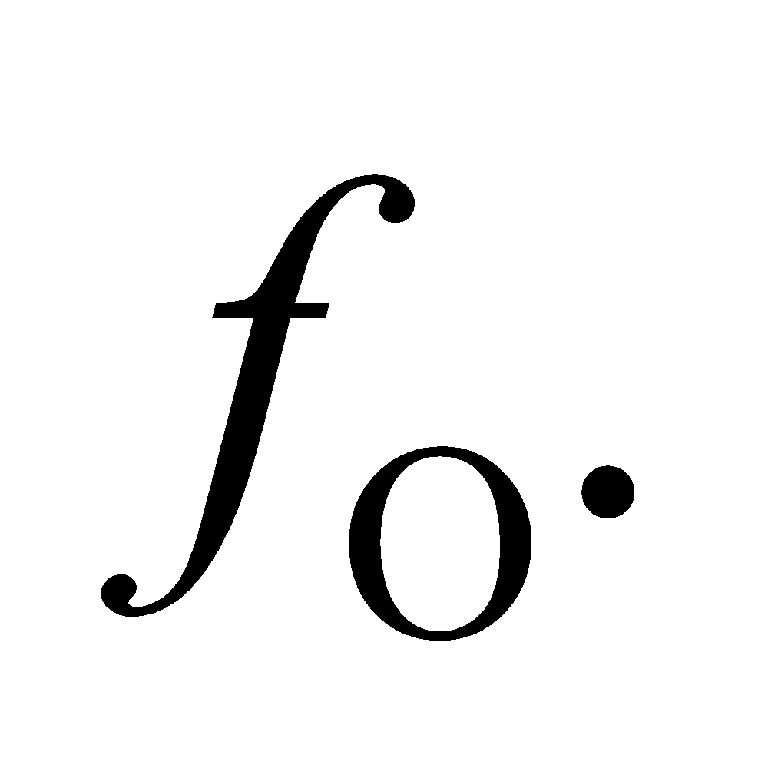

**Evaluate** From  and 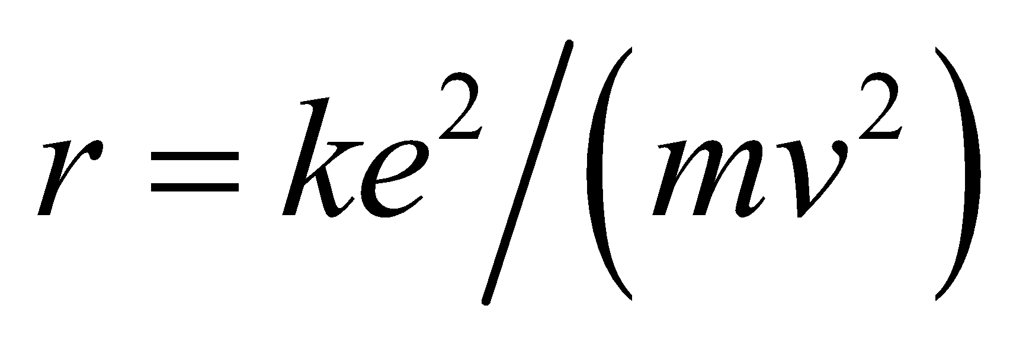 we obtain the orbital radius

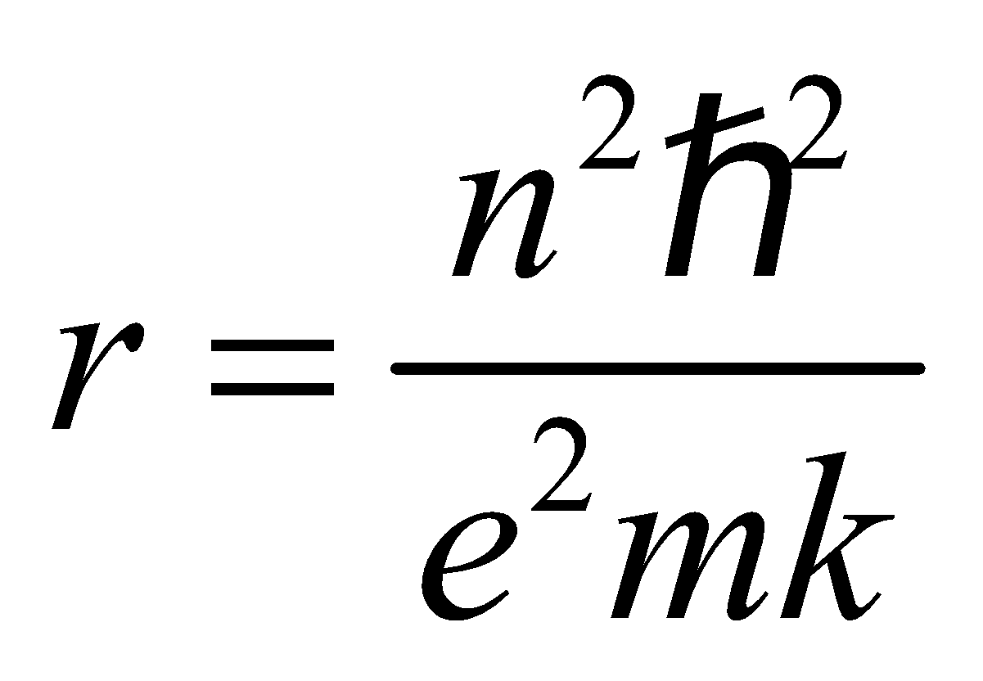

The orbital frequency is

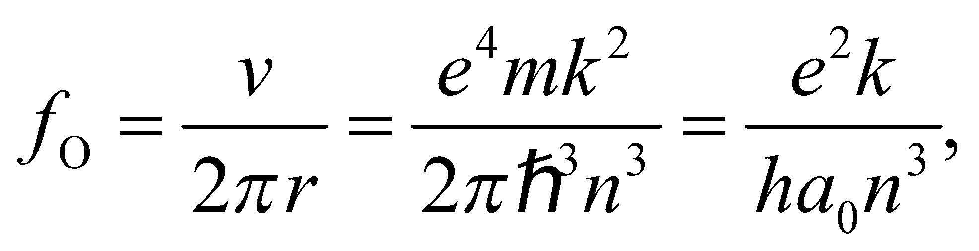 where 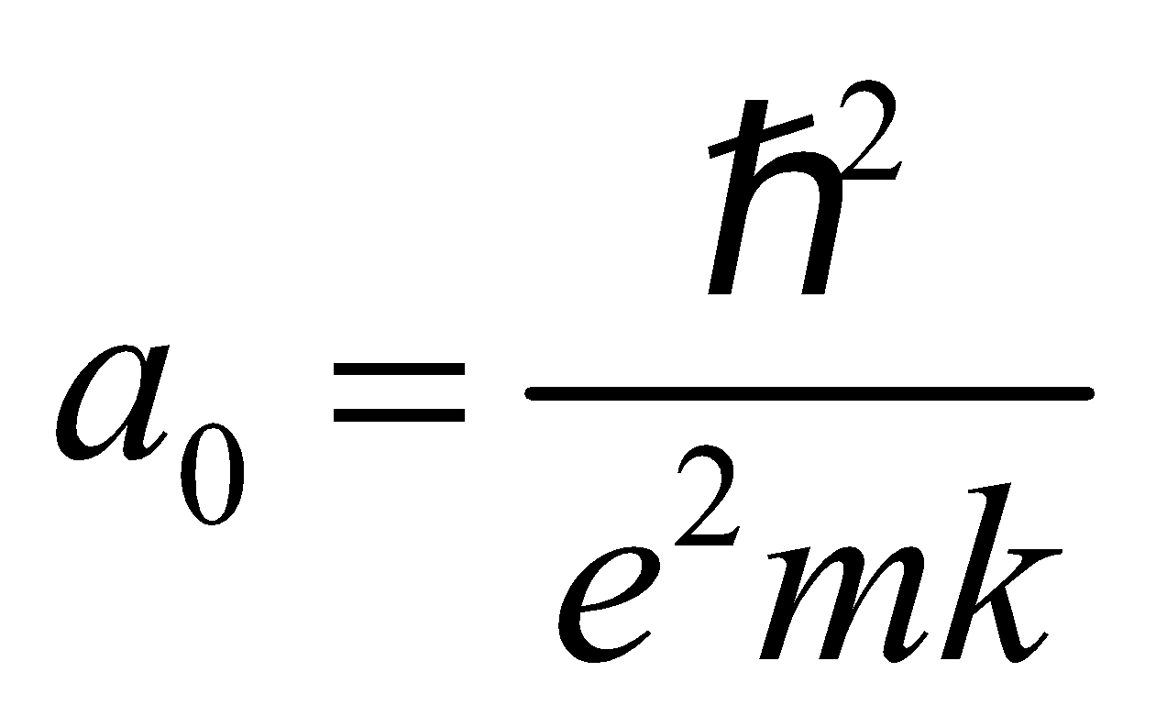

The frequency of the photon emitted is

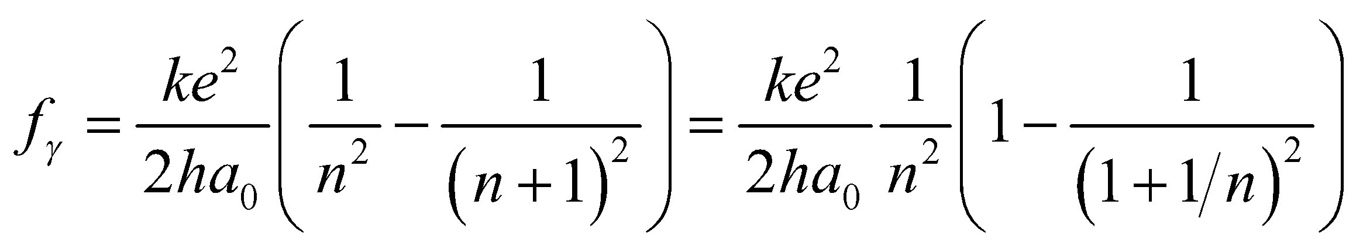

so for 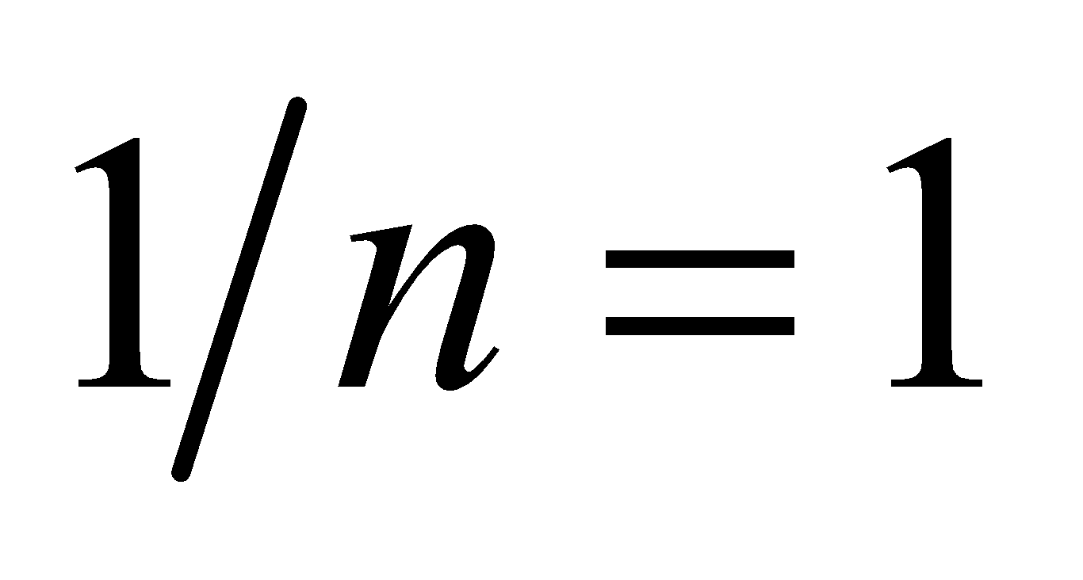

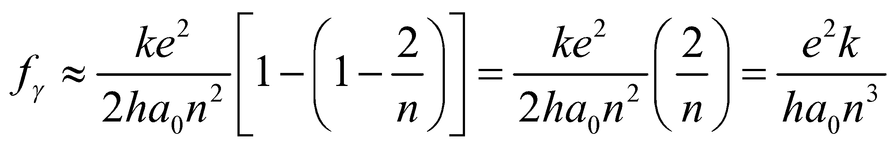

**Assess** For large values of *n*, the optical frequency  is the same as the orbital frequency 

**79. Interpret** We investigate the relation between particle lifetimes and uncertainty in their rest energy measurements.

**Develop** From Equation 34.16, the uncertainties in the energy and time are constrained by  Therefore, the lifetime of a given particle will be inversely proportional to the uncertainty in its rest energy: 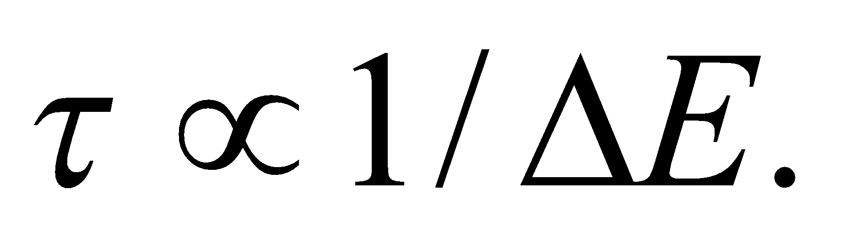

**Evaluate** The shortest lifetime will correspond to the curve with the largest uncertainty in its rest energy. In the graph, this is particle C.

The answer is (c).

**Assess** The distribution width shown in the graph is called the natural line width and is denoted by  It is called "natural" to signify that this uncertainty is inherent to the particle and does not, like other uncertainties, come simply from the imperfect instruments used to collect the data.

**80. Interpret** We investigate the relation between particle lifetimes and uncertainty in their rest energy measurements.

**Develop** As argued above, the lifetime is related to the uncertainty in its rest energy by 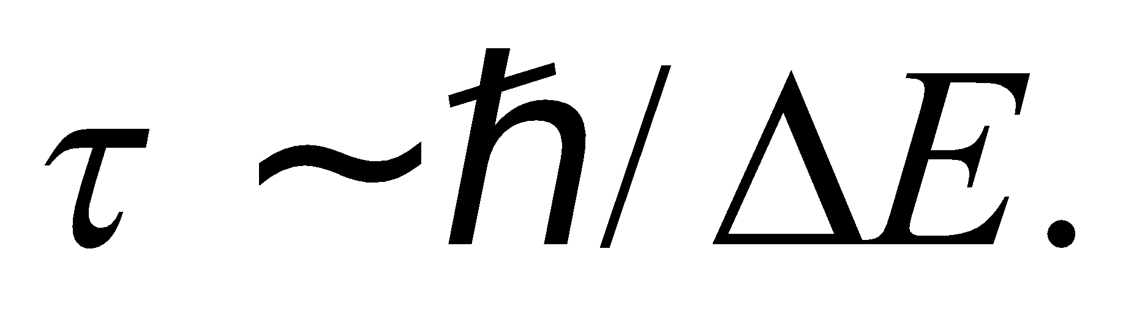

**Evaluate** For an uncertainty of 1 MeV, the lifetime must be roughly

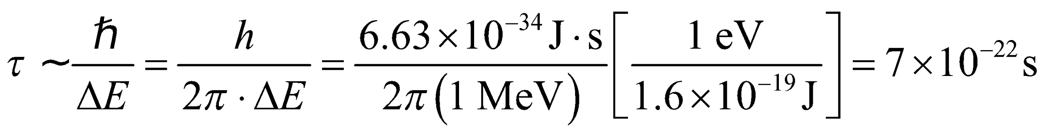

The answer is (b).

**Assess** Although this seems like an incredibly short amount of time, there are many particles that have lifetimes in this range.

**81. Interpret** We investigate the relation between particle lifetimes and uncertainty in their rest energy measurements.

**Develop** The inverse relation between energy uncertainty and lifetime is 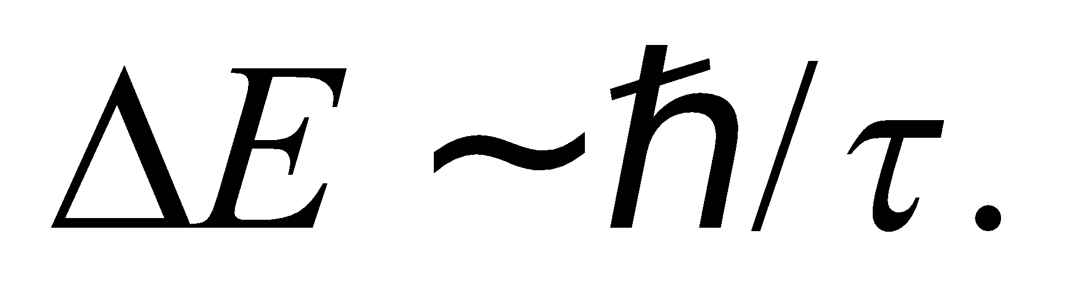

**Evaluate** A longer lifetime leads to a narrower range in the energy measurement. By Einstein's mass-energy equivalence, this corresponds to a narrower range in the mass, as well.

The answer is (d).

**Assess** Some particles, like the proton and the electron, appear to have infinite lifetimes, so we'd expect the uncertainty in their mass to be near to zero.

**82.** **Interpret** We investigate the relation between particle lifetimes and uncertainty in their rest energy measurements.

**Develop** Using Einstein's mass-energy equation 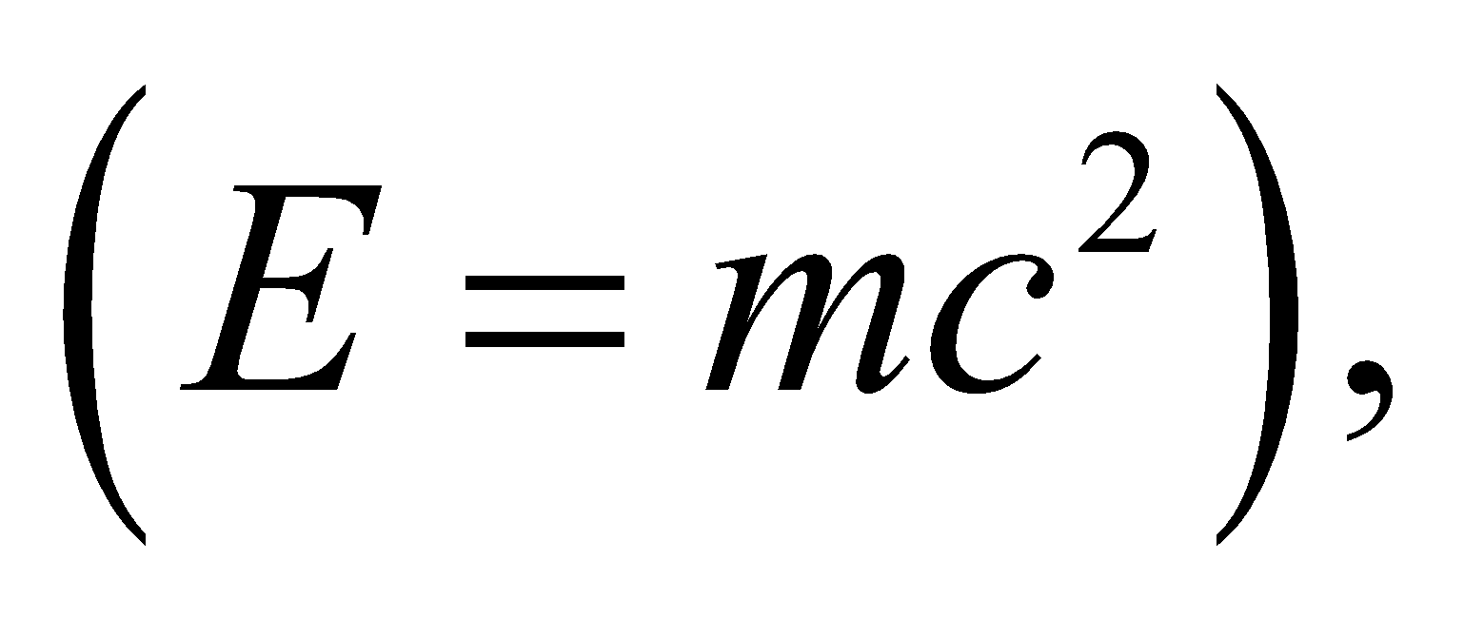we can write the time-energy uncertainty inequality as 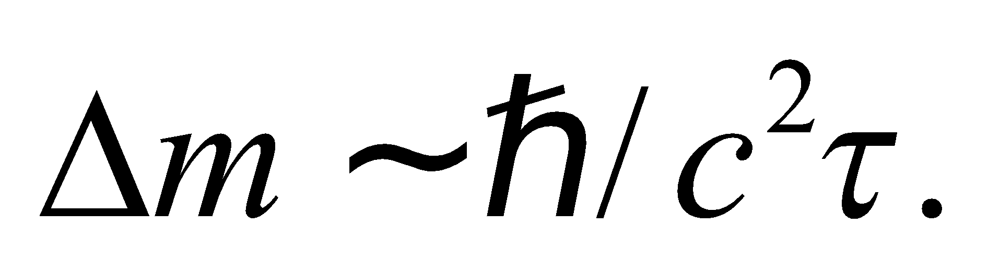

**Evaluate** Plugging in the lifetime, the mass range is

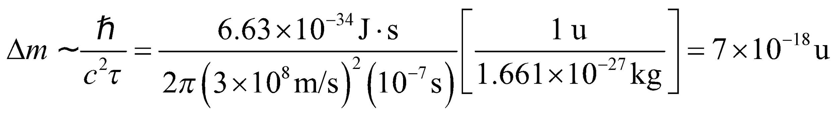

The answer is (c).

**Assess** In particle physics, 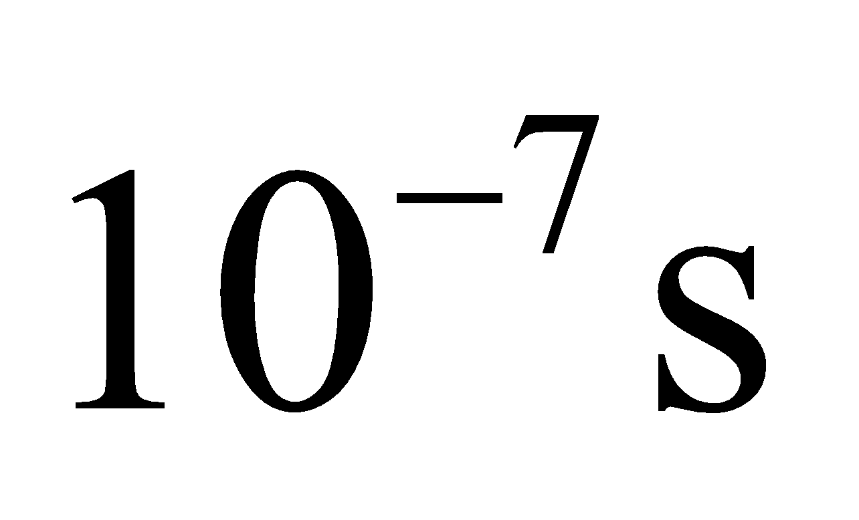is a relatively long lifetime. A particle with roughly this long of a lifetime is the charged pion with 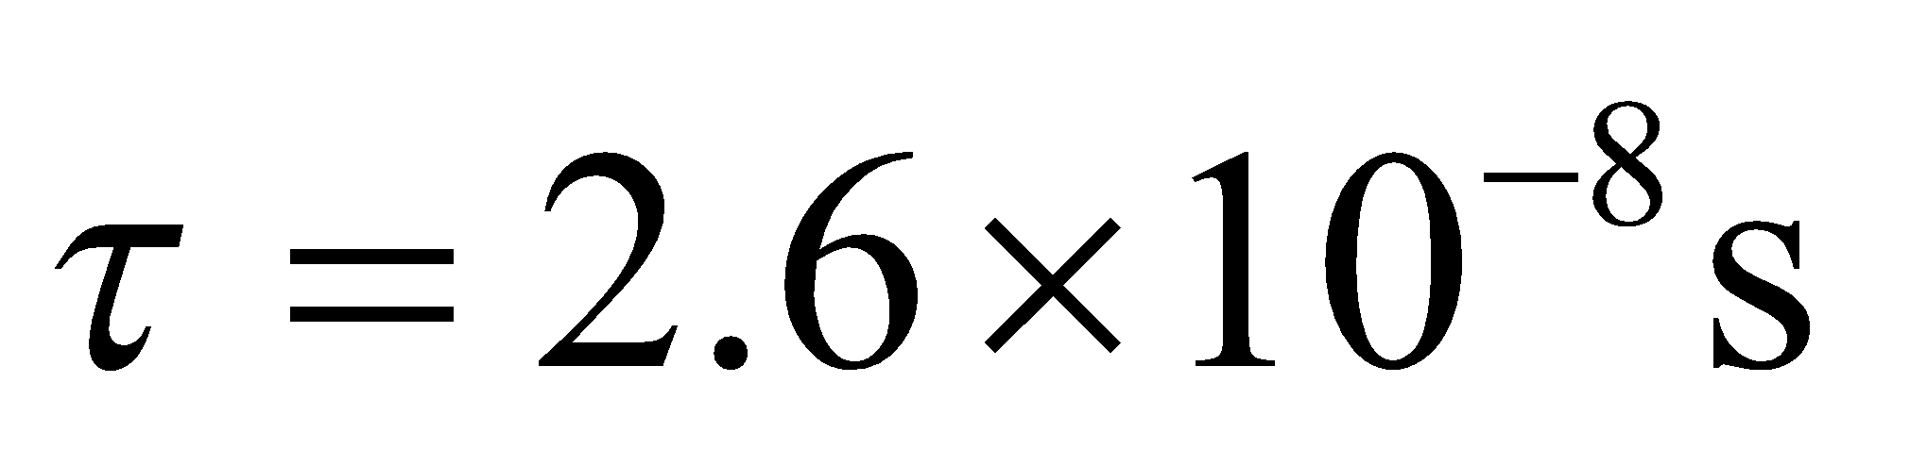 and a mass of 